**Graphs**

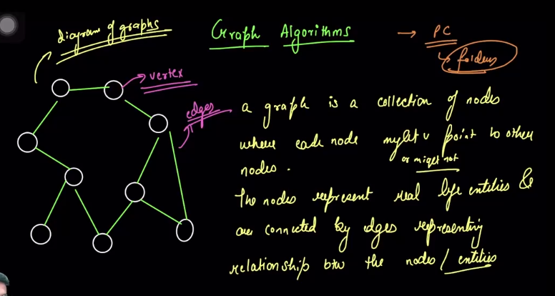

* 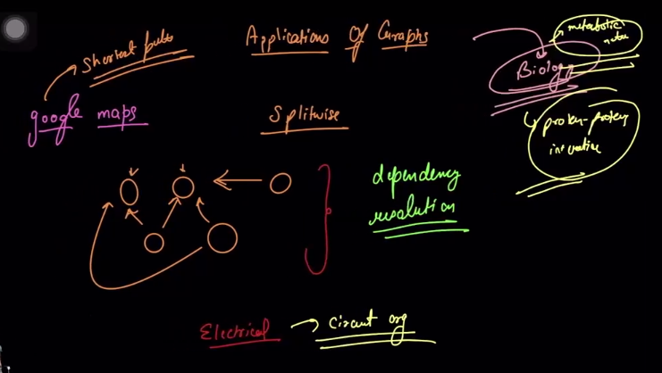
* 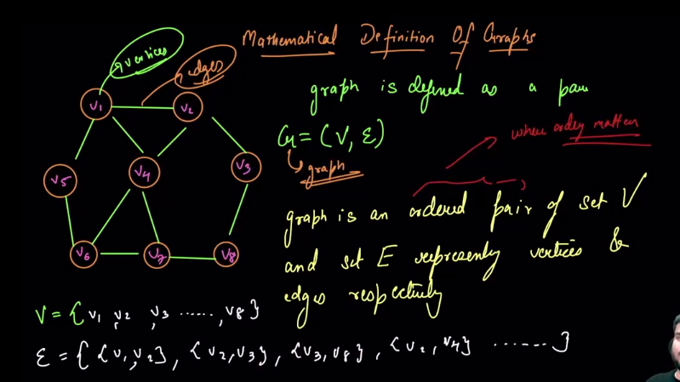

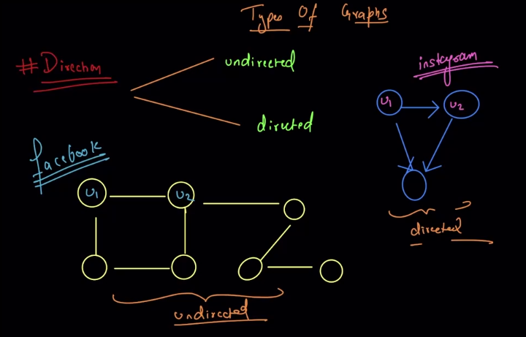

* 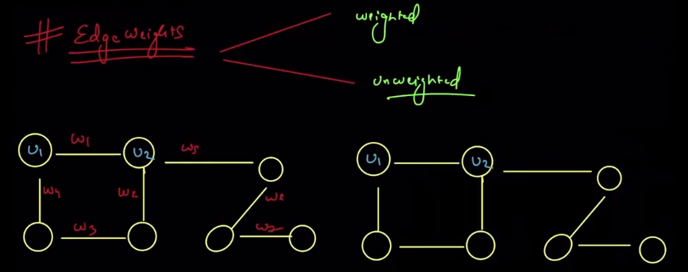
* **Types of graph on the basis of density of edges:** 
  + **Dense graph 🡪** edge emerging from almost every edges i.e very large number of edges are present
  + **Sparse graph 🡪** edges are present in less amount
  + 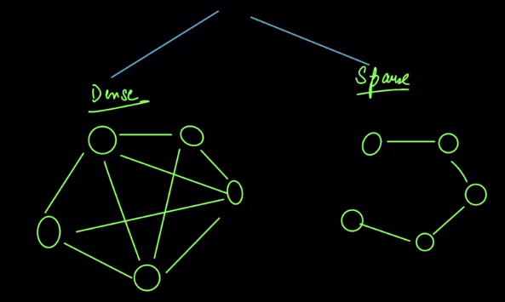
* 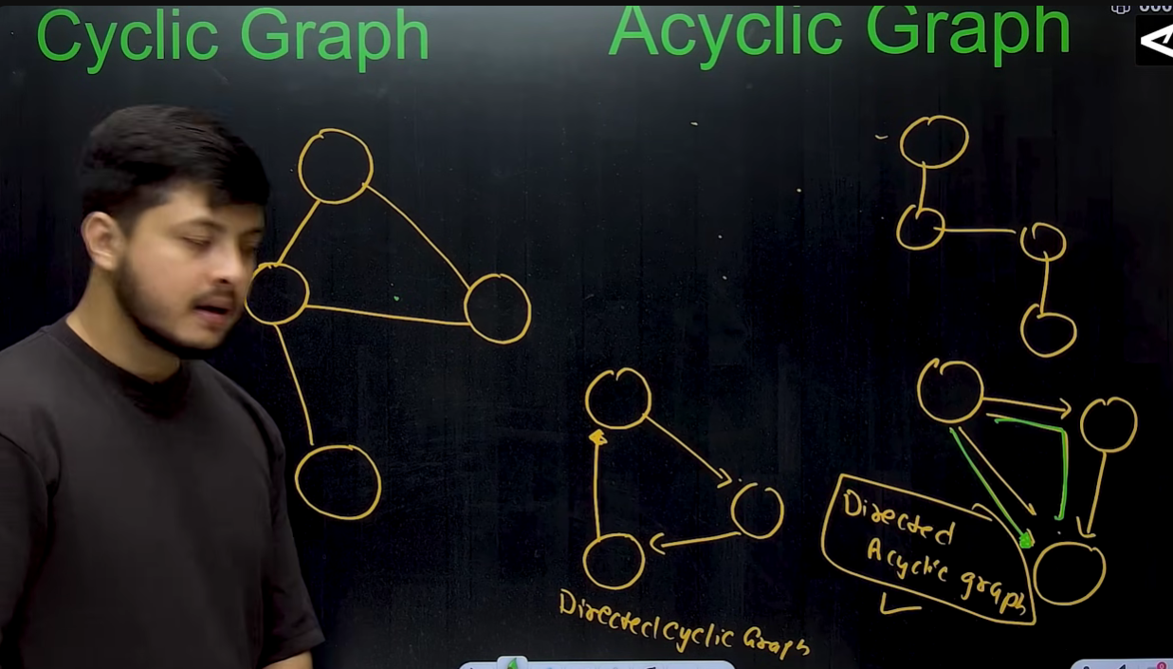

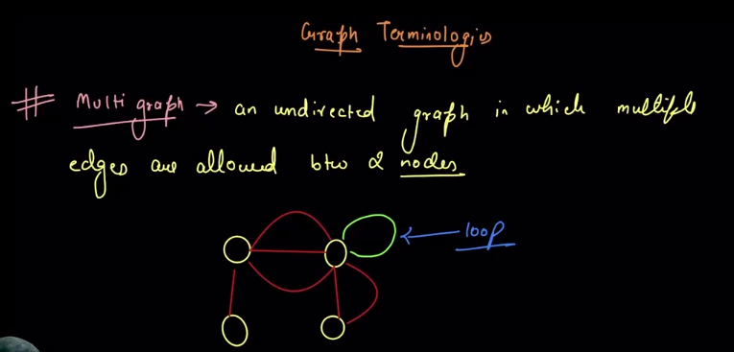

* 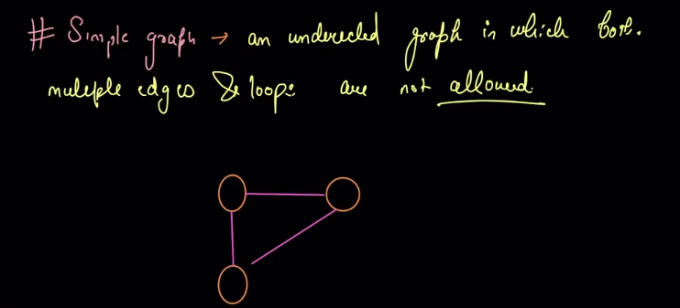
* 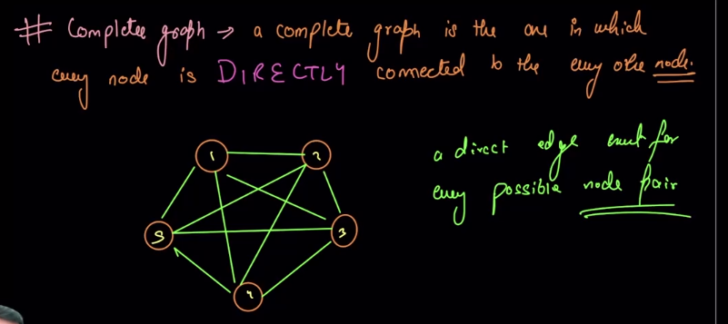
  + **No. of edges in a complete graph with n vertices** 🡪 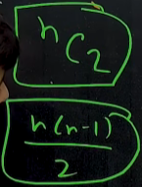
* 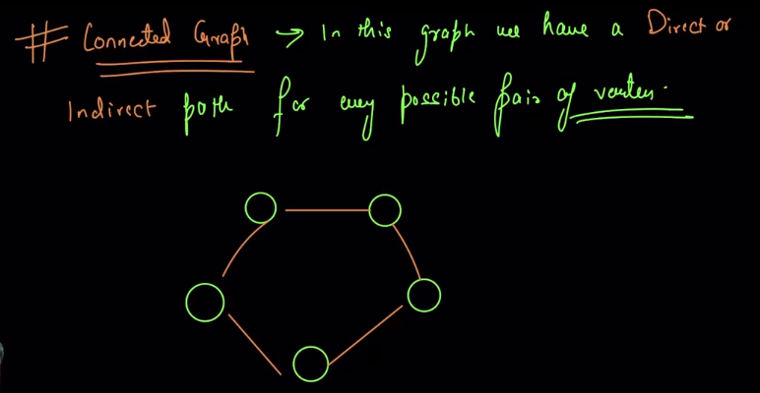
* 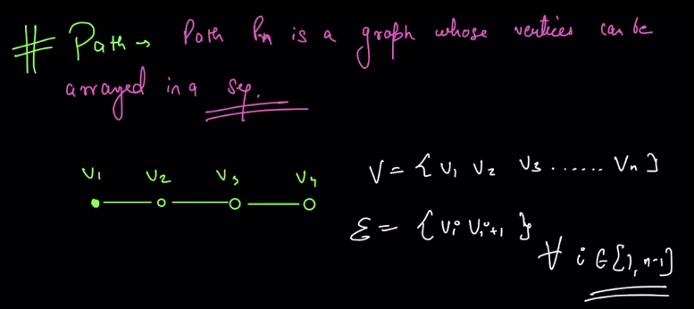
* 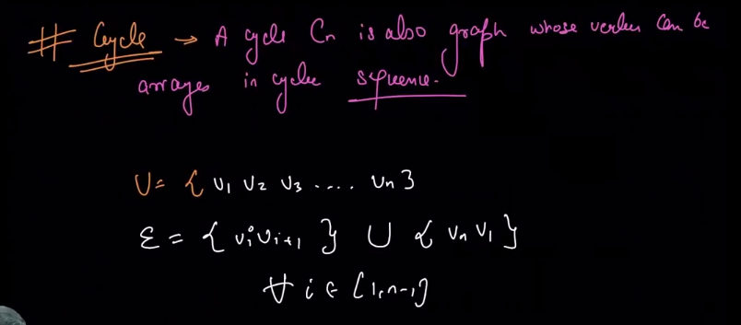
* 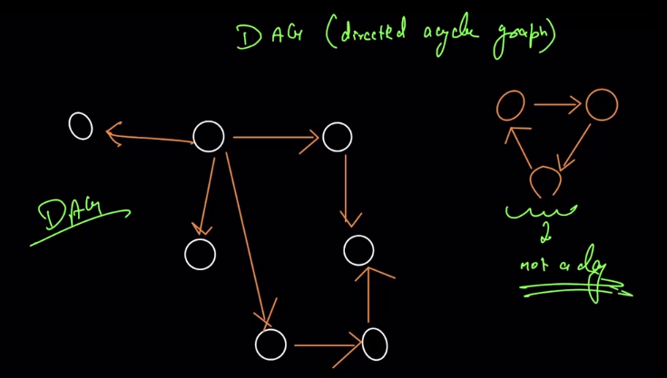

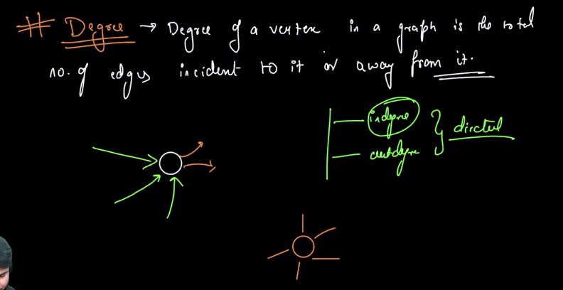

* 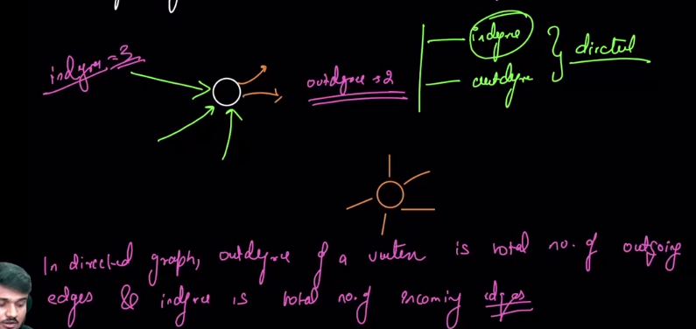

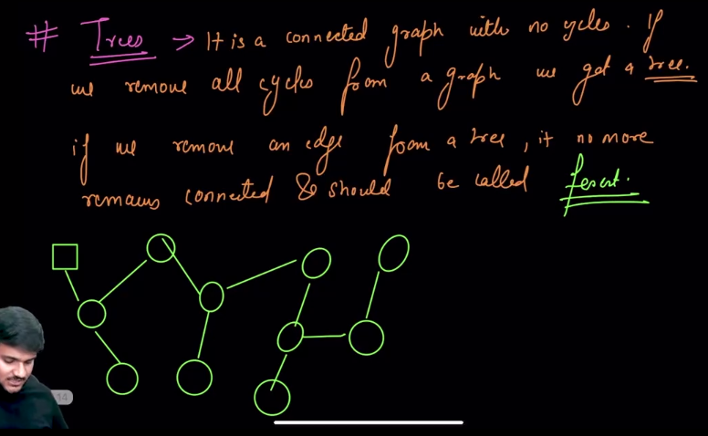

* 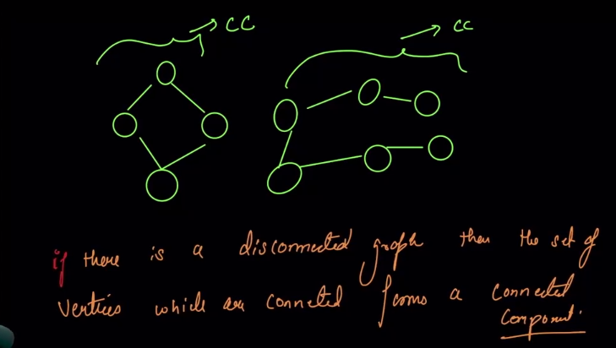
* 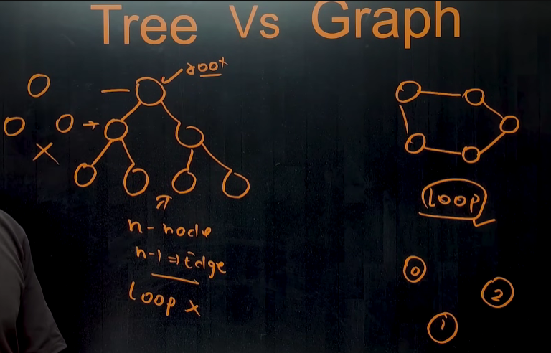

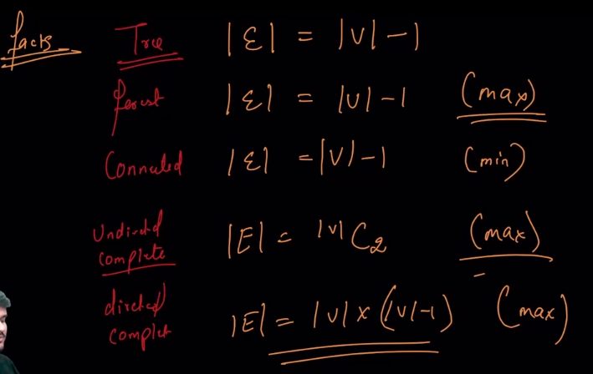

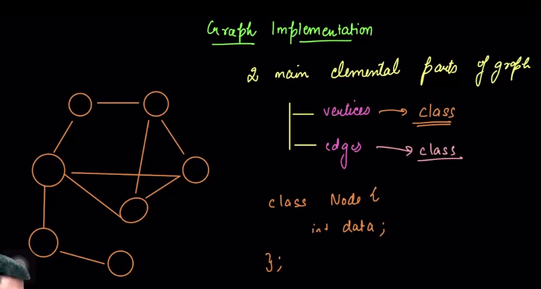

* 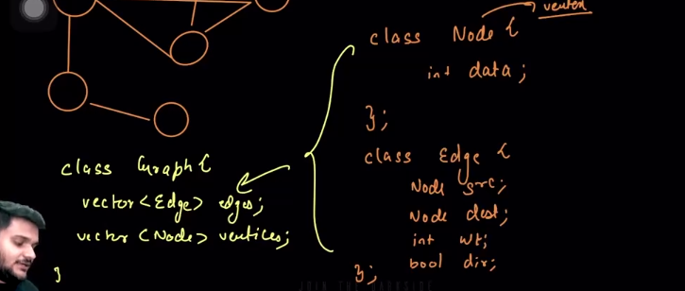🡪this method of implementation of graph is very tough and very time consuming so , we represent the graph in the following ways.
* **Method 1🡪Through Adjacency List**
  + 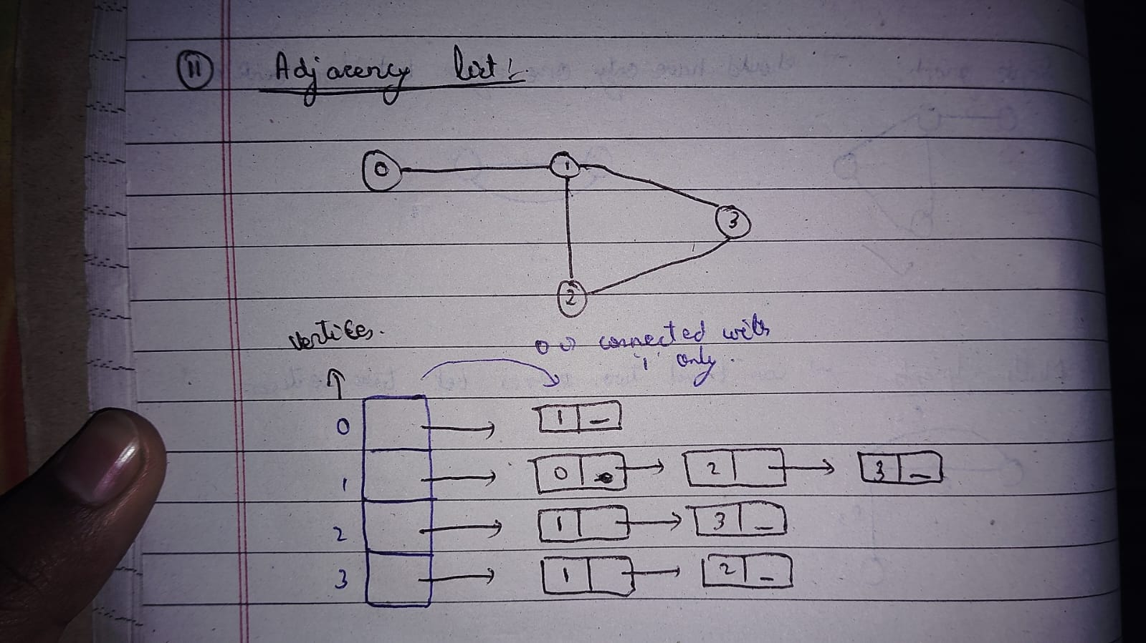
  + Case 1🡪through undirected unweighted graph
    - 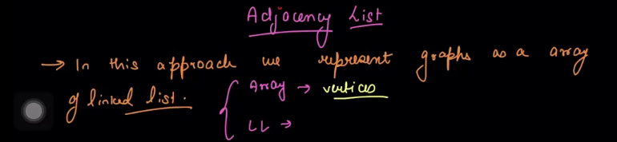🡪in this representation of graph, we represent the grah using Array and LinikedList/Vectors.
    - Eg : using Vecors 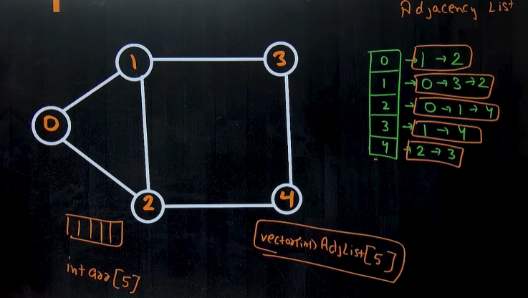🡪 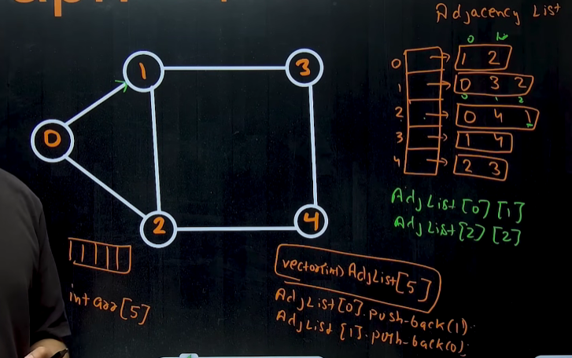 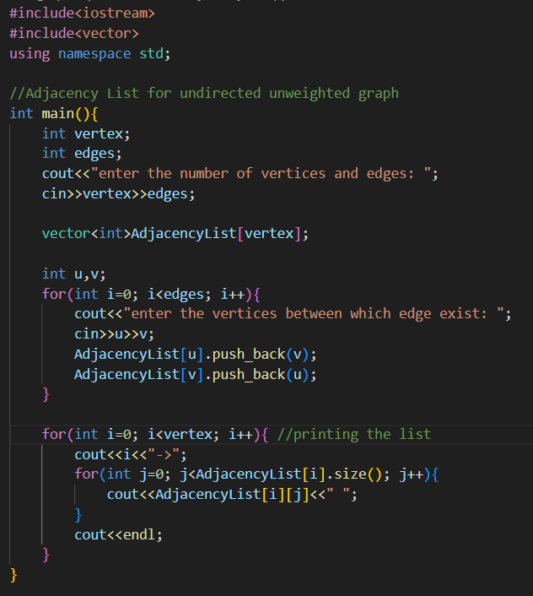 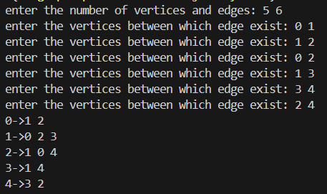
    - Using Linked list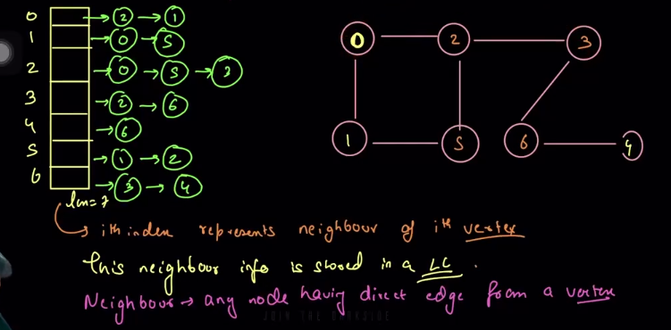
  + Case 2🡪through undirected weighted graph 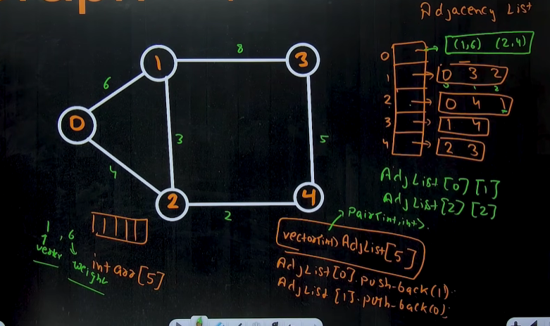
    - Time complexity 🡪 O(V + 2E) ~~ O(V+E) 🡪 [O(v) time to create the array and O(2E) time to connect vertices )
    - Space complexity 🡪 O(V + 2E) ~~ O(V+E)
    - Worst Case 🡪 in case of complete graph 🡪in which each node is connected to every other node
      * Time complexity 🡪 O(v^2)
      * Space Complexity 🡪O(v^2)
    - 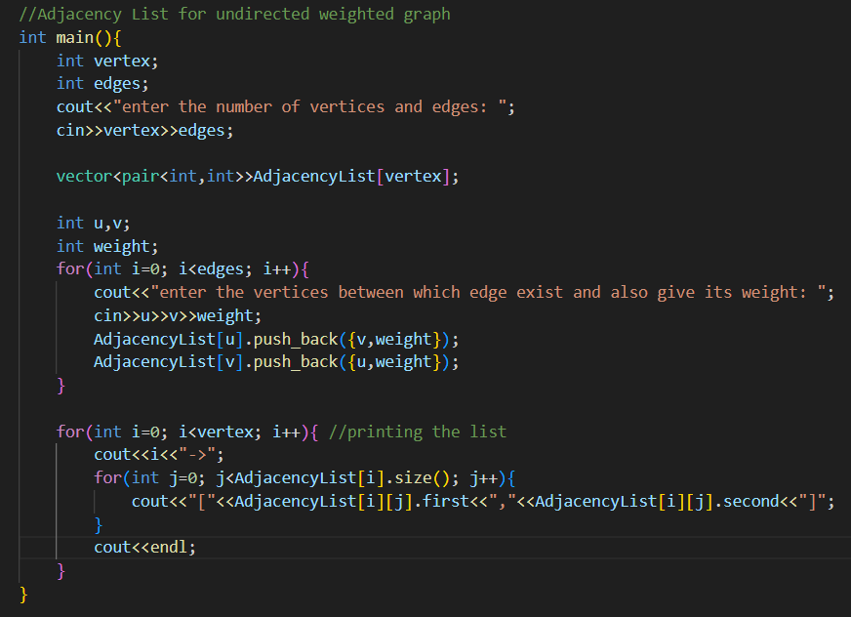 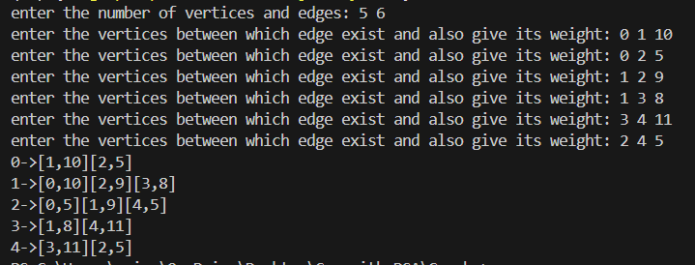
  + Case 3🡪through directed graph
    - 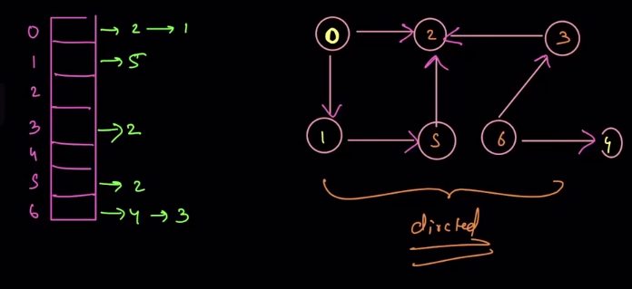
  + 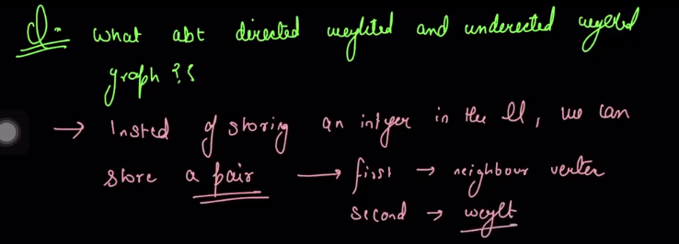
    - Eg: 🡪undirected graph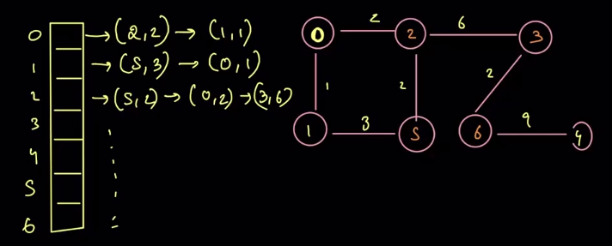
    - Eg: 🡪directed graph 🡪usme bhi pehle neighbour ko store kr lo and sbme bs 2 parameter paas kr do, one for node and one for the weight.
* **Method 2🡪 through Adjacency Map🡪this method of representation of graph does not have much benefits , this only optimizes the question in which we have to find that whether ‘a’ is a neighbour of ‘b’ or not.** 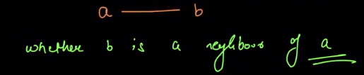
  + 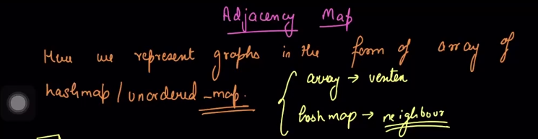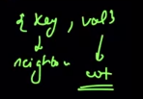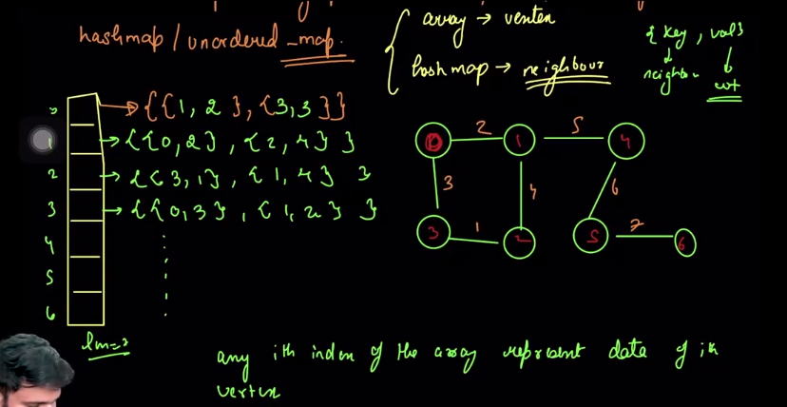
* **Method 3🡪adjacency Matrix**
  + 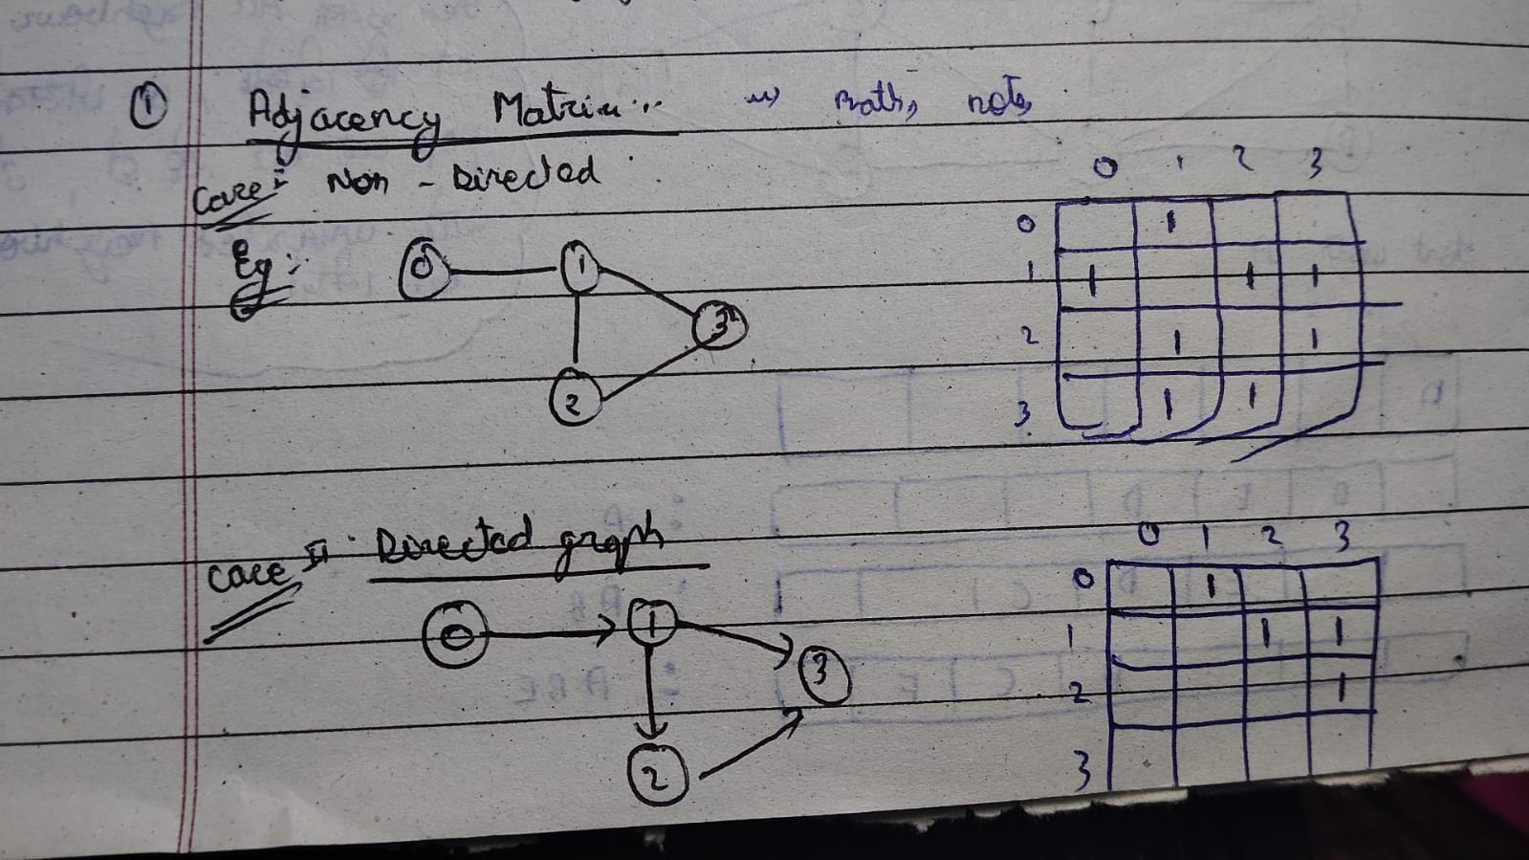
  + 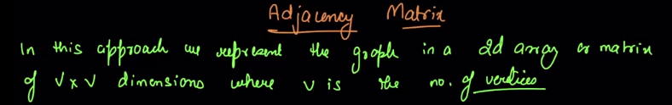

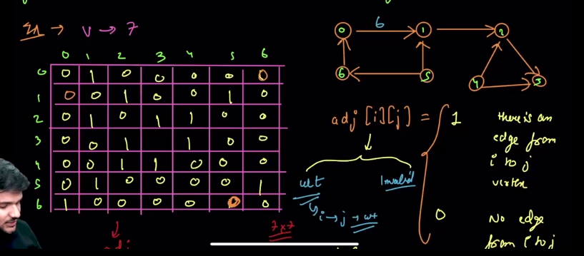

* + **The disadvantage of storing the graph in adjacency matrix is that it is not space efficient🡪** isme jin do nodes k beech edge hota h, unka data to store krte hi h, but , unka bhi data store krte h , jin do vertices k beech m edge nhi h (i.e hme 0 to store krna hi hota h to represent that there is no edge between the nodes.)
  + **Code to represent the undirected unweighted graph using Adjacency matrix** 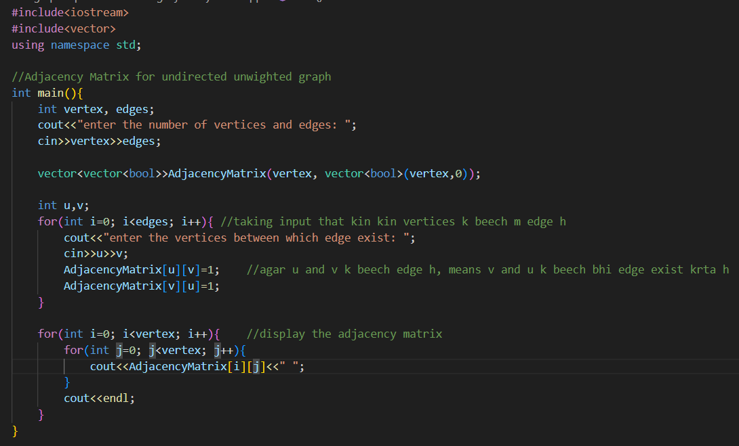 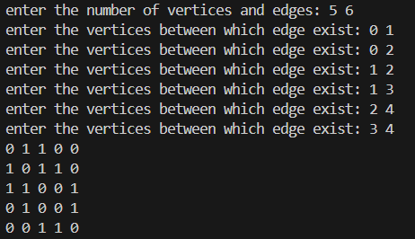
  + **Code to represent the undirected weighted graph using Adjacency matrix** 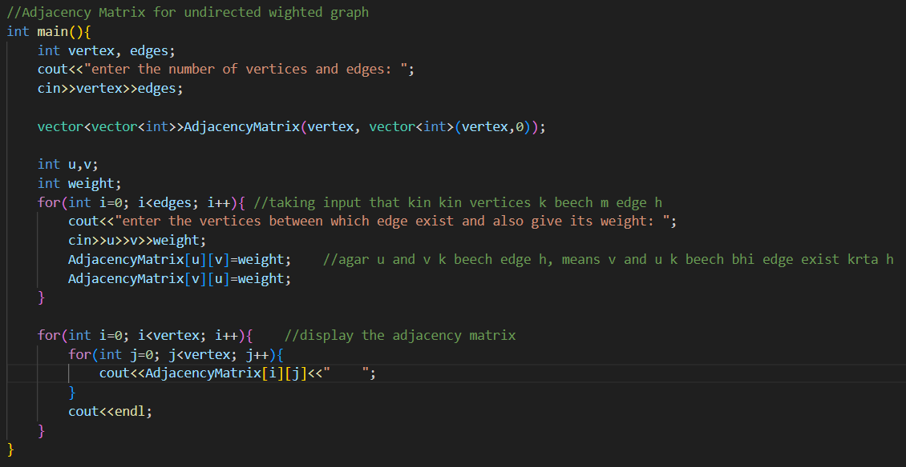 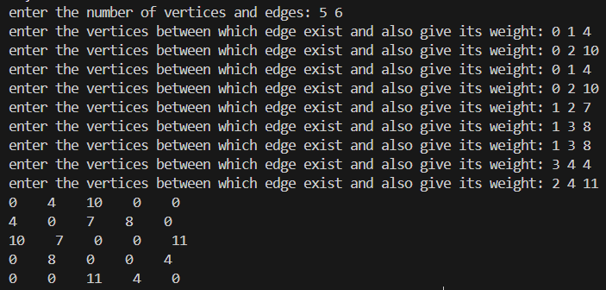
  + **Code to represent the directed unweighted graph using Adjacency matrix** 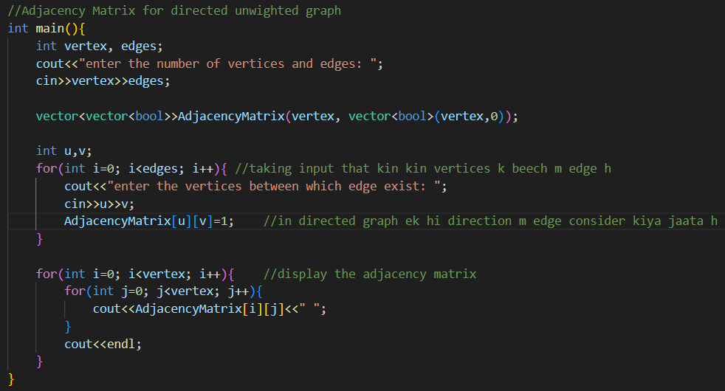

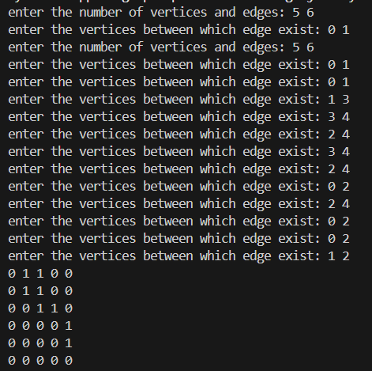

* + **Time and Space complexity of graph representation using Adjacency matrix**
    - **Time complexity🡪 O(v*v) 🡪O(v^2)🡪 since we have to fill each cell of the matrix by visiting it.**
    - **Space complexity🡪 O(v*v) 🡪O(v^2)🡪 since we make matrix of v*v**
* **Method 4🡪 through incidence matrix** 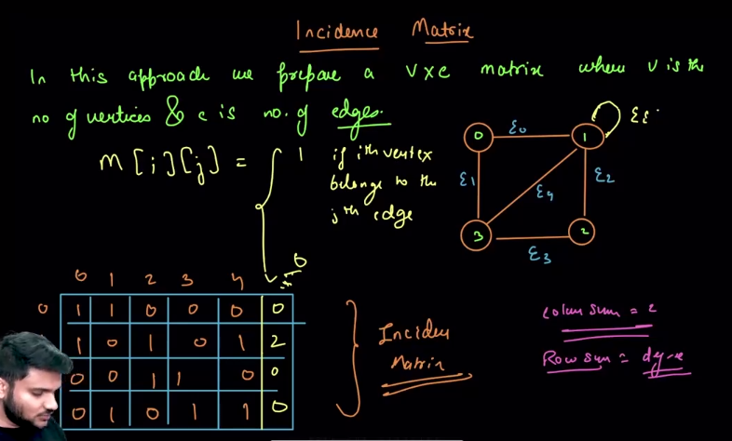
  + In this method of representation of graphs, we represent using **V*E matrix**, in whichh **edges on the x-axis** and the **vertices on the y-axis**.
  + To represent the nodes connected by an edge ,
    - **1** is used to represent that , who particuular edge kis kis vertices se connected h.
    - **0** is used to represent that , who vertex uss edge se connected nhi h.
    - For self loops, we write **2** in the incidence matrix.
  + Properties of graph reprsented via incidence matrix :
    - **Sum of each column is always 2**.
    - **Sum of the each row represent the degree of an edge**

**Note : Best way to represent the graph is to use an Adjacency List, because it is very much space efficient. And after Adjacency list, we the 2nd most used representation is Adjacency Matrix.**

* 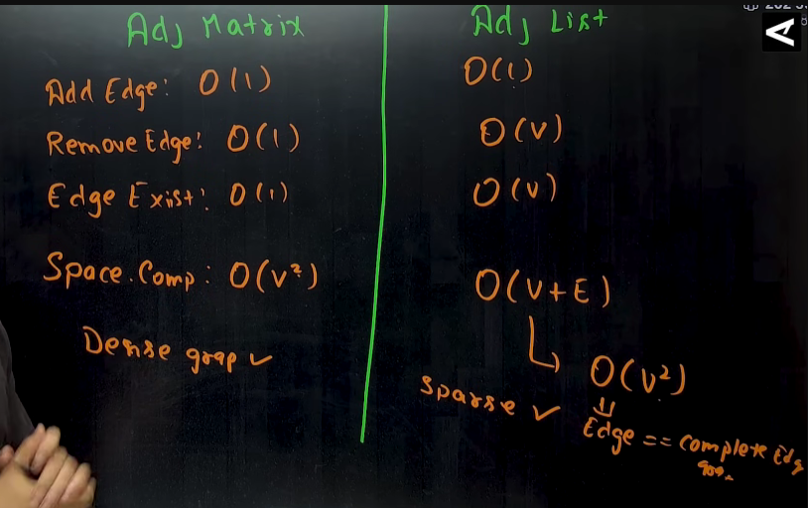

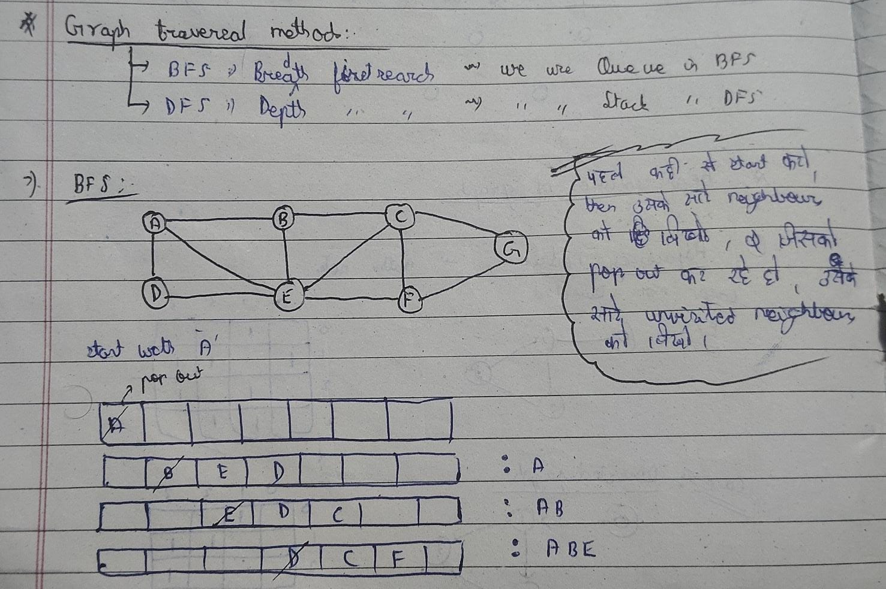 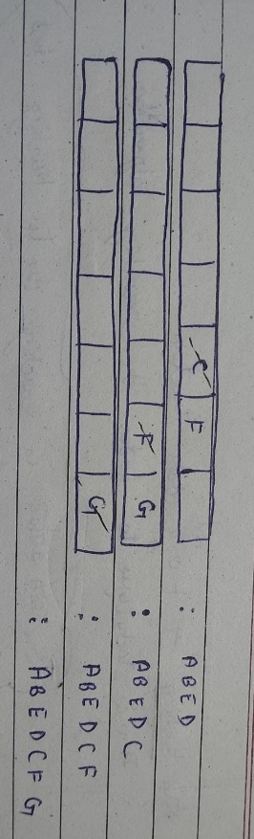

* 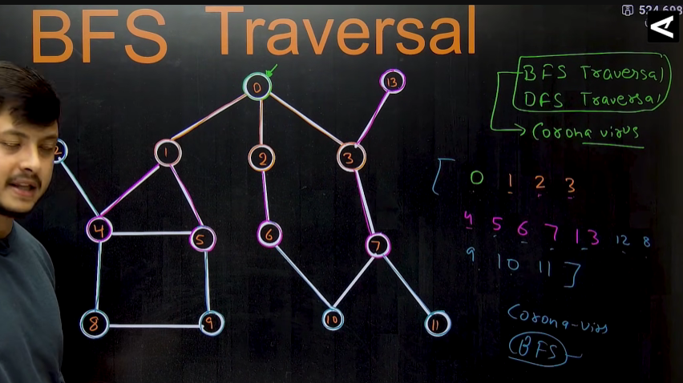
* **Eg:** 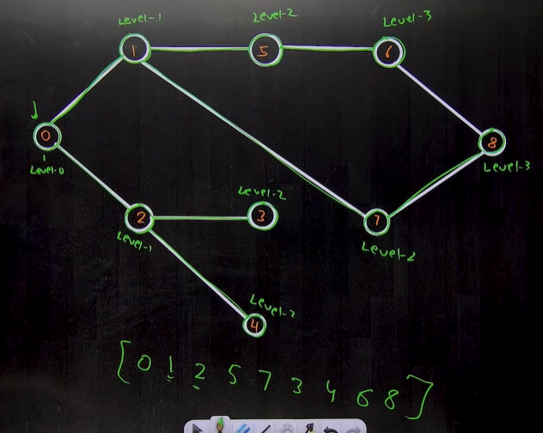
* BFS traversal when the Adjacency list is given :
  + 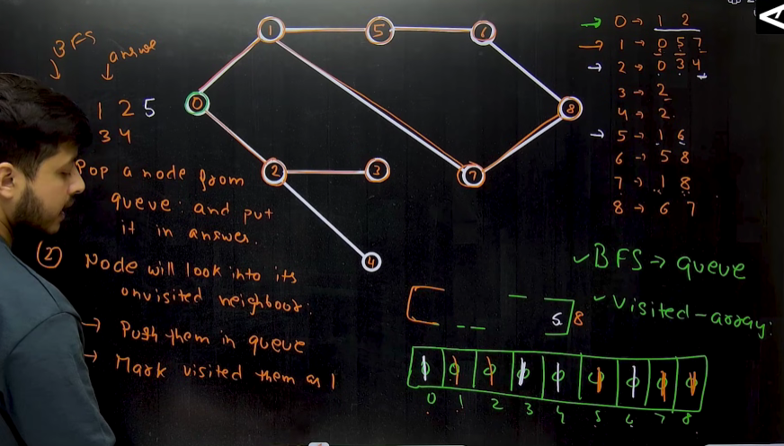
  + 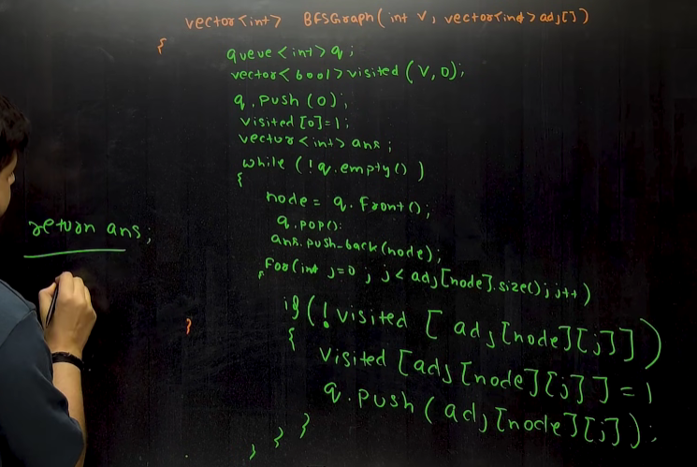
    - **T.C 🡪 O(V)~~O(V+E)**
    - **S.C 🡪 O(V+2E) ~~ O(V+E)**

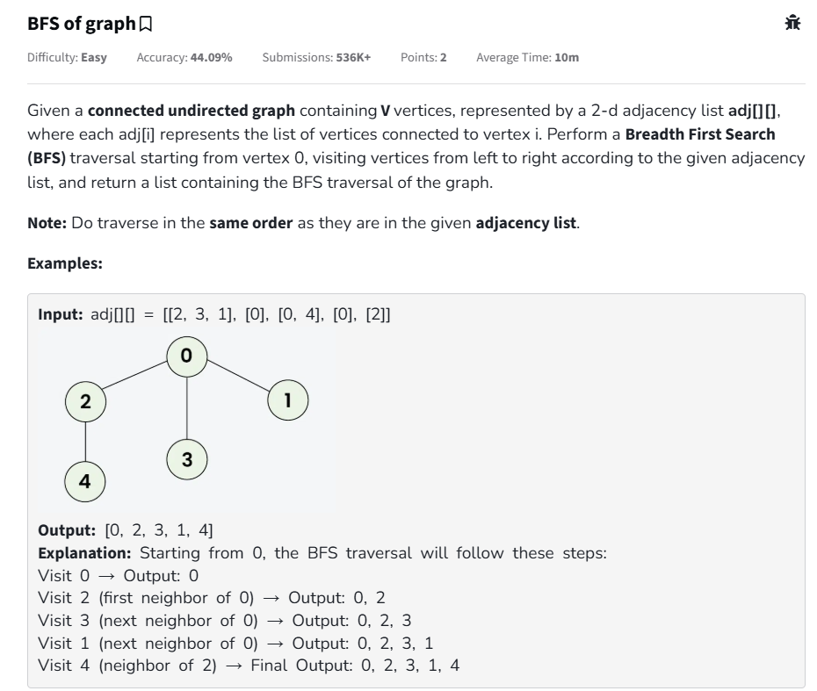 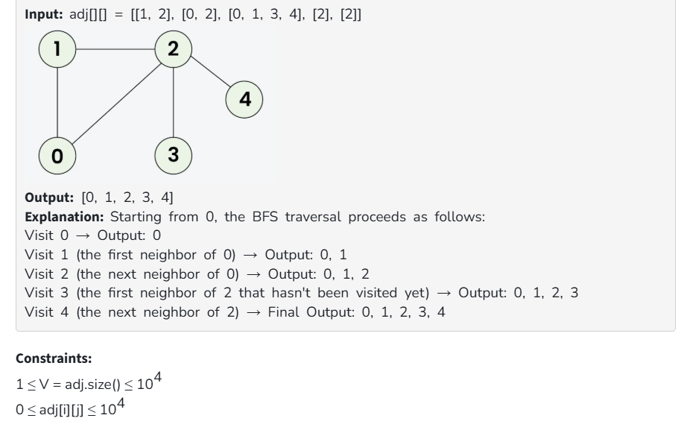

* 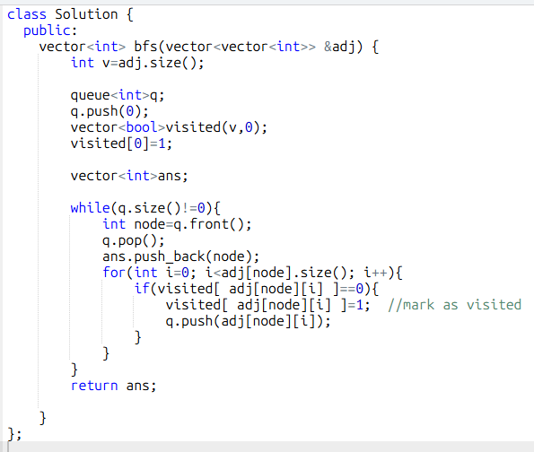

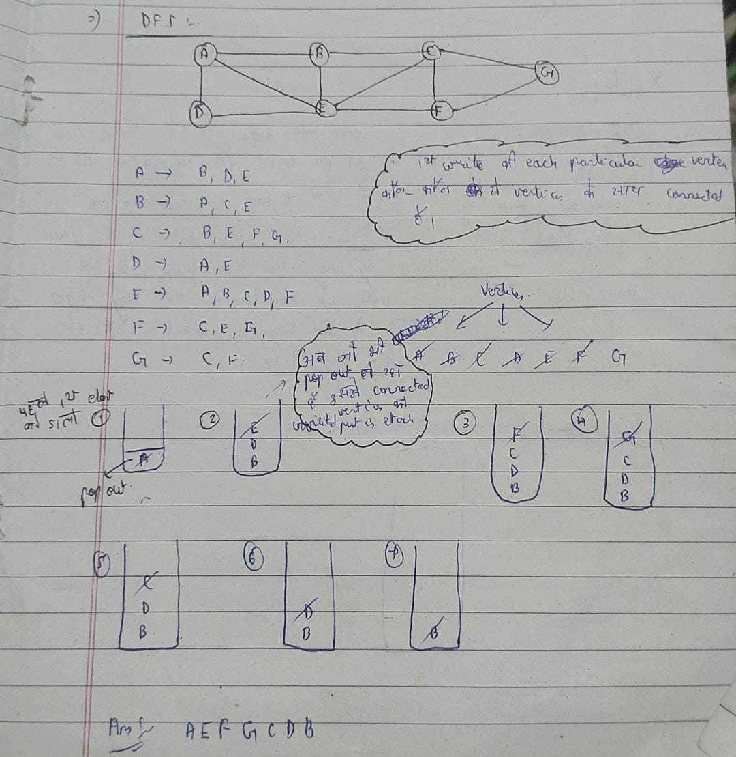

* 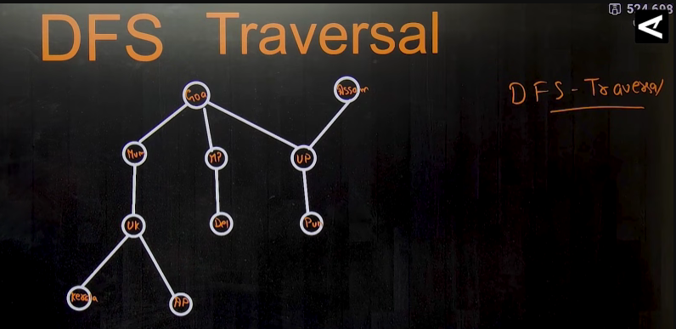
* 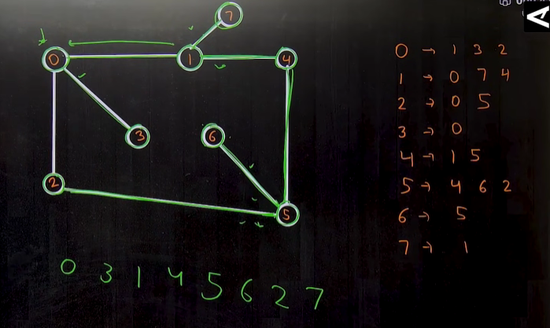
* **DFS traversal can be done by using 2 methods :**
  + **Using Stack**
  + **Using Recursion**
* **Method 1🡪 using Recursion** 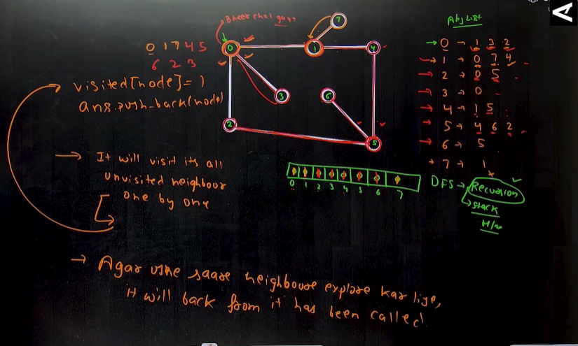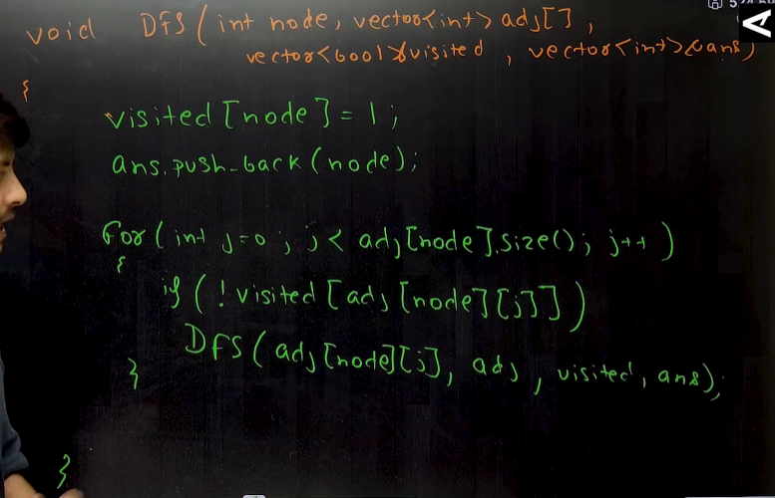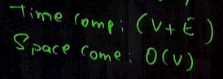

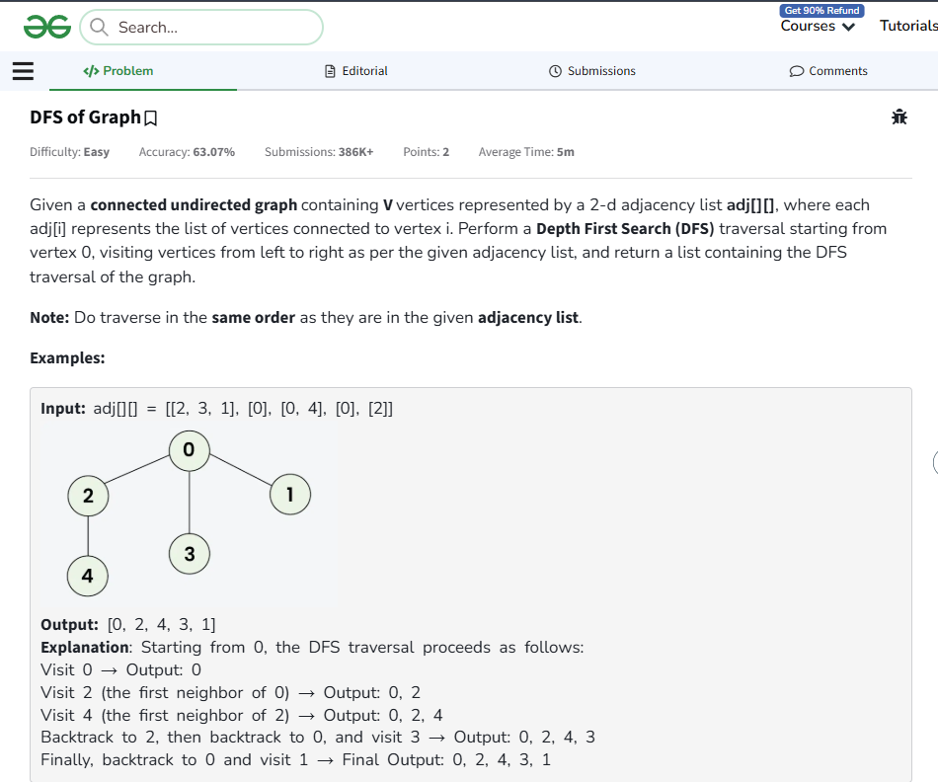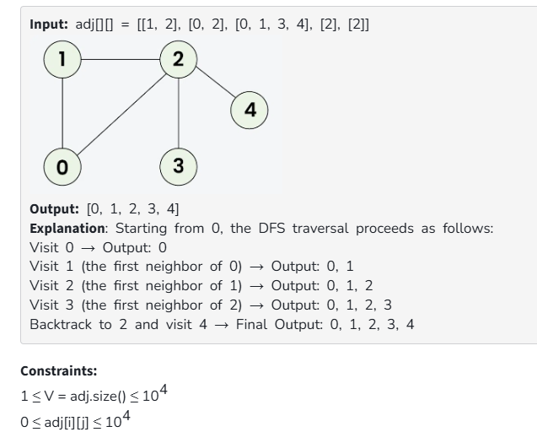

* 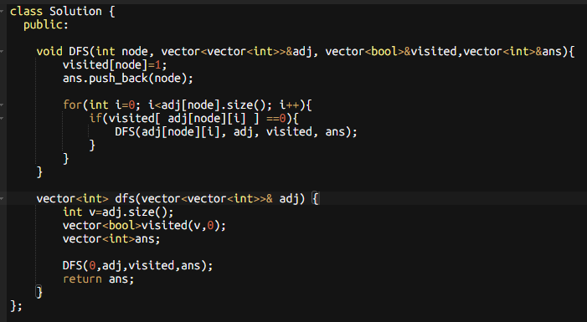

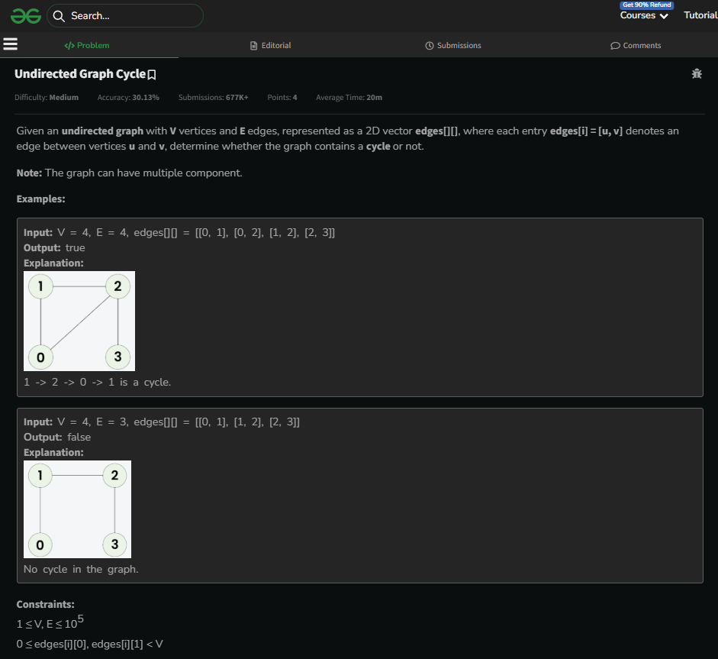

* 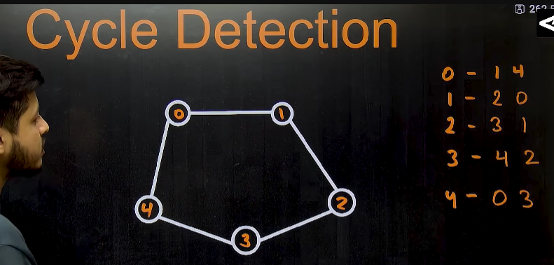
* Method 1🡪by DFS🡪koii bhi node, agar ek baaar se jyada baar aaye, then, it forms a cycle(loop)
  + Eg: 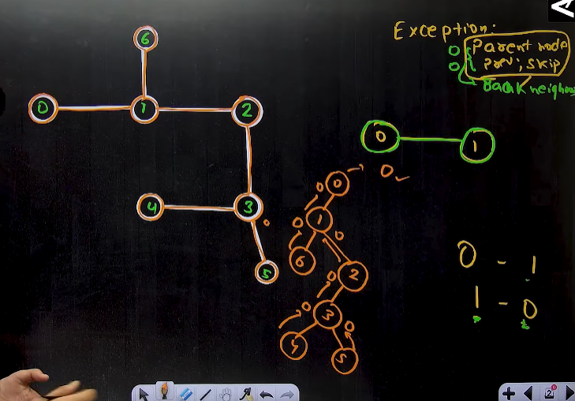
  + 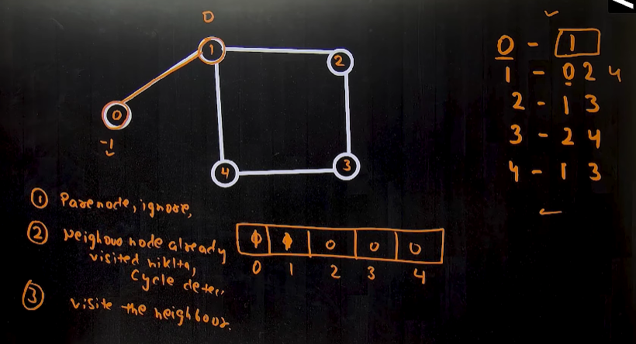🡪if we are trying to find the cycle in the graph, then there can be three cases:
    - For a node ‘n’, if (parent ==adj[node][j] ) then , ignore that becoz hm phir se parent k paas pahuch gye h ,
    - And if , we reach the node again then, we found a cycle in the graph 🡪so return true i.e 1
    - And if we have not visited a particular node, the visit that node using recursion.
  + 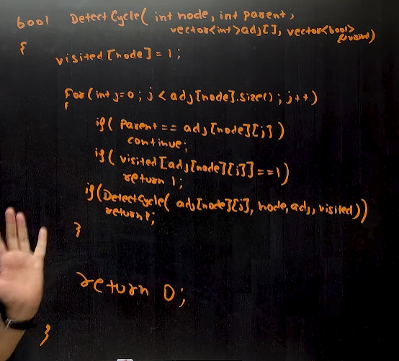
  + 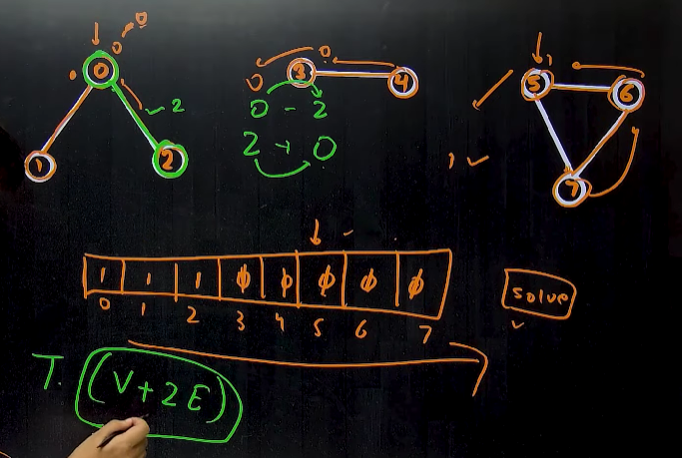🡪case when the graph is not connected ,, then, we have to check each node by a loop.
  + 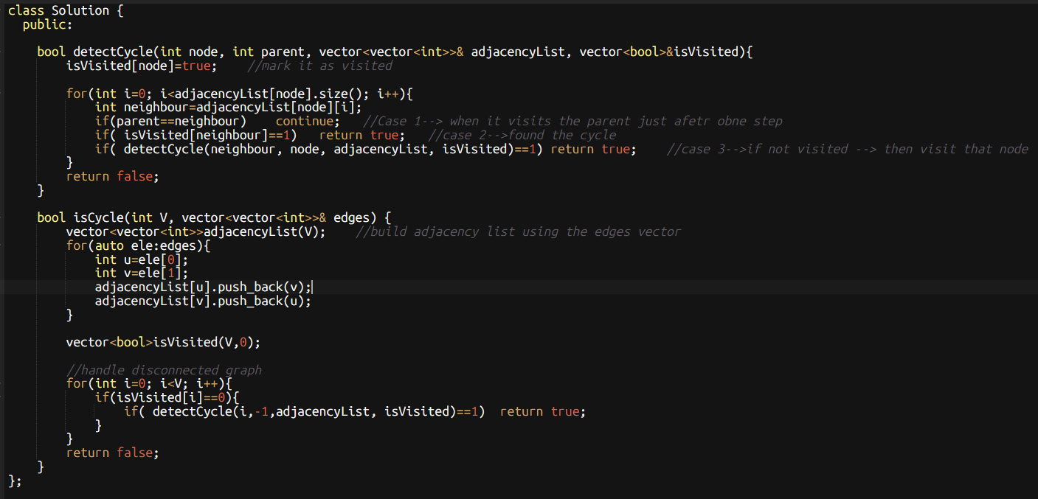
* Method 2🡪using BFS 🡪same concept as DFS, bs implement using the BFS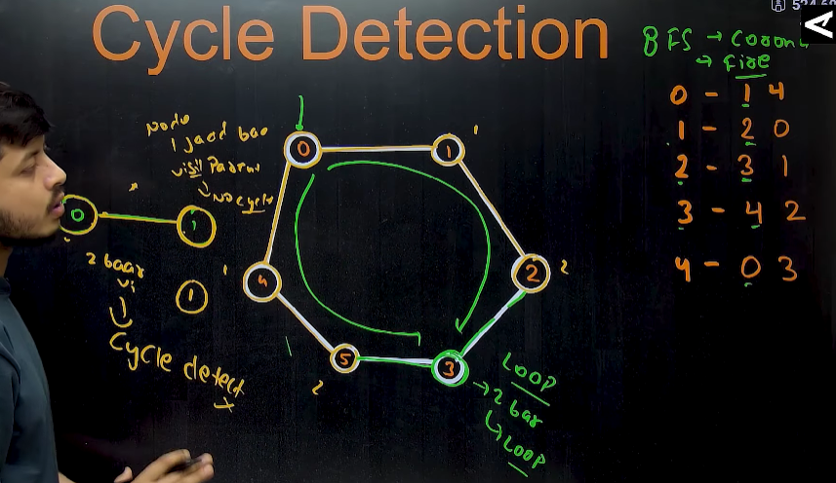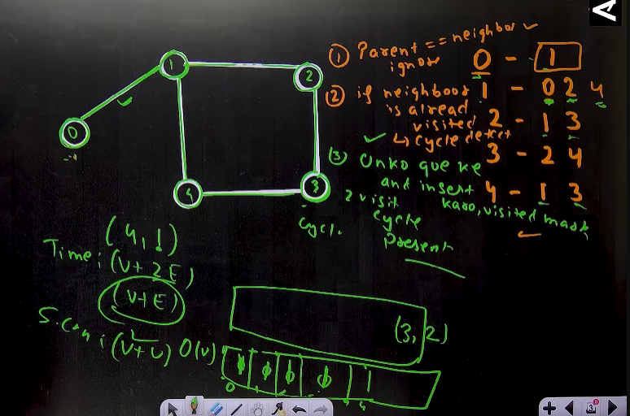
  + 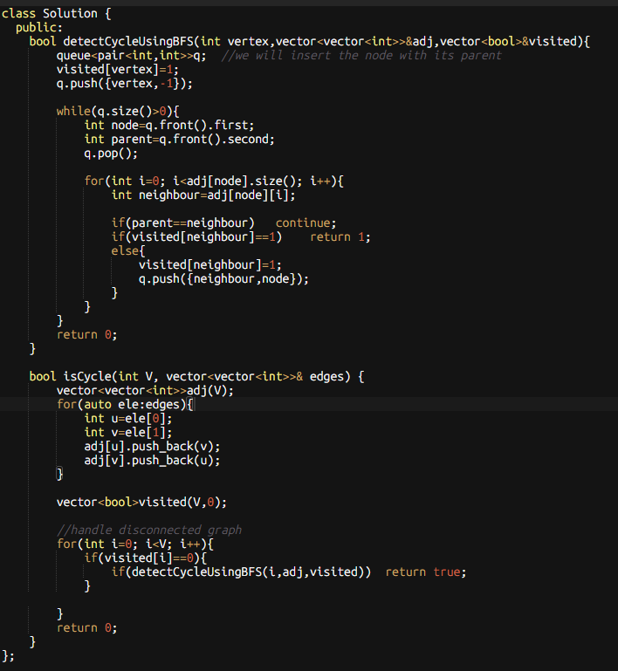

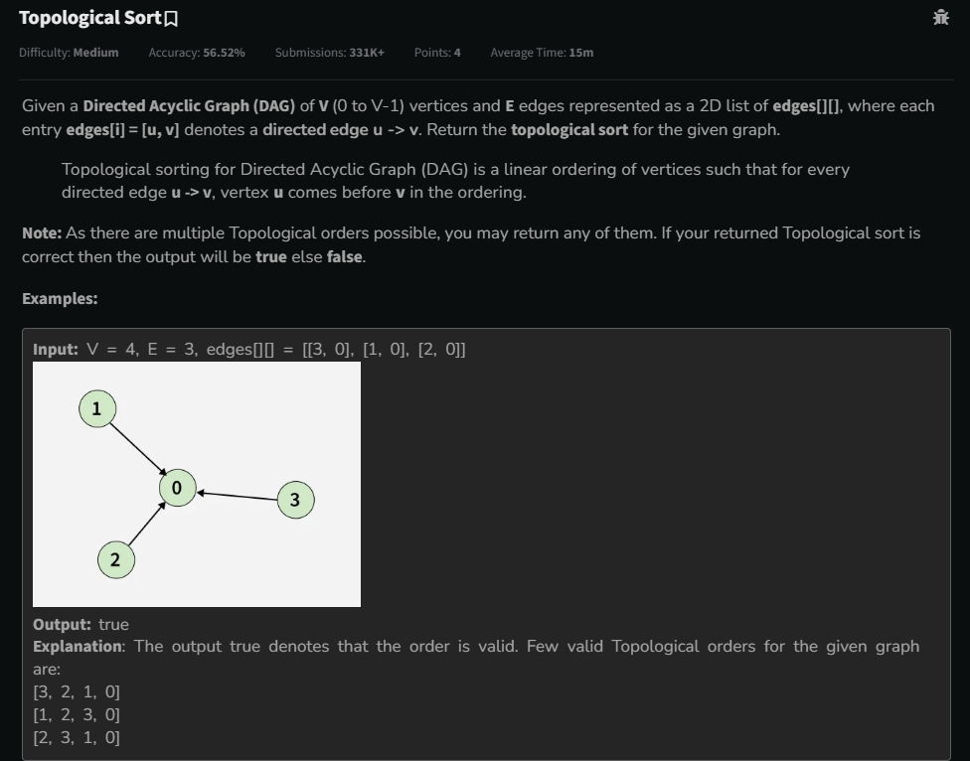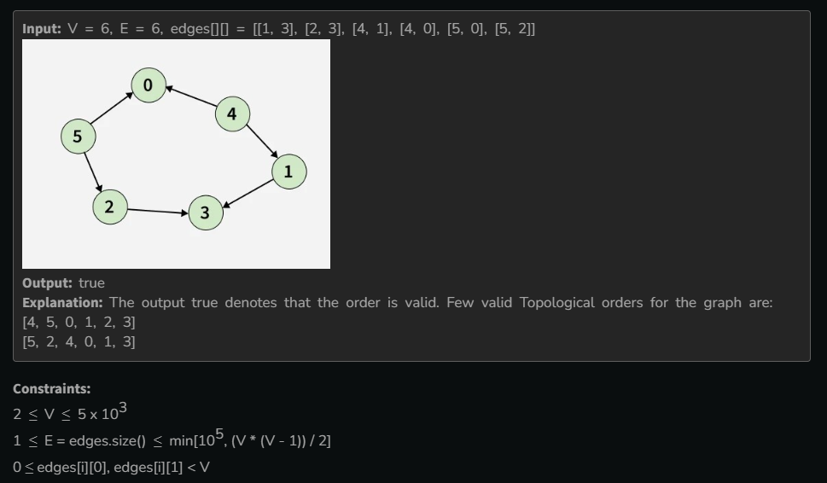

* 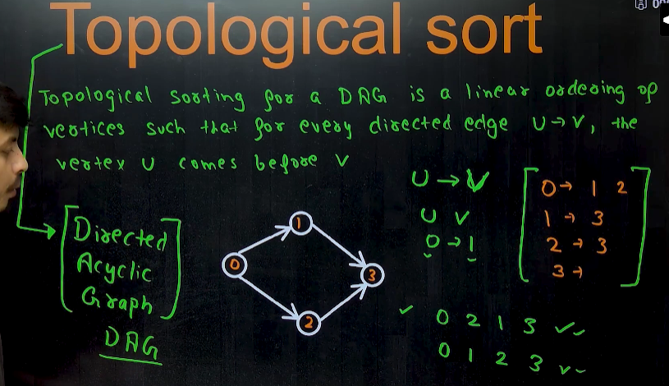🡪topological sort ka mtlbb hota h ki, jo node pehle aa rha h , usko pehle likho and jo baad m aa rha h usko baad m likho , irrespective of their node values.
* For eg: in above picture, 1 se pehle 0 aa rha h, so 0 pehle likhenge and 1 baad m, similarly 1 pehle aa rha h 3 se , so 1 pehle likhenge 3 se, so there are 2 possible ways to sort the above graph,
  + 0 1 2 3
  + 0 2 1 3
* Note : topological sort can only be done for , Directed acyclic graph(DAG)🡪(jisme cycle present na ho and have direction).
* **Method 1🡪using DFS traversal** 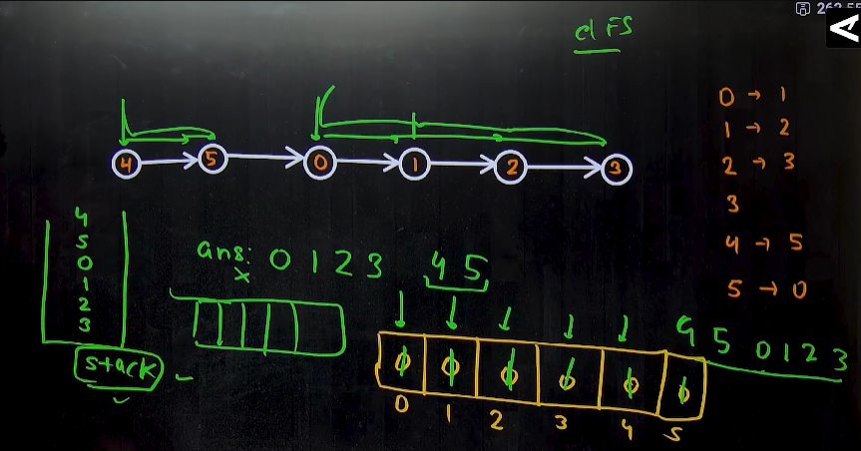

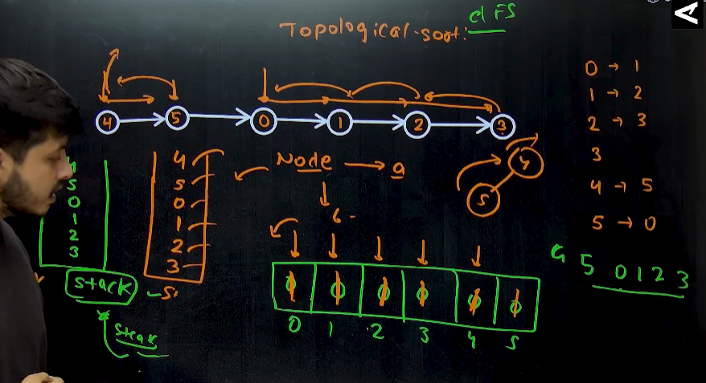🡪algorithm of topological sort🡪while traversing using DFS , we can perform the topological sort, but isme ek problem hota h ki, last waala node pehle aa jaata h, but hme who node pehle rakhna h jo pehele visit hua h, so here we use the stack 🡪 so here we traverse using the DFS, strating from the initial node and mark them in the visited array , and then, put the dpendent elements in the stack 1st and then the 1st visited node, 🡪eg🡪we started from 0, and now 0 se jo bhi connected h usko pehle visit kro using DfS, and jb lge ki ar aage nhi jaa skte , then wha se leke peeche jaaoo, and element ko stack m daalte rho. 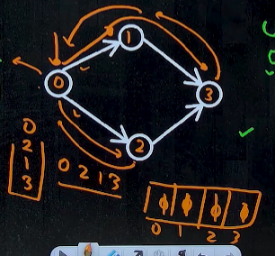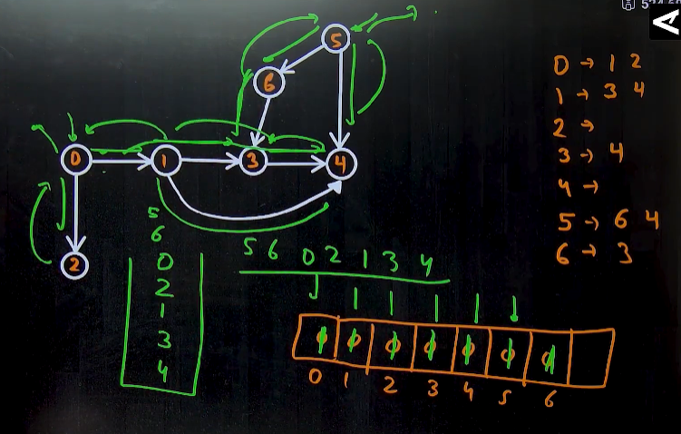

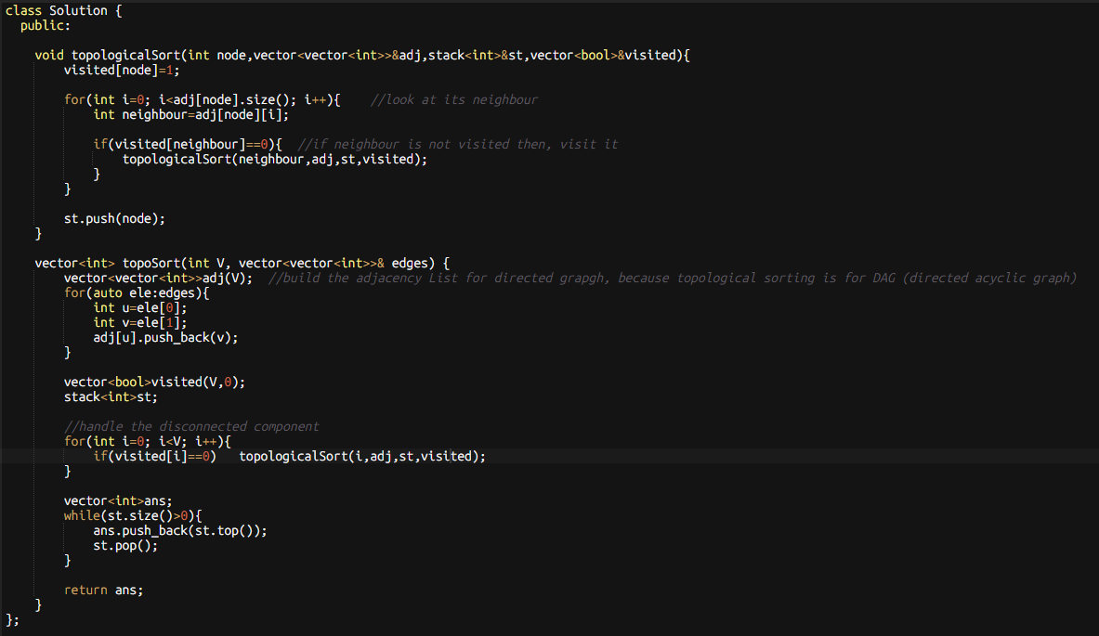

* **Method 2🡪using BFS traversal🡪 called Kahn’s Algorithm** 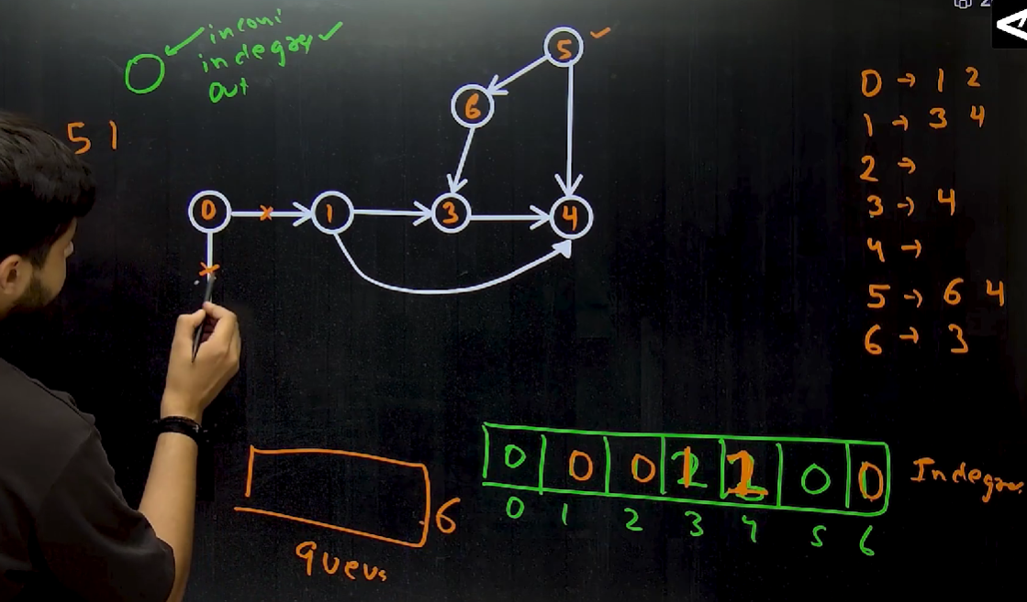 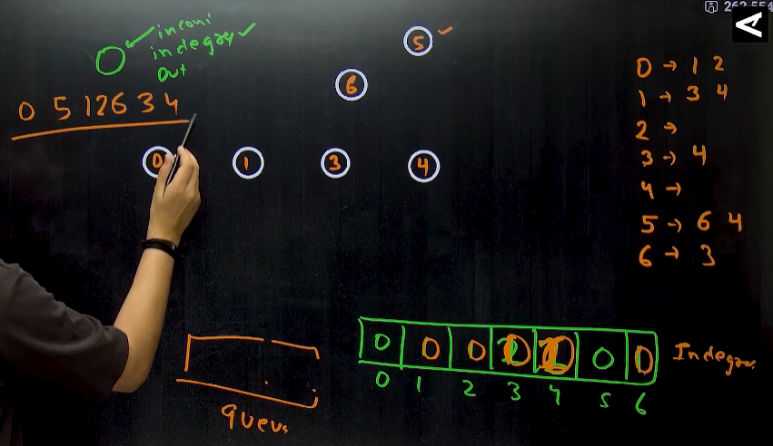
  + Algorithm 🡪 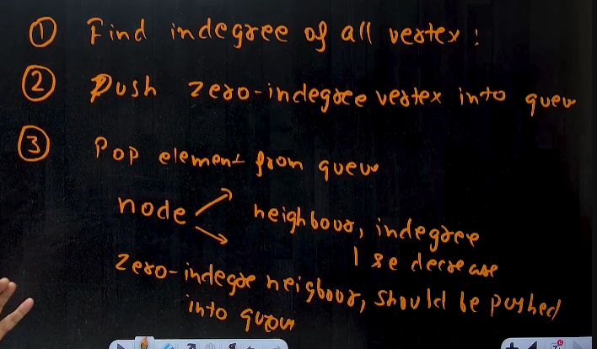
    - Pehle saare nodes ka indegree nikaal lo (i.e kissi ek particular node p kitne elements aa rhe h)
    - Uske baad jo jo vertices ka indegree 0 h, woh log pehle aayega in the answer, so unlog ko, queue m daal do.
    - Uske baad elements ko pop krte jaaoo, and uske jitne bhi neighbours h unke indegree ko km kr do.
    - And then again jiska jiska indegree 0 ho jaaye usko , queue m push kr do.
    - 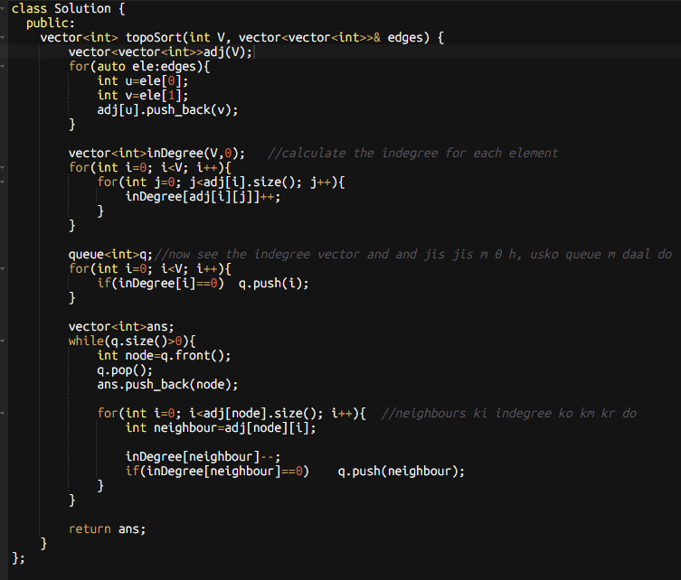

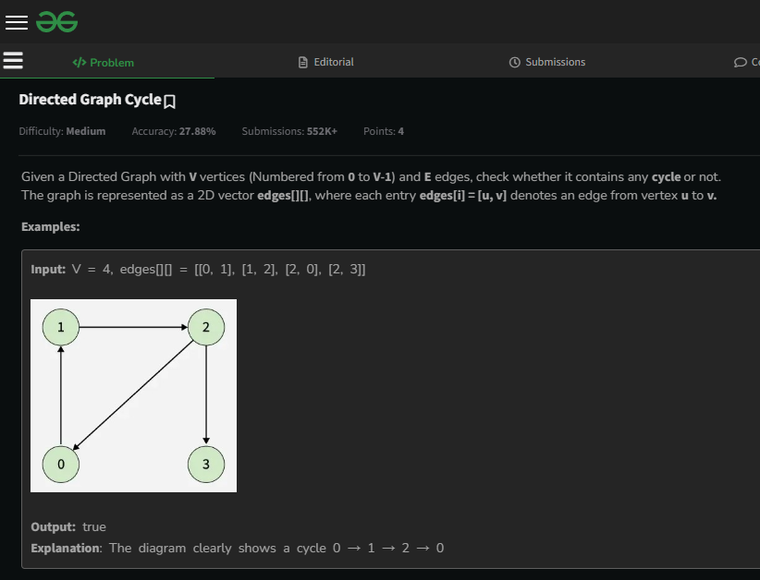 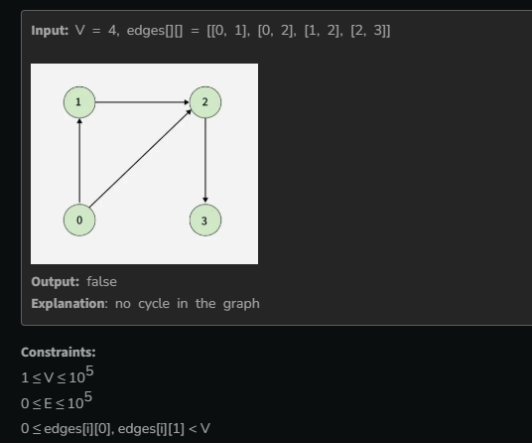

* 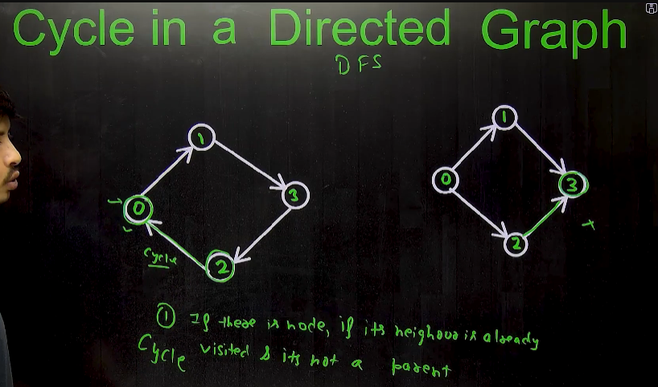🡪if we use the same **concept of Cycle Detection in Undirected graph** in this question then, it gives the wrong answer
* **Method 1🡪using DFS**🡪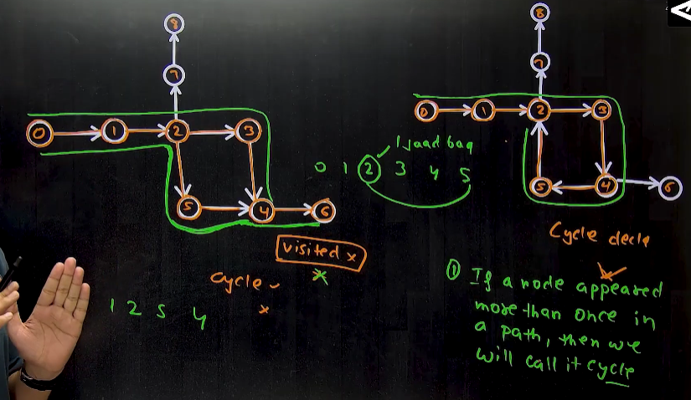🡪Algorithm 🡪 if any node, appears more than once on a single path , then there will be a cycle🡪by using the DFS traverse on every path , and if any node comes more than once declare a cycle, but if not then, keep traversing and once jb aage jaane ka jagah na ho, then peeche jaoo, and visited kp phir se 0 bna do , becoz uss path p hme cycle nhi mila, and now we will explore new path 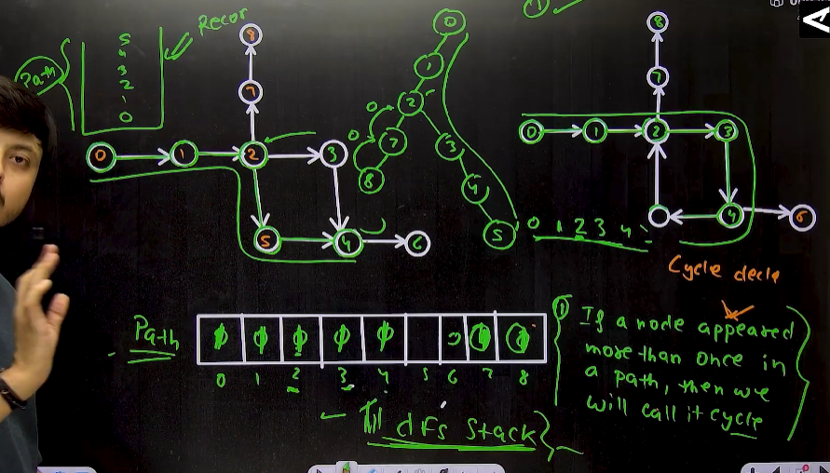

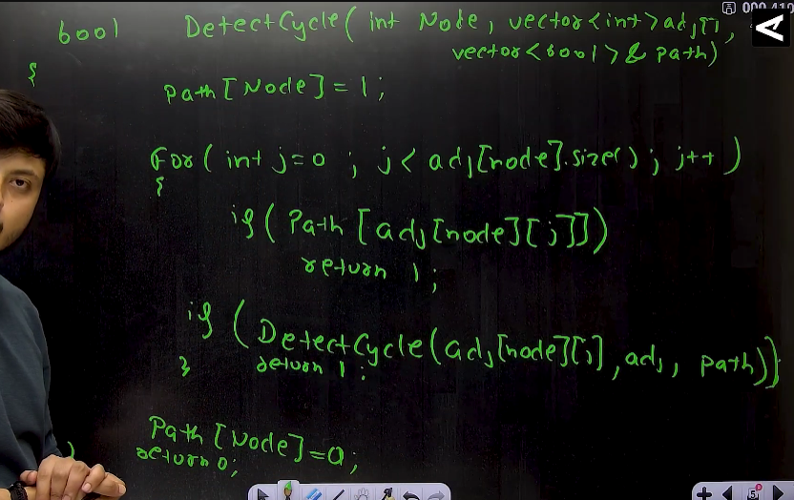🡪**Not optimized** because , jb hm ek path travel kr lete h, and another path try krte h then, it may possible uss path ka kchh hissa hm travel kr chuke ho, so usse bhi hm dobara visit krte h , jiski koii jaroorat nhi h🡪 so not optimized 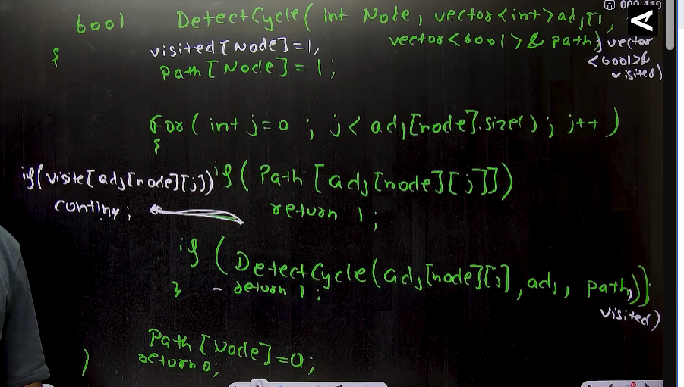 🡪 **optimized 🡪** jb hm check kr lenge ki kissi node p hm pehle hi jaa chuke h ya nhi , just uske baad hm visited waale array ko check kr skte h 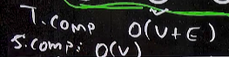 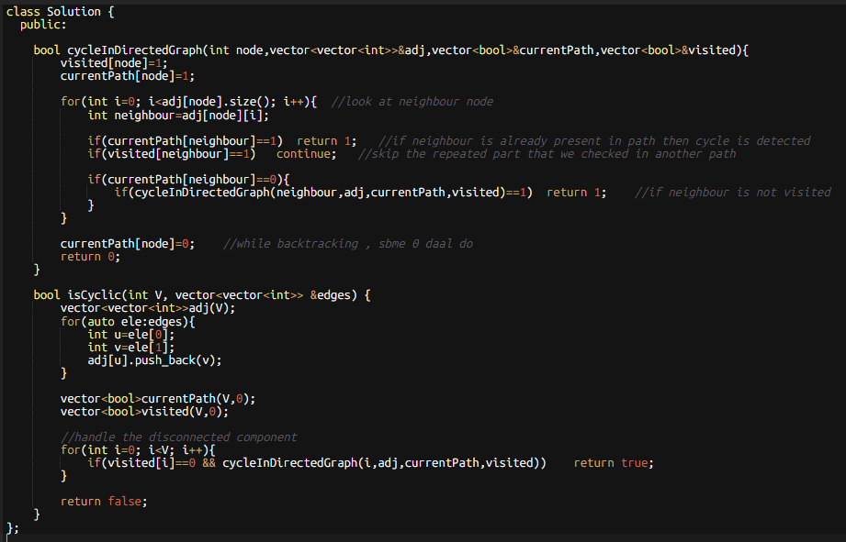

* Method 2🡪 using BFS 🡪topological sort 🡪kahn’s algorithm 🡪topologcal sort works only on the Directed acyclic graph , i.e in topological sort , hm ek ek krke saare vertices ka inDegree 0 hote jaata h, and hm unhe answer m daal lete h, but in cyclic graph saare verices ka indegree 0 nhi ho paata , that is why saare elements answer array m nhi jaa paate
  + So in Directed acyclic graph(DAG) 🡪number of element in answer array **is equal** to the total number of vertices present in Graph
  + in Directed cyclic graph(DCG) 🡪 number of element in answer array **is not equal** to the total number of vertices present in Graph
  + 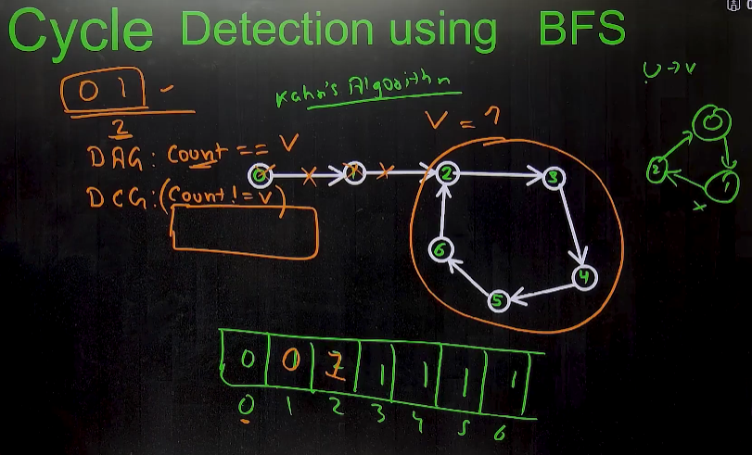
  + 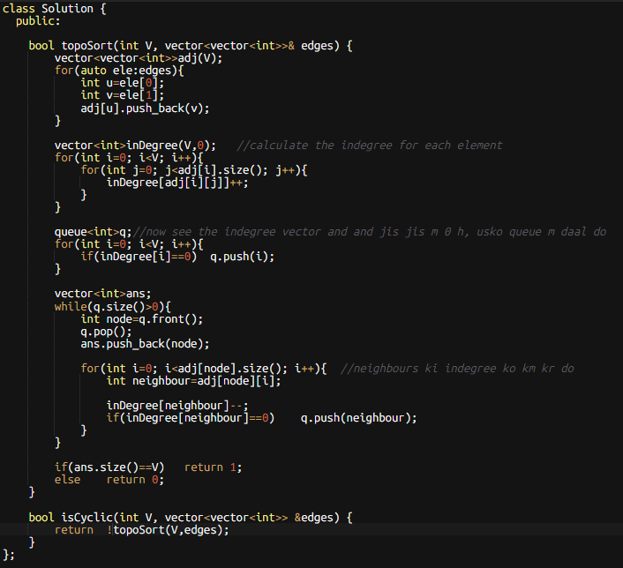
* Real Life use of cycle detection in Directed graph 🡪deadlock in CPU Scheduling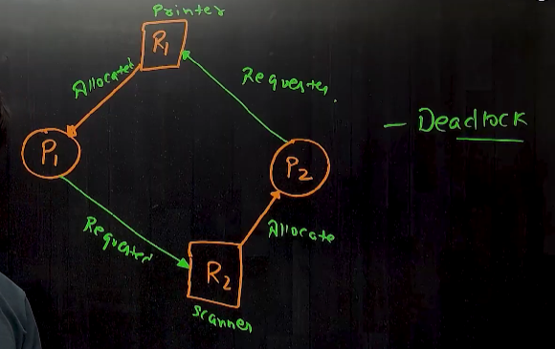

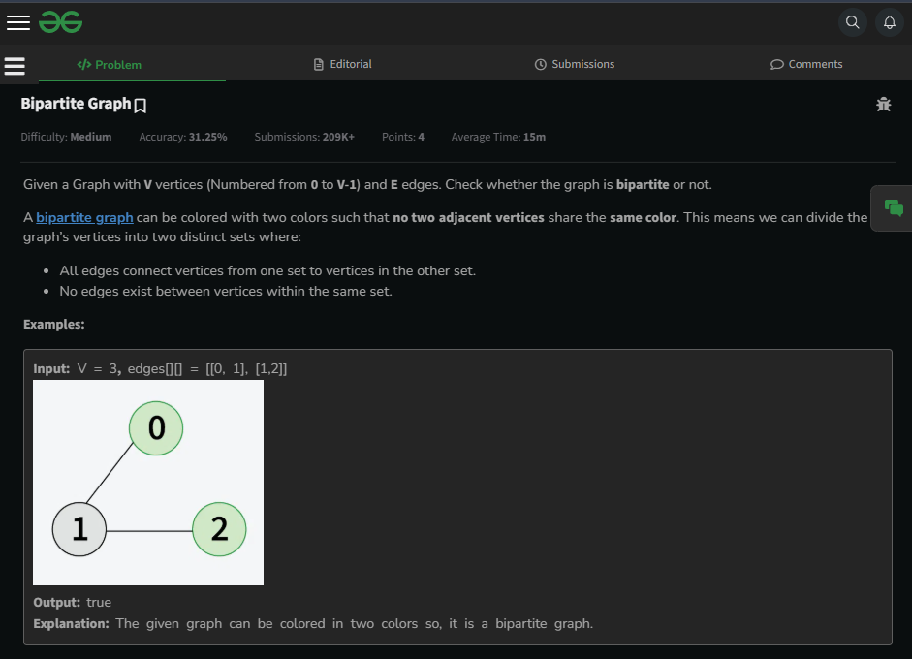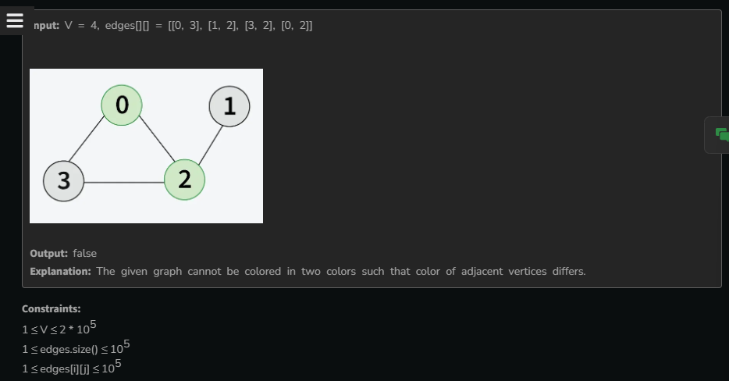

* 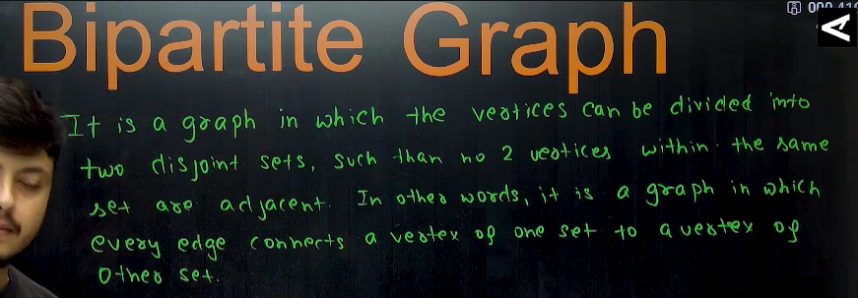

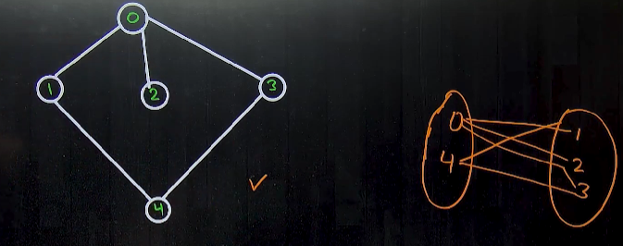

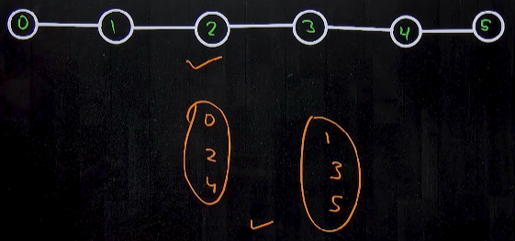🡪to divide the vertices in two sets such that, no 2 adjacent vertices lie in the same set 🡪we can use **2 coloring algorithm**  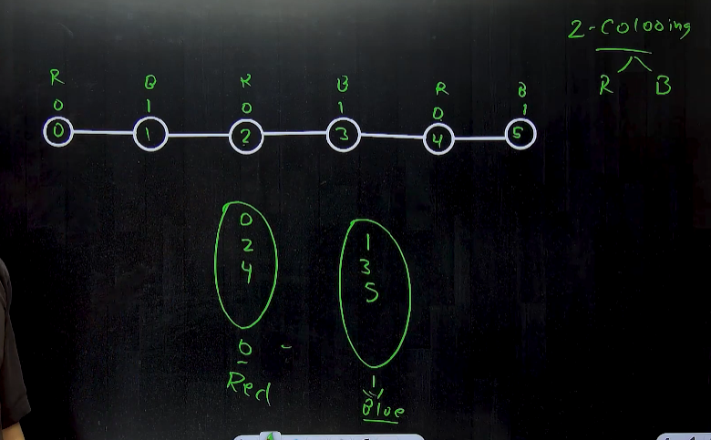

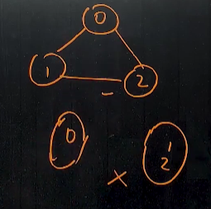

Note: to know whether the graph is bipartite or not:

* + If no. of vertices in graph is odd 🡪 not a bipartite graph
  + If no. of vertices in graph is even 🡪 bipartite graph
* **Method 1🡪using BFS** 
  + 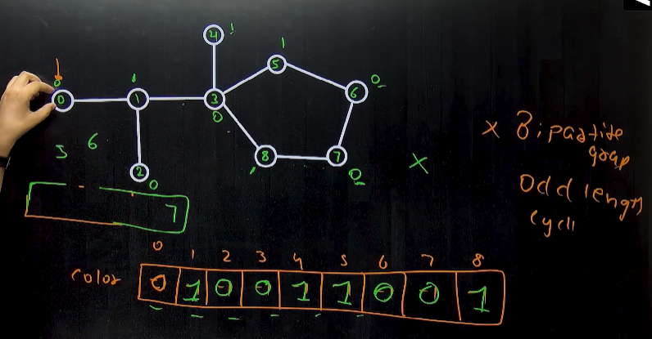
  + Algorithm🡪kissi graph ko hm bipartite tb maanenge , jb uske har ek node ko hm colour kr paaye by using two colors only such that no two adjacent vertices have the same color 🡪ek color naam ka vector bna lo and sbme -1 bhar do (-1 will represent ki abhi tk uss vertex ko color nhi kiya gya h), ek queue naam ka vector bnaao, and jis jis ko color kr diye h usko queue m daalo, and phir pop element from the queue one by one and unke neigbours ko color kro and phir unko bhi queue m daal do
    - 0 and 1 will represent the color 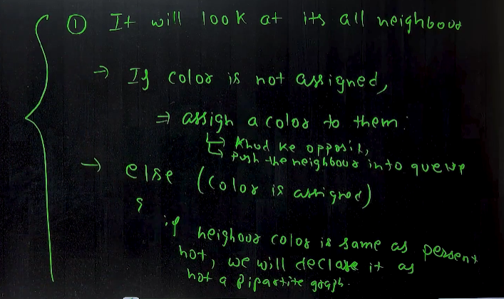
    - 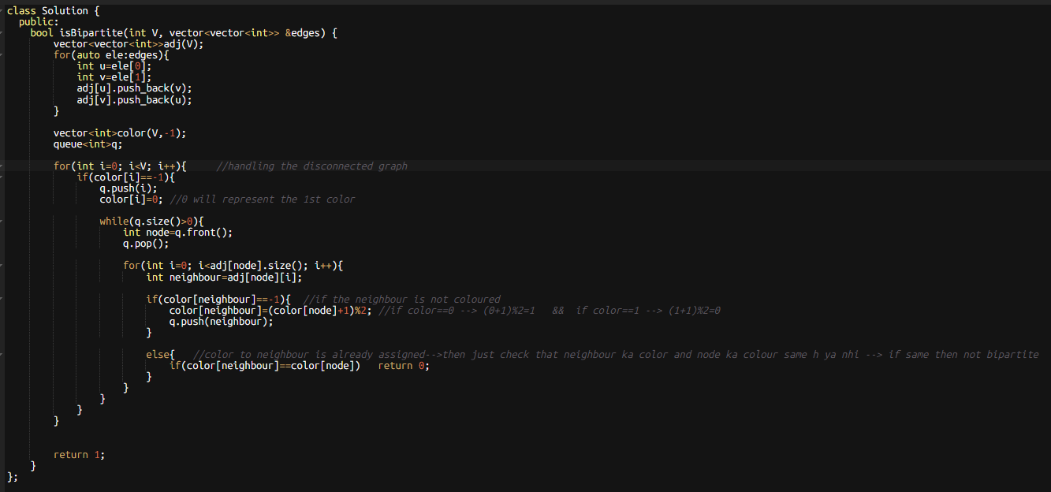
* **Method 2🡪 using DFS🡪** 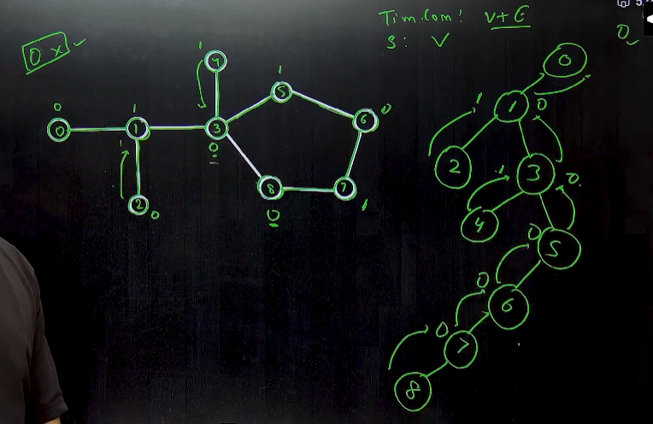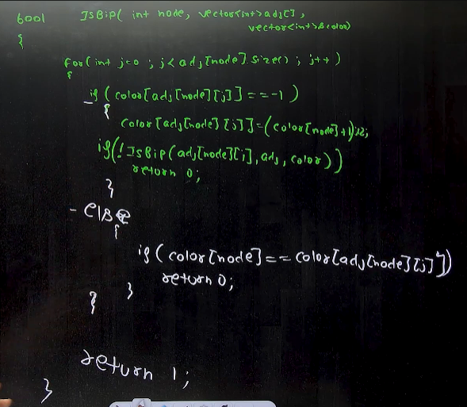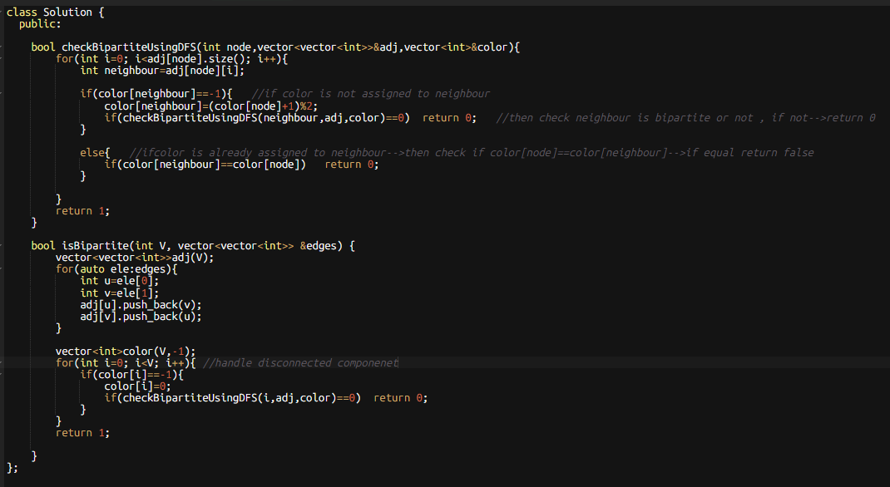

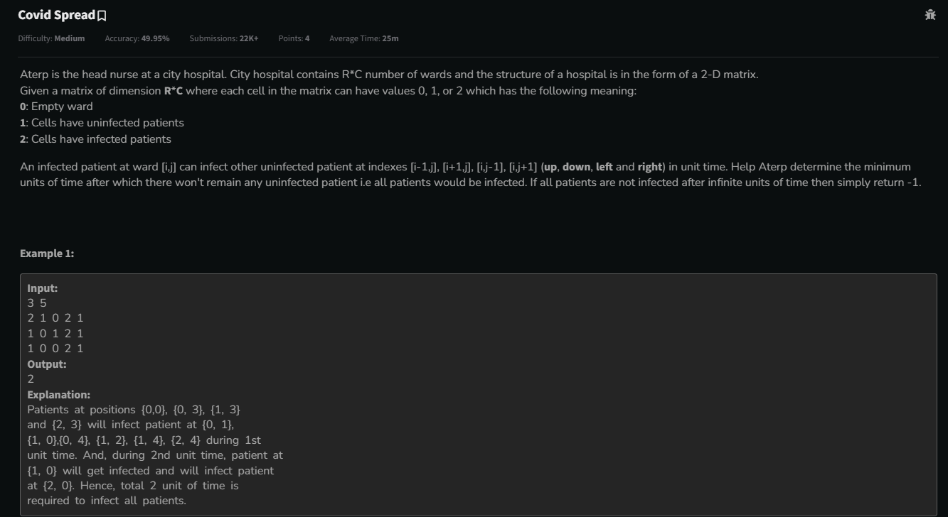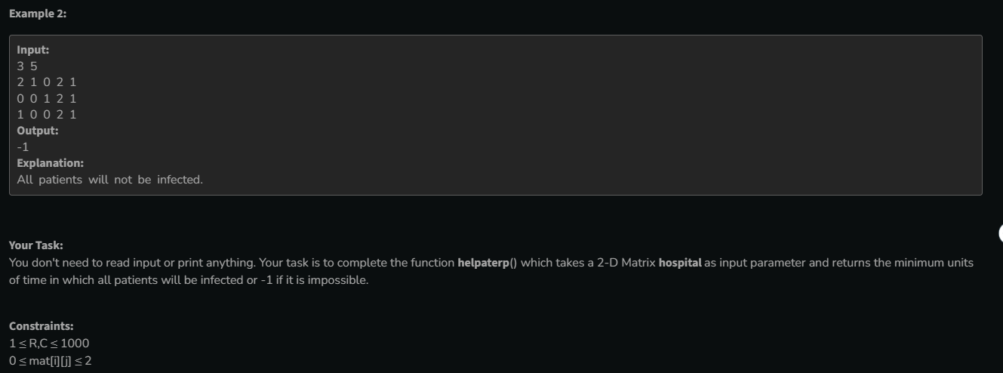

* 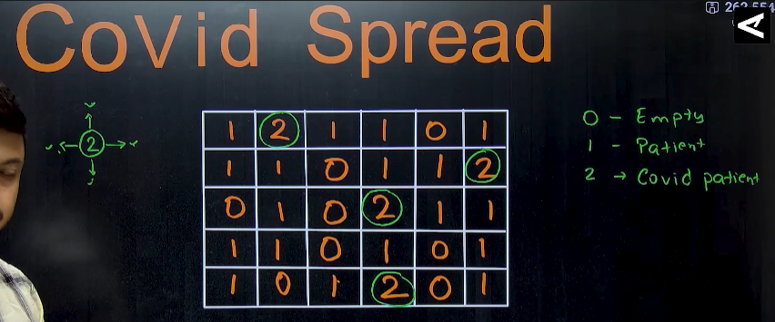🡪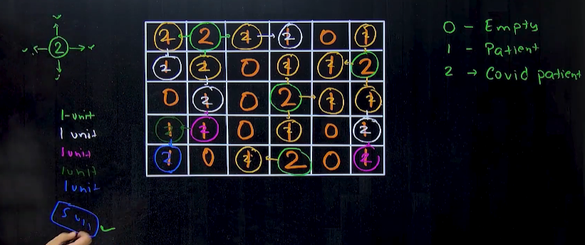
* **Method 1🡪using BFS**🡪Eg: 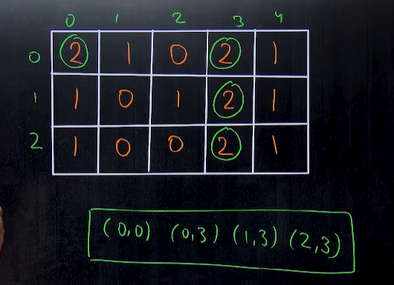🡪initial stage🡪next stage🡪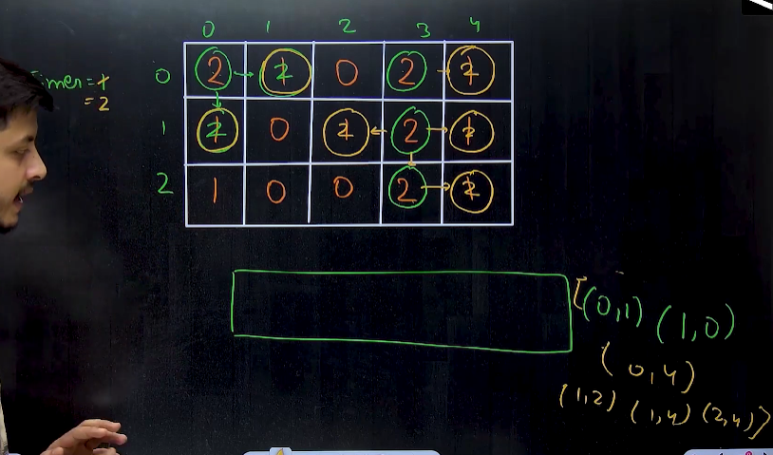🡪final stage🡪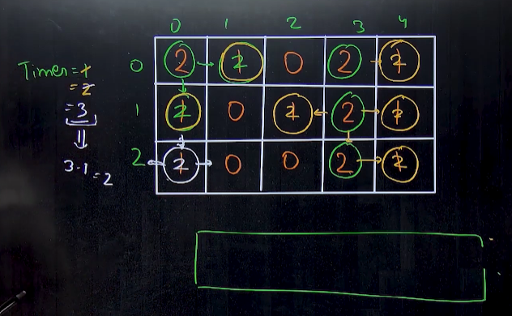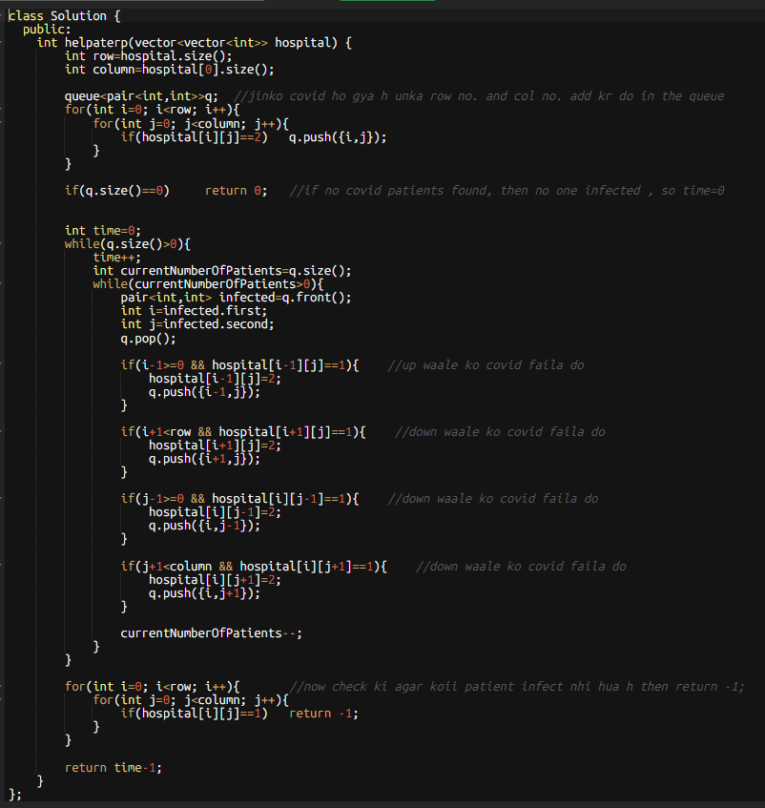

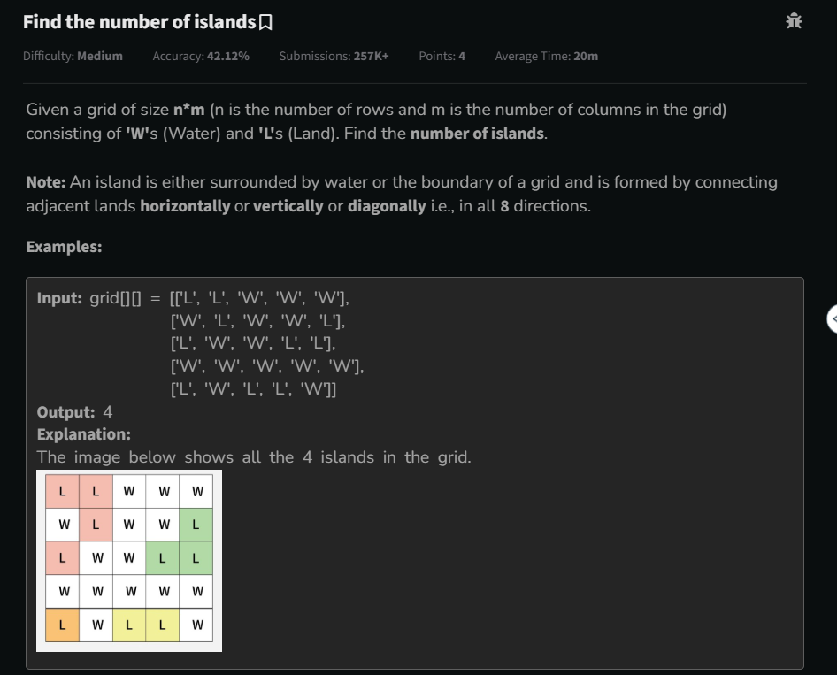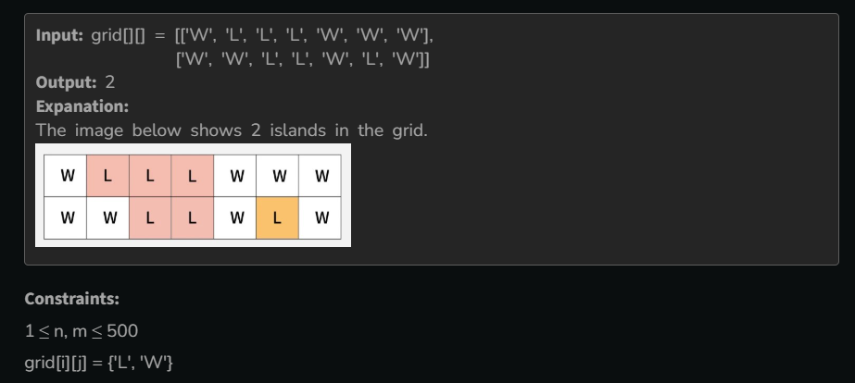

* 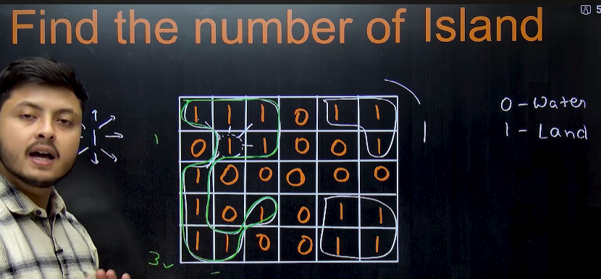
* 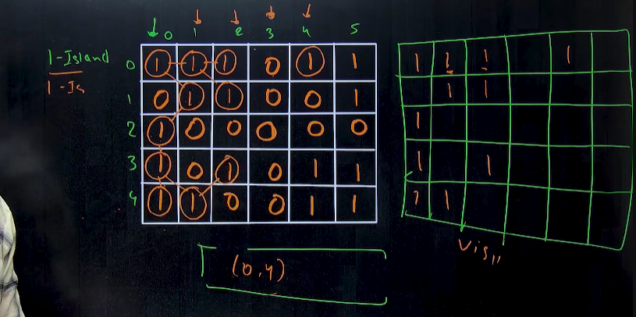🡪Method 1🡪using visitedArray🡪ek same given array k size ka ek new array (named🡪 Visited) banana h, and hm jis jis node (jaha 1 h) ka use krke island bna lenge, uss index p in the visited array mark kr denge.
* Method 2🡪in the same matrix , jha jha hm visit kr lenge wha hm 1 ko 0 bna denge after forming an island
  + Algorithm 🡪dhundho ki 1st one kha h, if found then 🡪count++🡪and then usse connected(up,down,left,right,and two at diagonals), jo bhi 1 h usko 0 kr do, and then, search for a new 1 and 🡪count++ ……..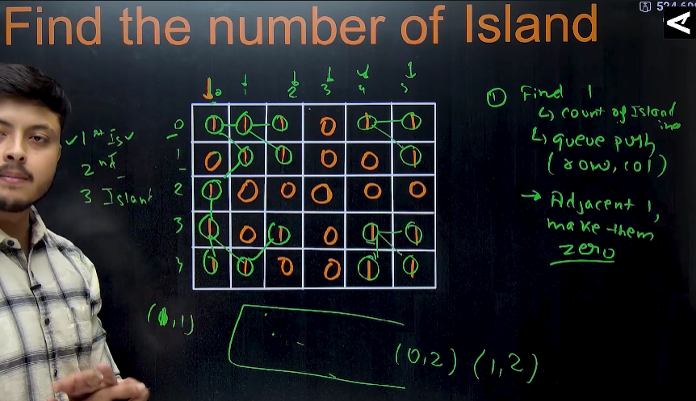
  + 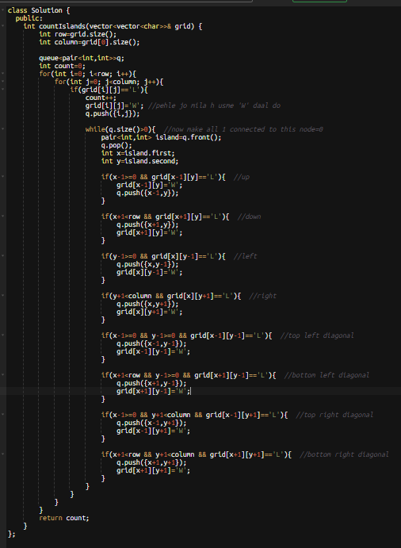

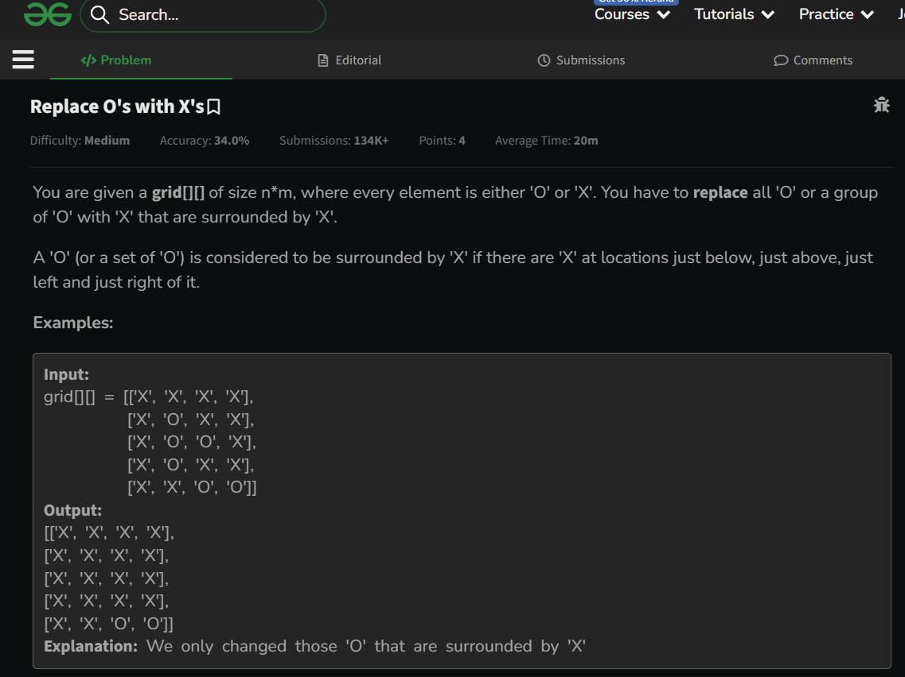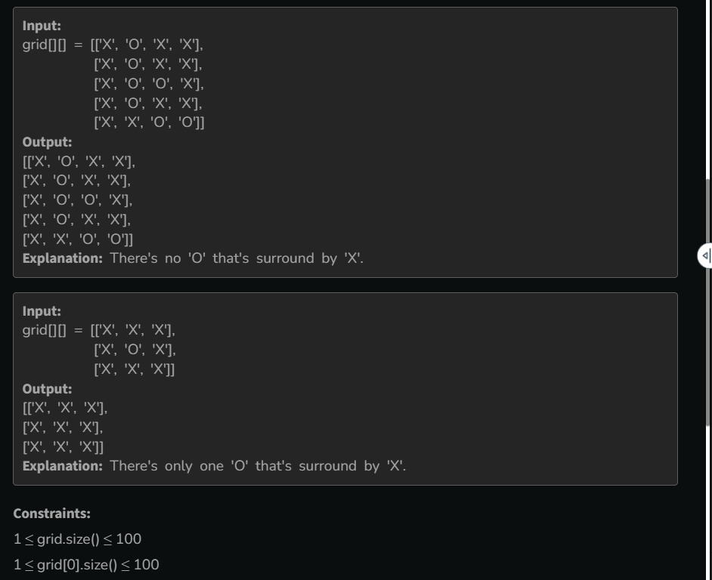

* Eg: 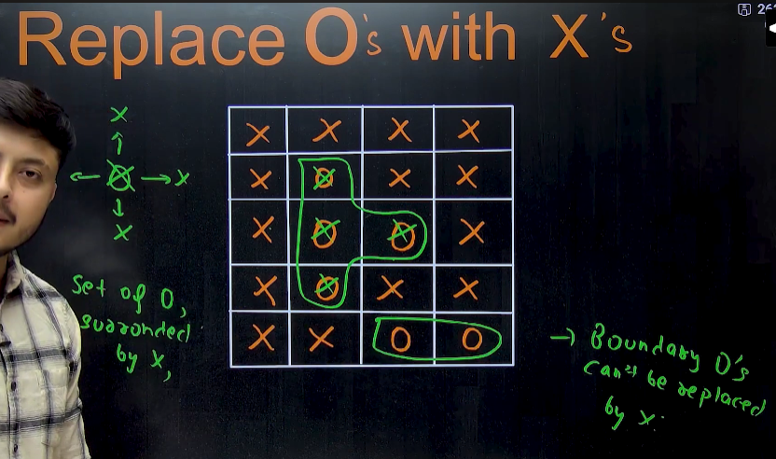🡪condition 1
* Eg: 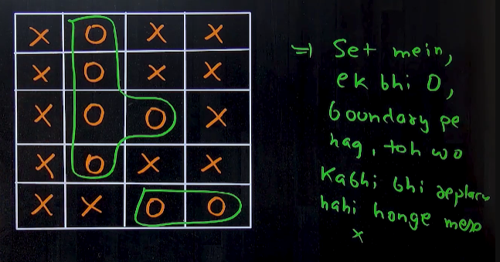🡪condition 2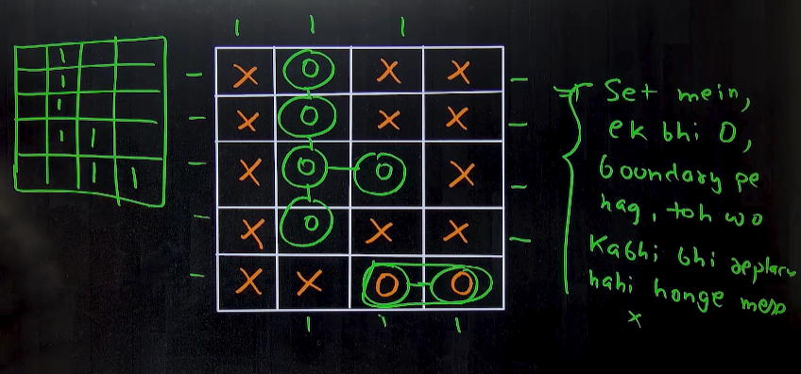
* Algorithm🡪hm ussi ko ‘x’ m convert kr skte h , jo ‘o’ or froup of ‘o’ is surrounded by ‘x’.
  + If set m ek bhi aisa ‘o’ h jo boundary p h, that whole set cant be converted ‘x’ becoz, that set is not surrounded by ‘x’ from all sides, becoz one size is boundary not ‘x’. And except those sets , all internal ‘o’ can be converted to ‘x’
  + So start traversing on the boundary , if we find ‘o’ then uss ‘o’ se connected jitne bhi ‘’o’ h unme , pehle ‘T’ bhar do, and when we find all the sets , then now traverse in the whole matrix, and jha jha ‘T’ h usse ‘o’ kro and jha ‘o’ h usko ‘x’ kro 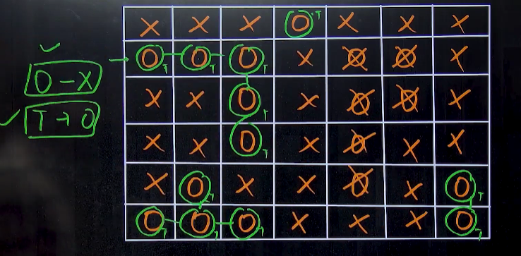
  + 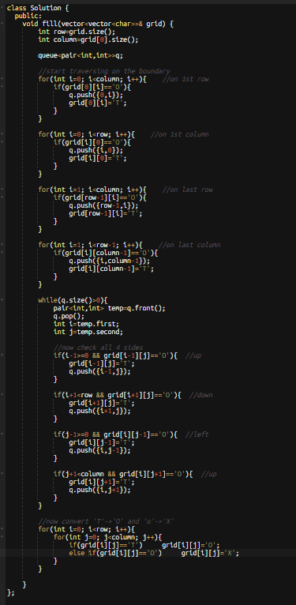

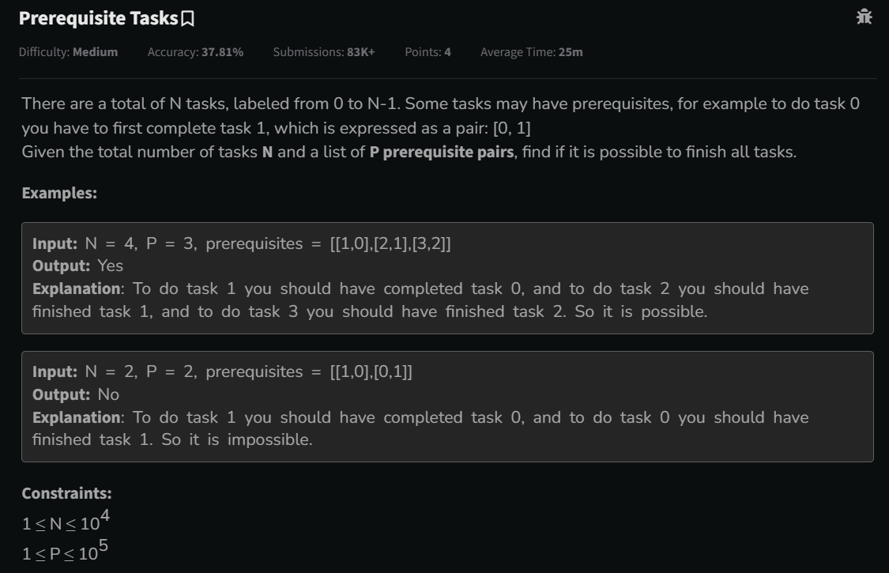

* 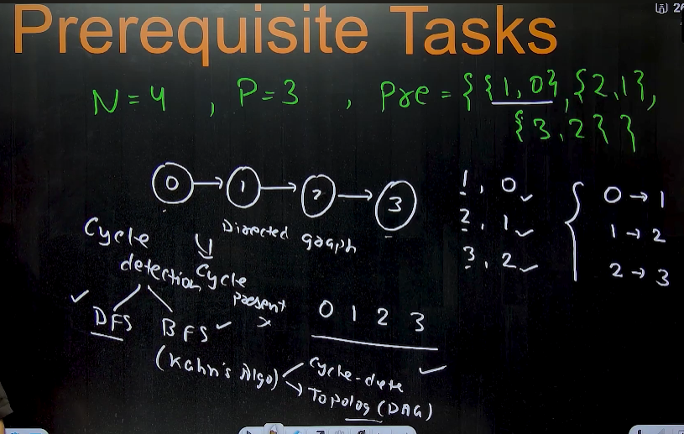 🡪means jo given kaam h , agar unko unke proper order m krwaana h , then usme cycle present nhi hona chahiye.
* 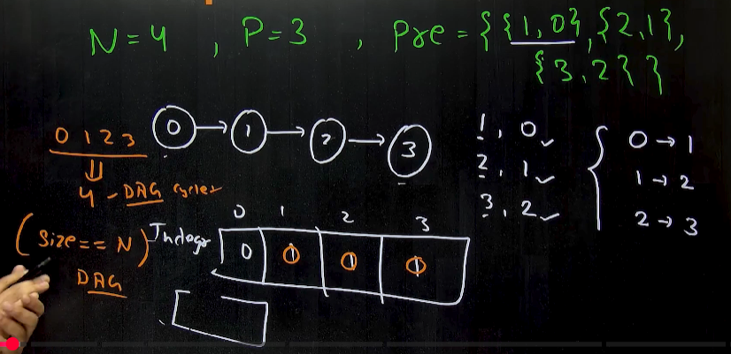
* 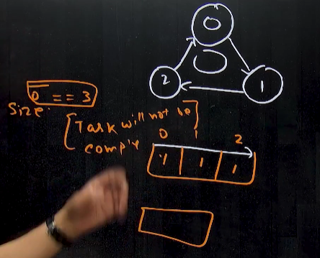
* 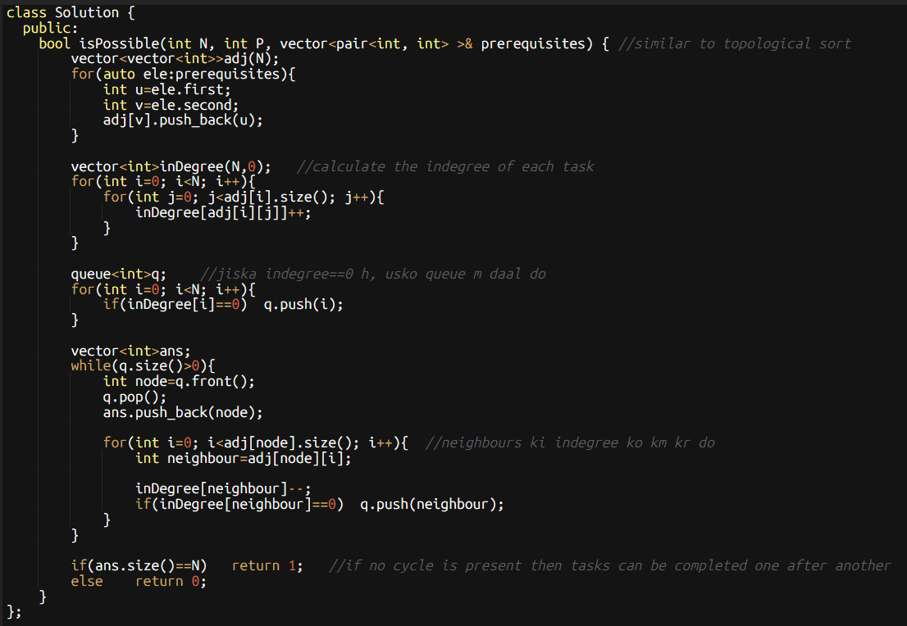🡪if cycle hoga then task one after other nhi ho paayega.

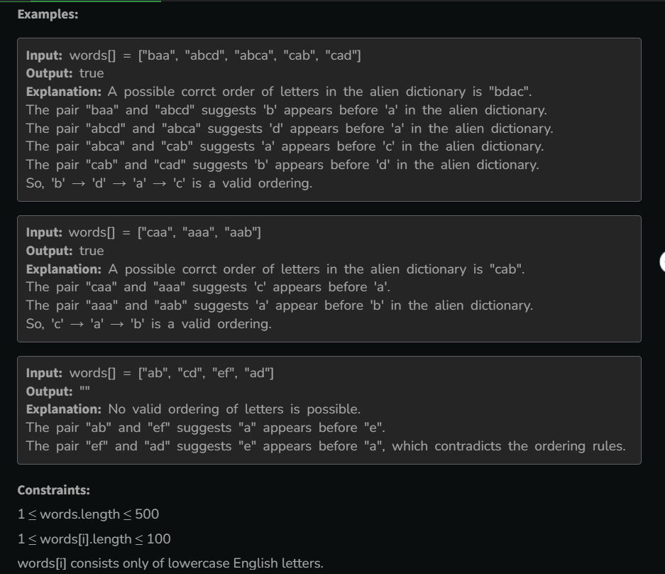

* 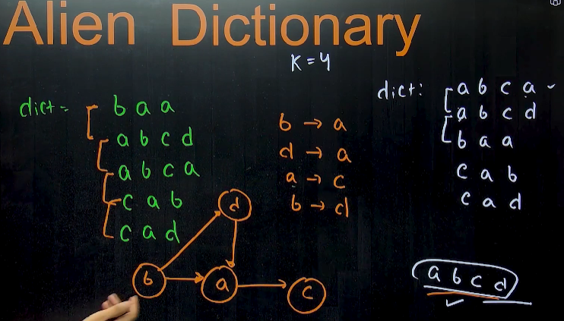🡪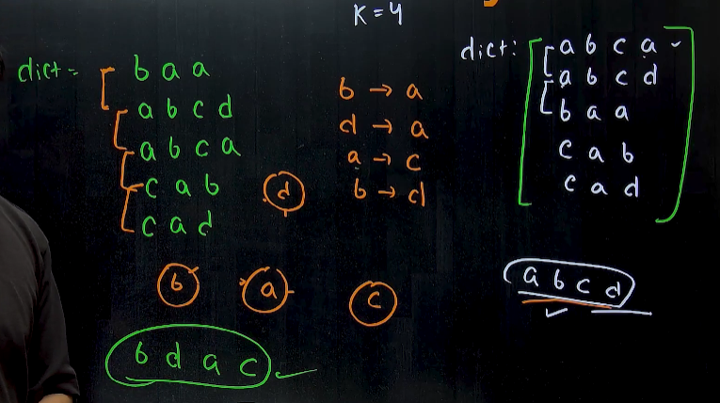
* Algorithm 🡪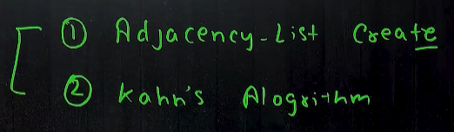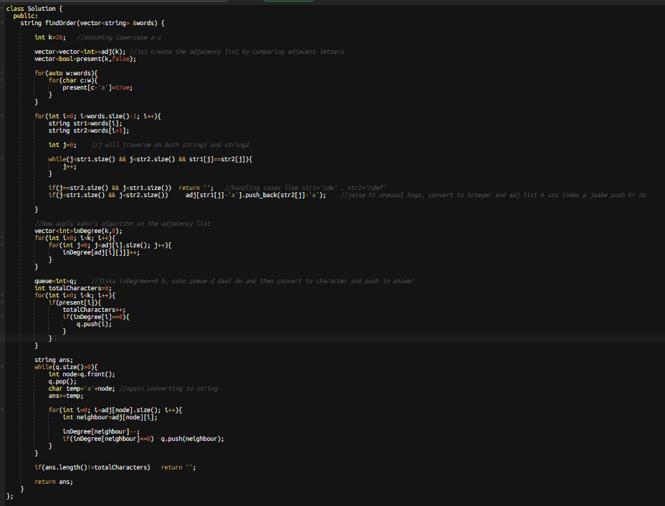

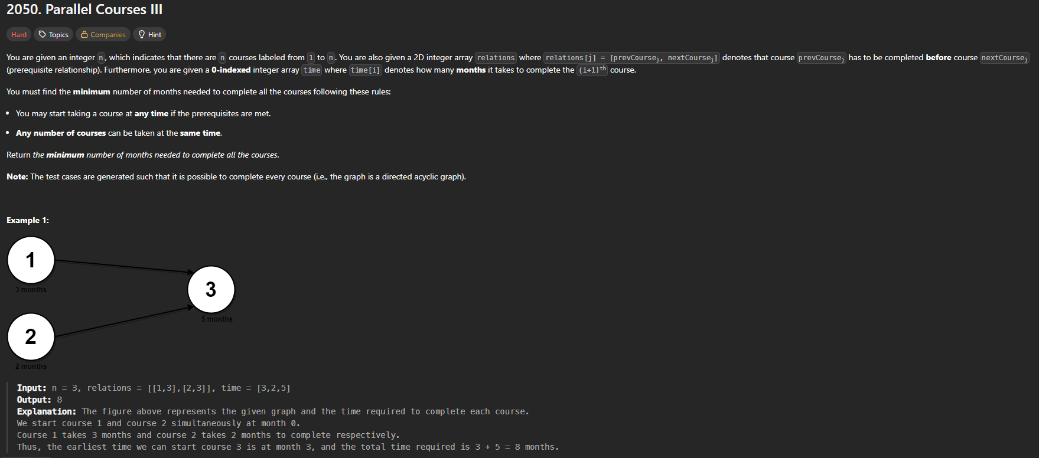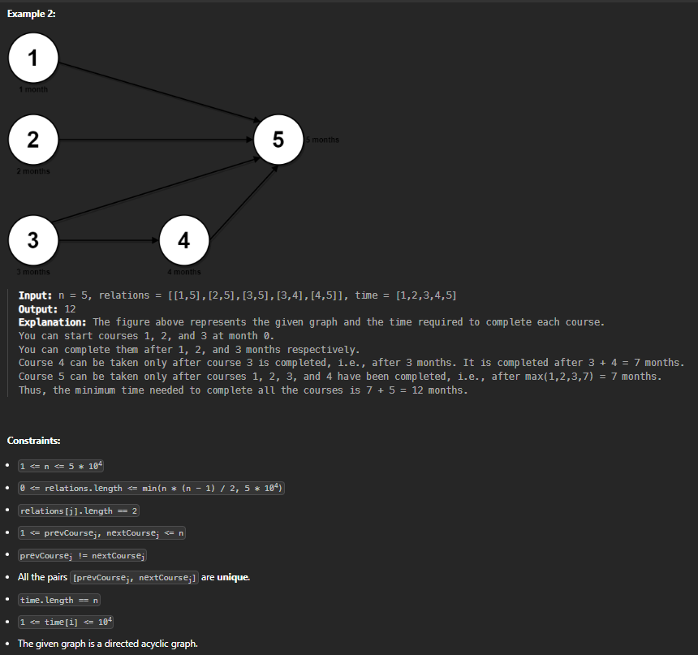

* 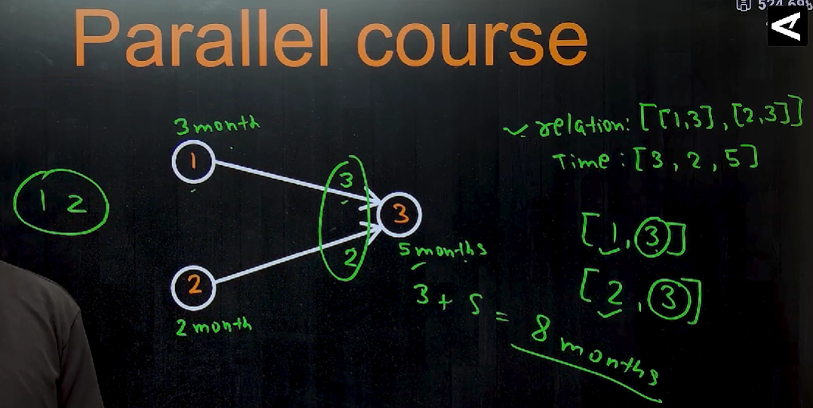🡪this question is just the application of topological sort, upr waale questions k jaisa
* Eg: 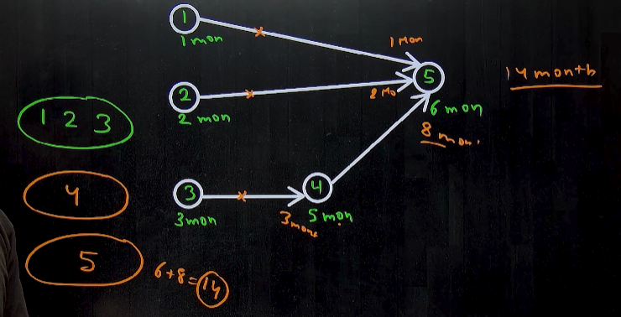
* Eg: 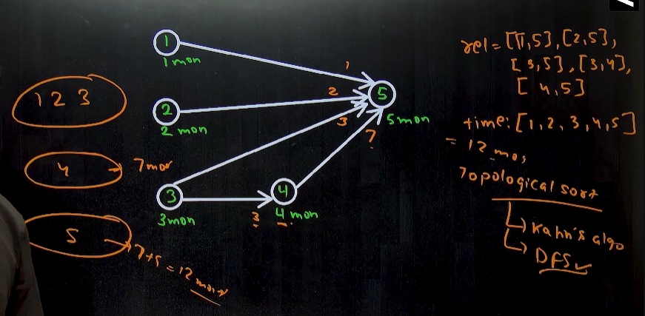
* Use kahn’s algortihm: 🡪1st crete the indegree waala vector, jisme sbka saare nodes ka indegree push krenge and then 0 indegree waale ko queue m push kr do, and then pop from queue ek ek krke and jisko pop kr rhe ho, usse connected jo bhi nodes h, unke indegree ko km krte jaaoo, and again jiska indegree 0 ho gya h, usko queue m push kr do. 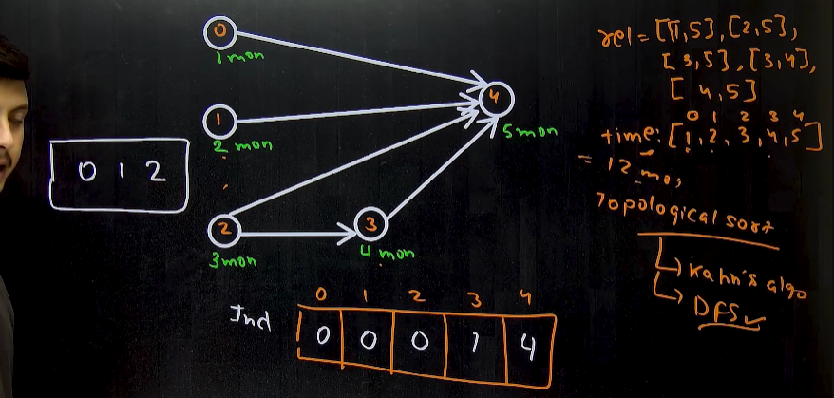🡪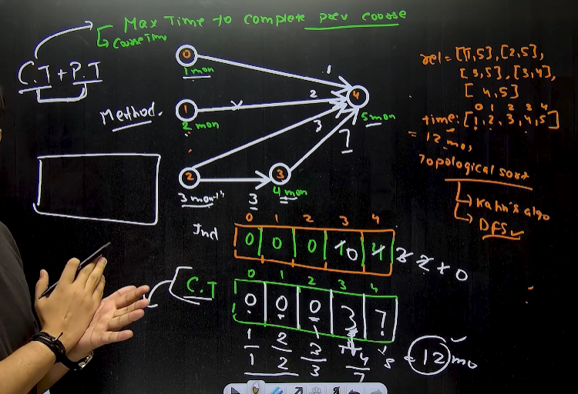

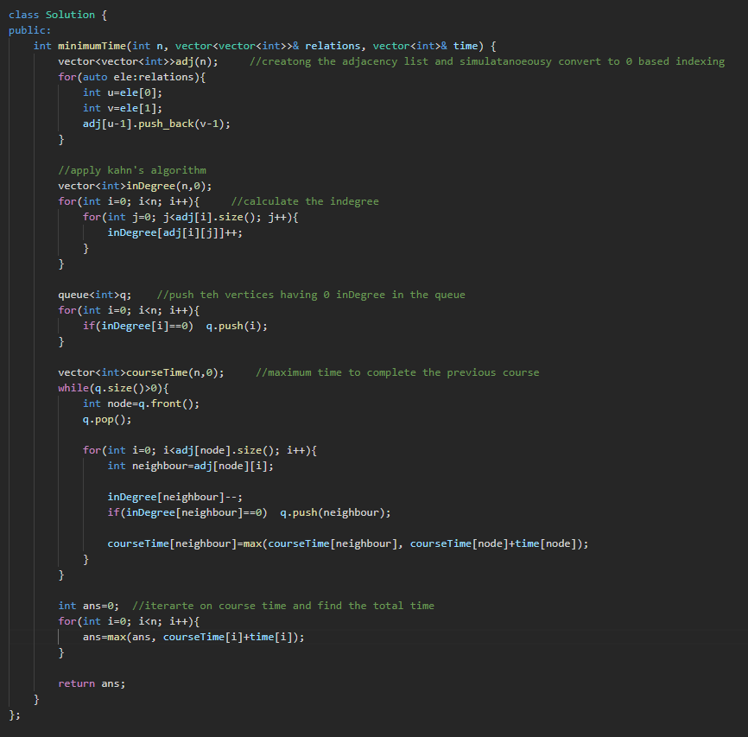

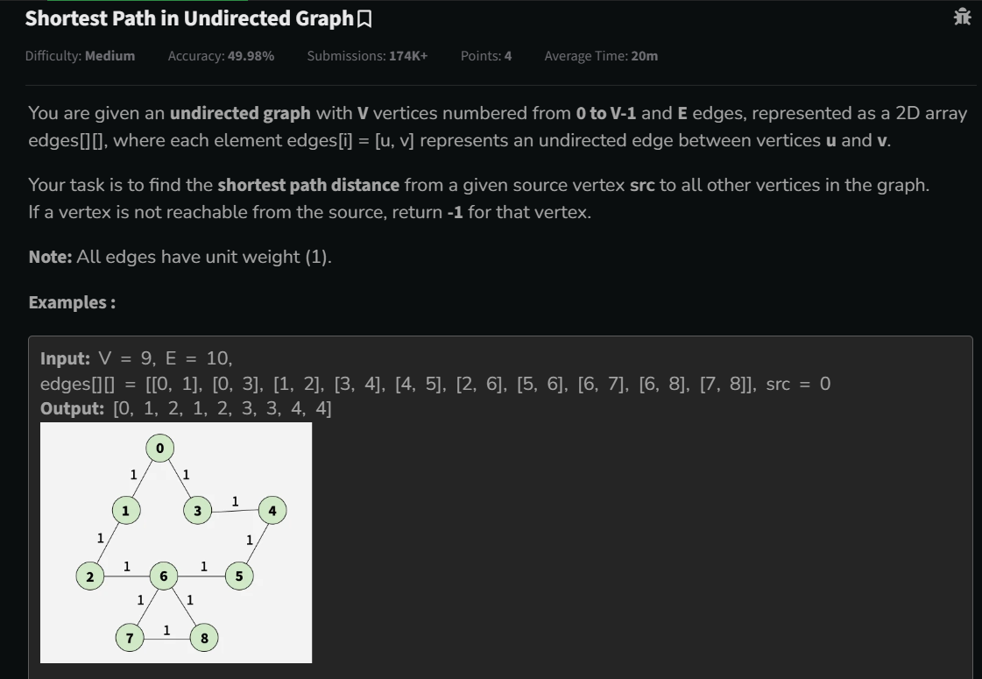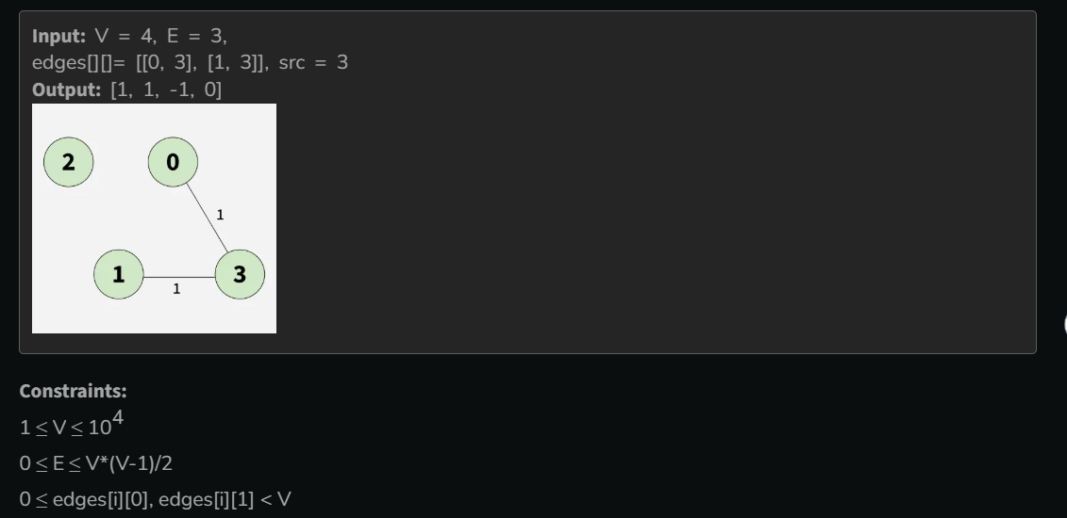

* 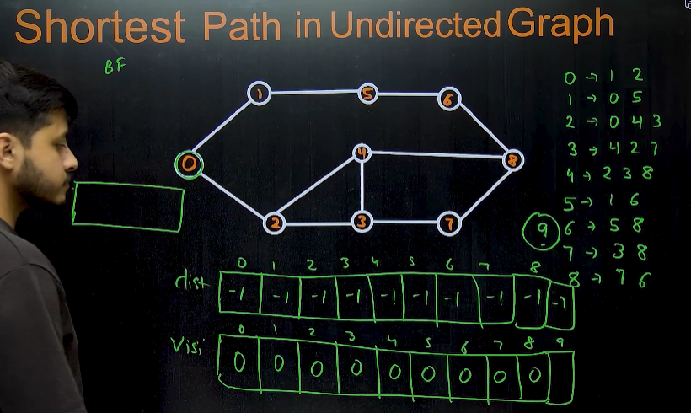🡪we have to find the minimum distance of all the nodes from a particular node. Eg: 0 -> 1 jaane k liye minimum distance, 0->5 jaane k liye minimum distance, 0->4 jaane k liye minimum distance ……..
  + Also in disconnected graph (above eg), 0->9 nhi pahuch skte h, so return -1.
* Method 1 🡪 use BFS🡪ek **distance** naam ka vector bnaoo (and fill -1 in every index) that will store the minimum distance of the source from the every index. And also make one visited vector that will store that kon kon sa node hmne visit kr liya h. now start traversing from the source , and source k index ko queue m daalo, then start popping from the queue unless queue gets empty, and uske adjacent vertices ka distance ko store krlo in the distance vector.

🡪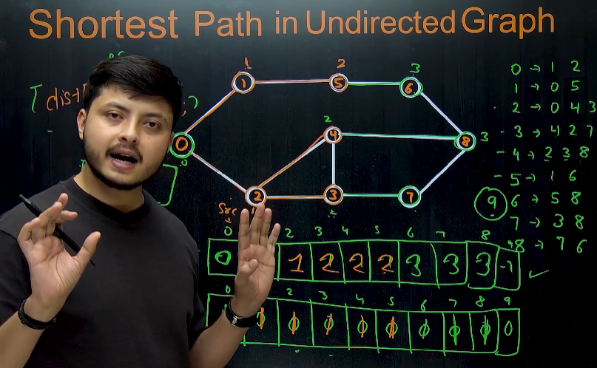🡪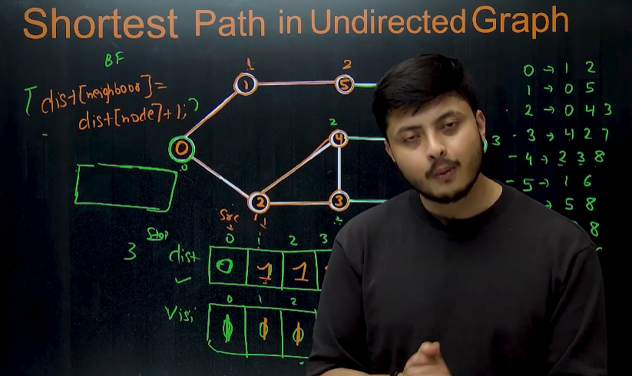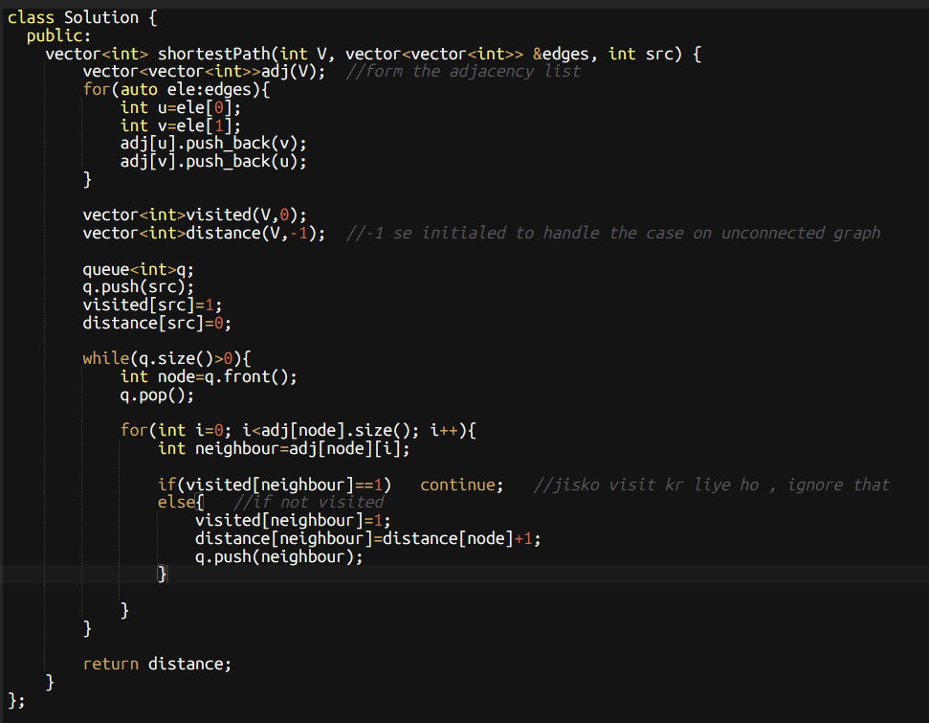

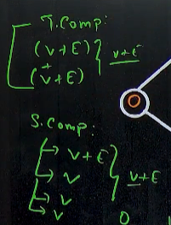

* Method 2🡪 DFS 🡪very tough 🡪 very high time complexity

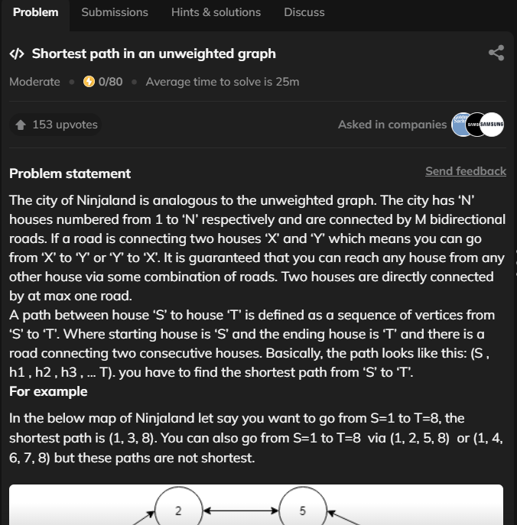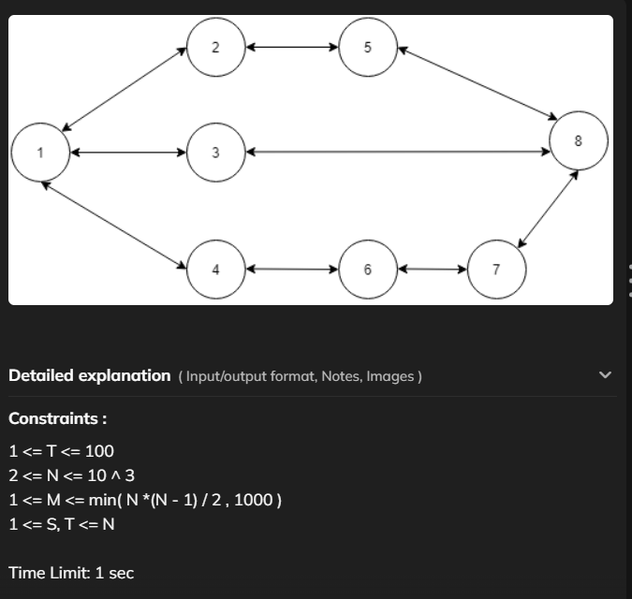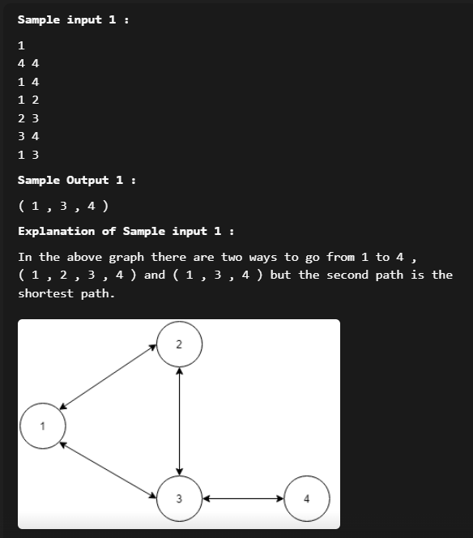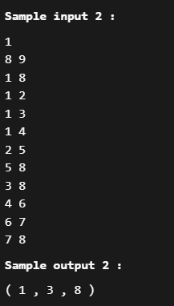🡪same as above question, bs usme distance from the source of each node ka array return krnaa tha and isme proper path return krna h of a particular node from the source.

* Algorithm 🡪 same as above question , isme bs sbke parents ko store krke rakh lena h
* 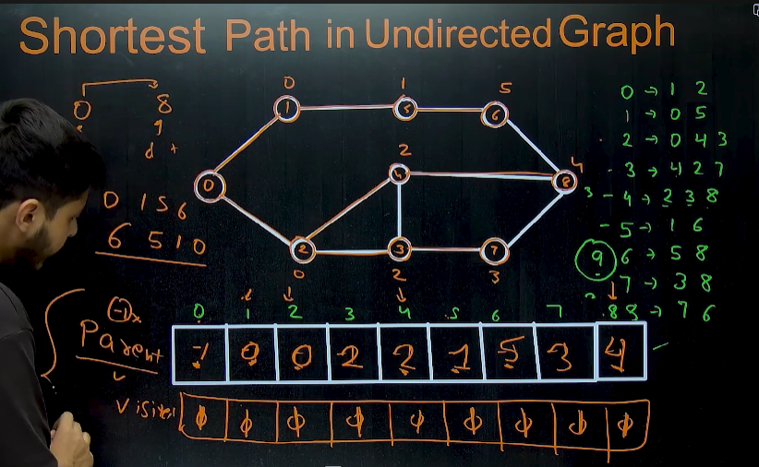 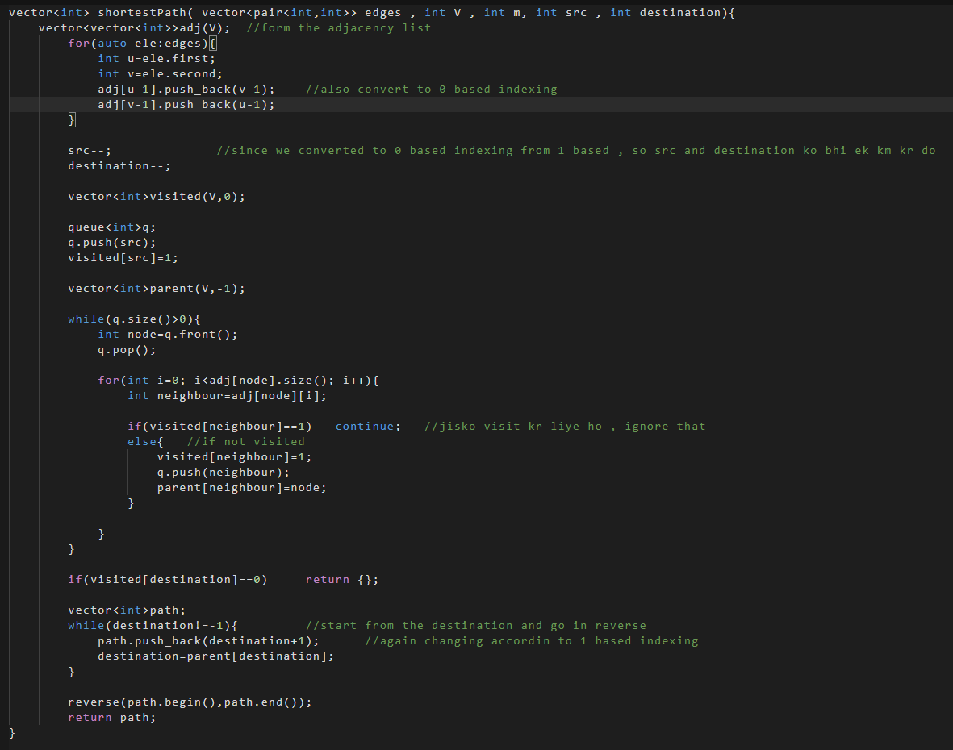

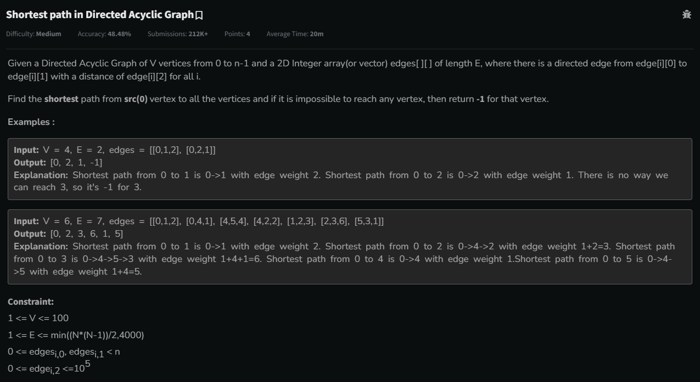

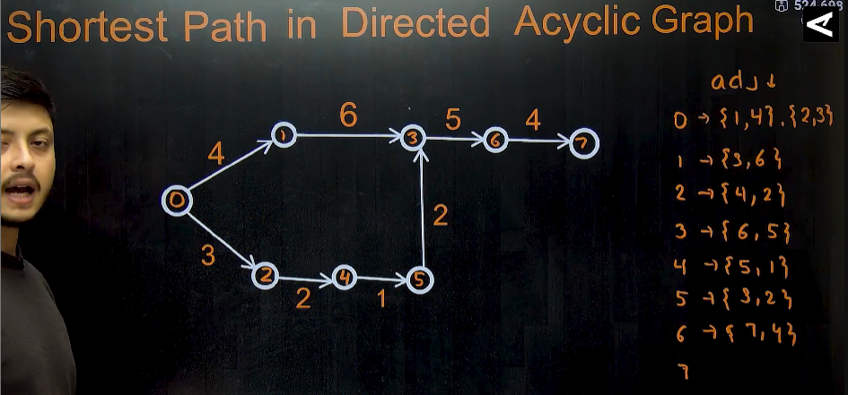🡪 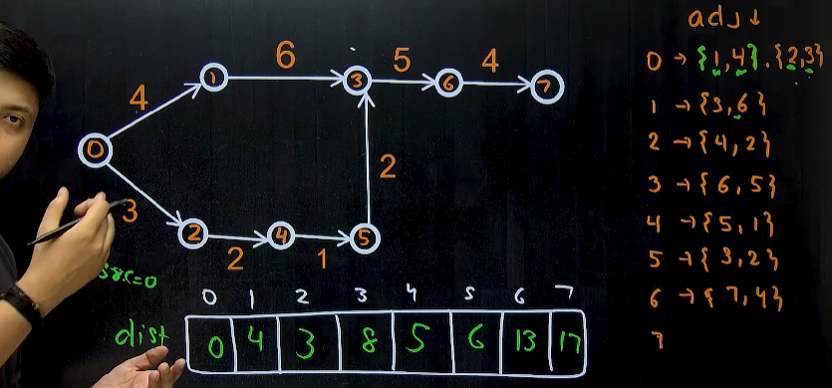

* **Method 1🡪BFS🡪**We have earlier solved the question named “shortest path in undirected graph”, , using BFS method, but that method fails in this question becoz that gives a wrong answer.
* **Method 2🡪DFS🡪** gives the correct answer when we travel on the current path and keep updating the cost at each vertex-->but the time complexity drastically increses if we use this method becoz we visit some nodes multples times if the same node comes in other path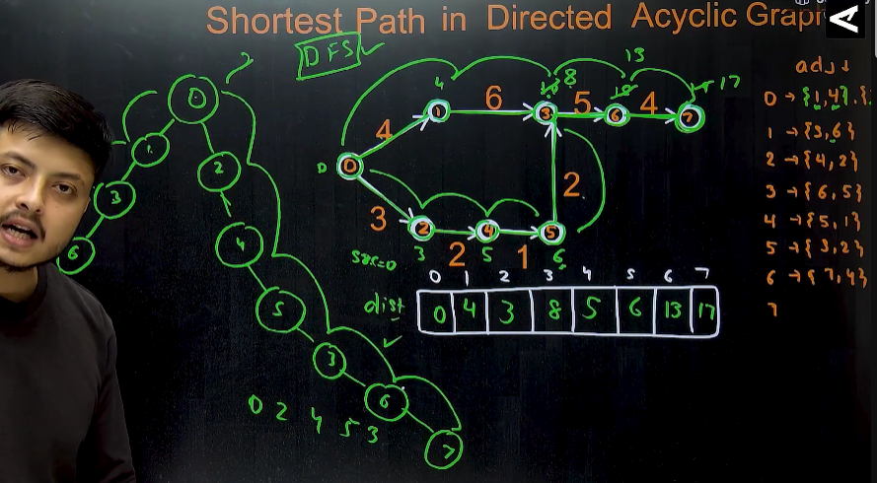
  + **Algorithm🡪** 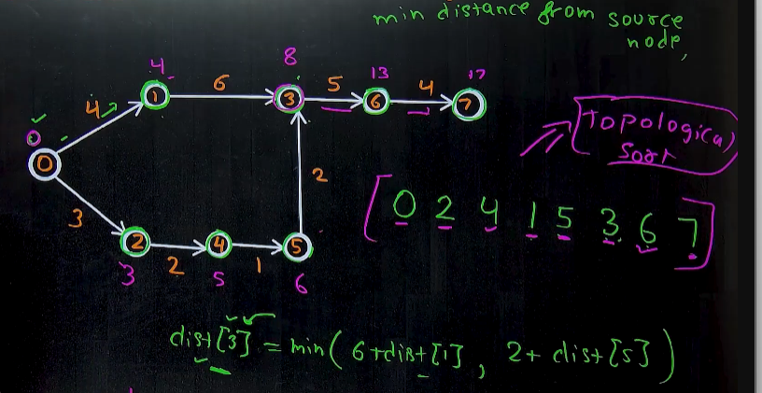 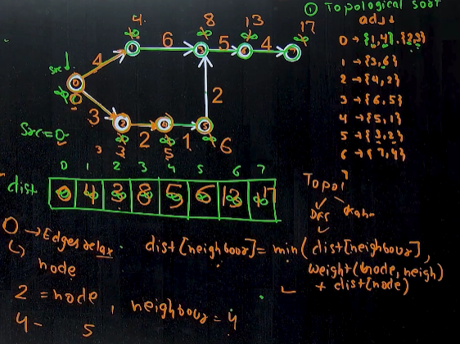
    - 1st find the topological sort of the the graph (ki kiska weight pehle calculate krna h), then ek distnce naam ka vector bnaao and sbme infinity bhar do),
    - Then distance of source m 0 daal do,
    - Then jb tk queue khaali nhi ho jaata , queue se pop krte rho and distance[i] m minimum(distance[node], weight[node->neighbou]+distance[node]), daalte rho.
    - 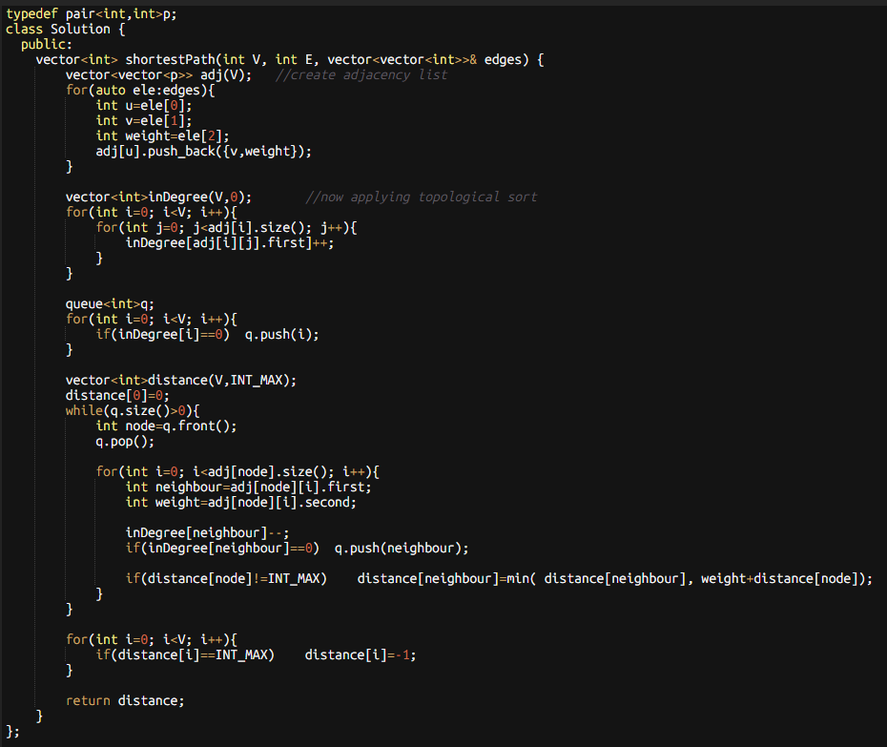

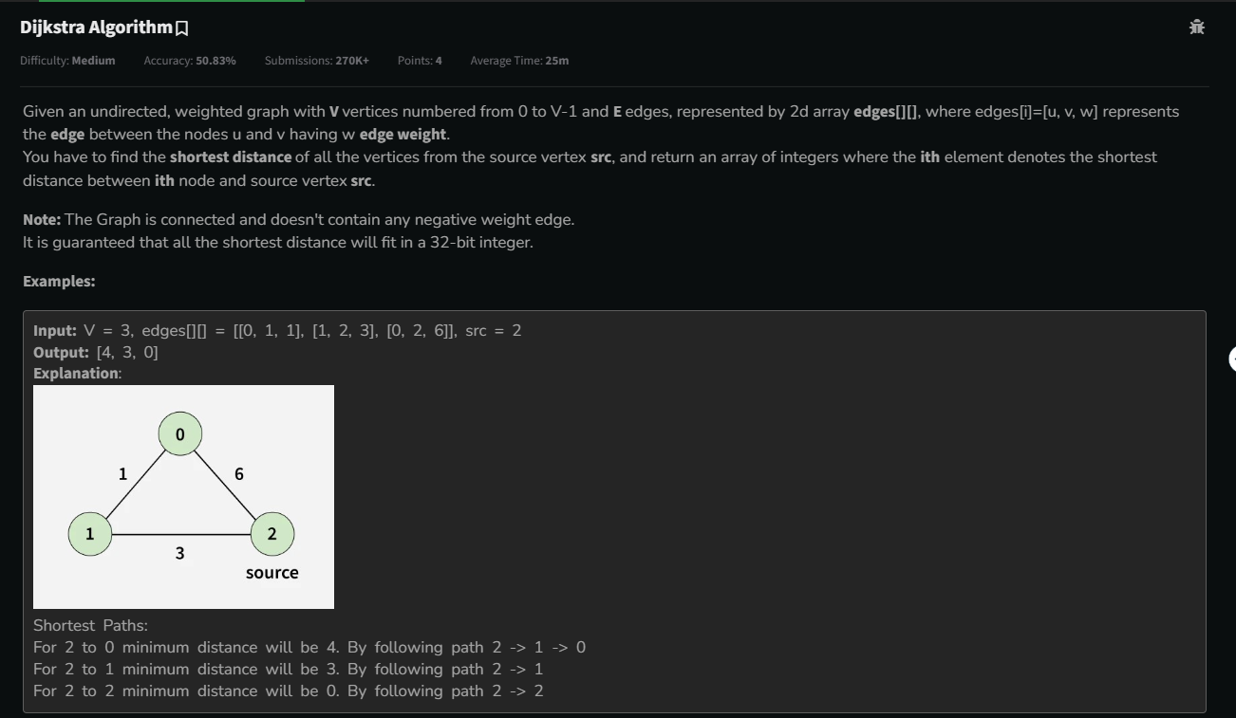 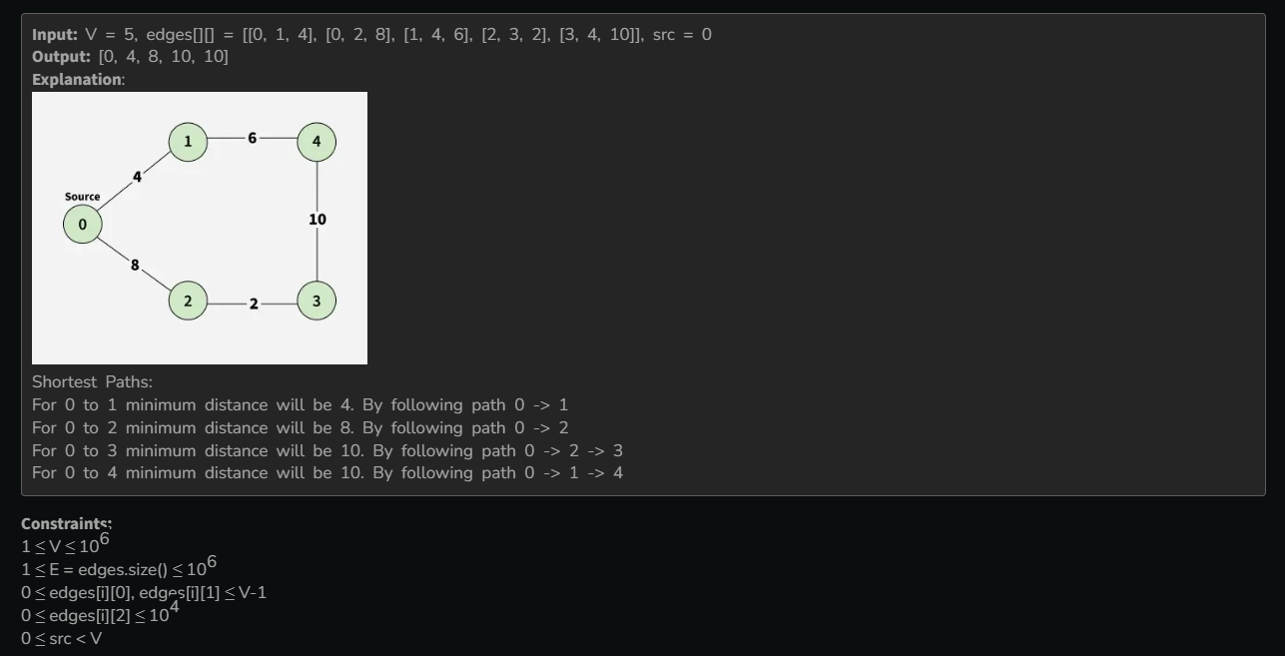

* **Method 1🡪shows time limit exceeded**🡪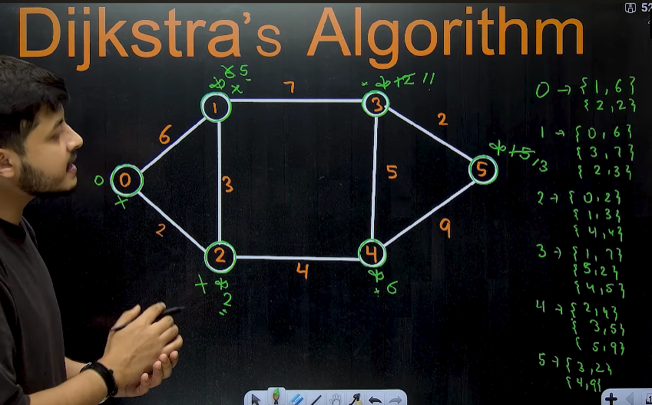🡪single source shortest path algorithm
  + Eg: 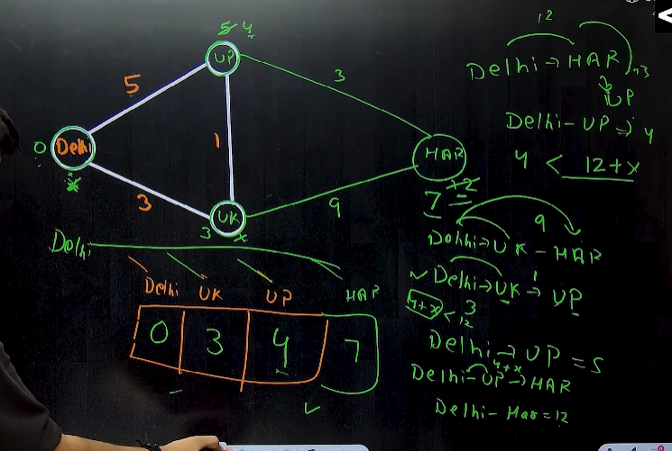
  + Algorithm🡪 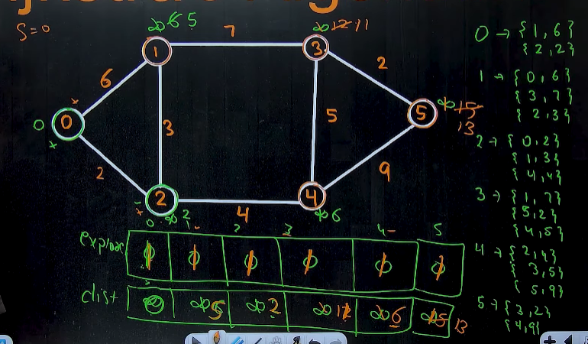 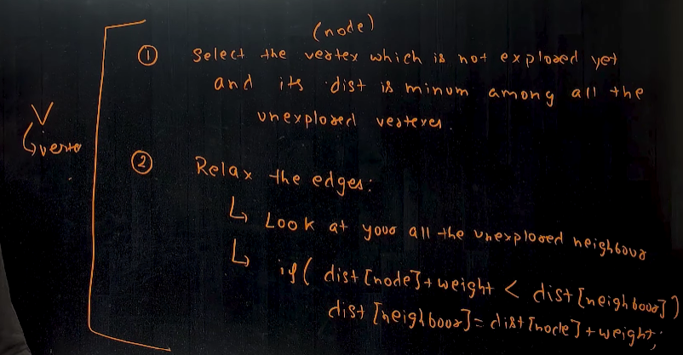
  + 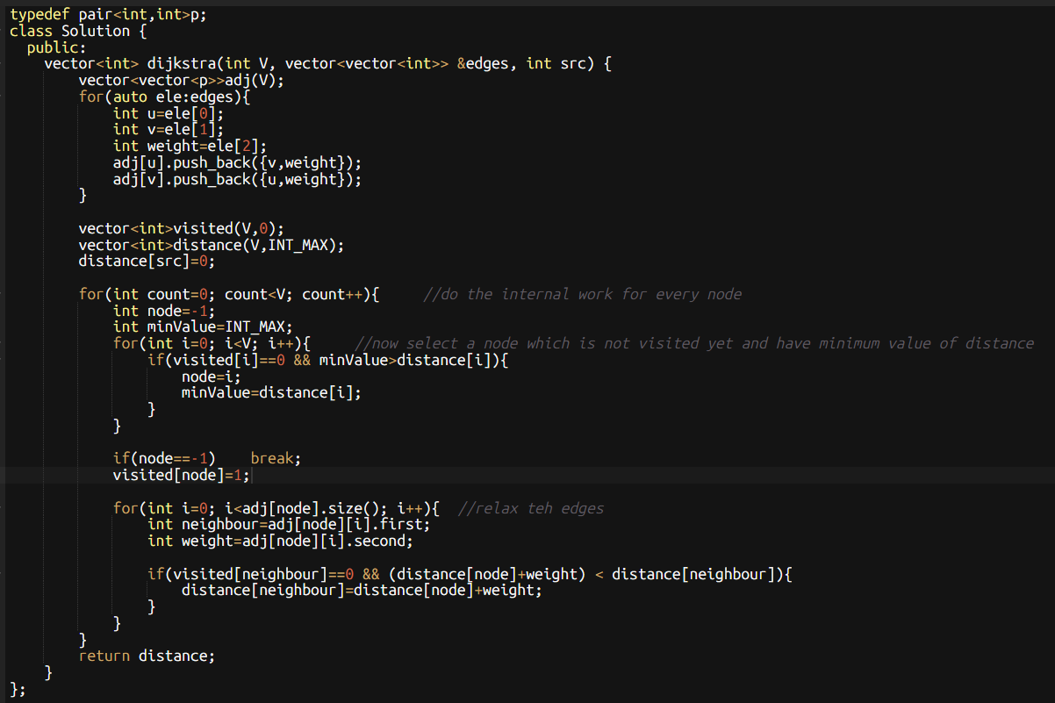
  + 
* **Method 2🡪using minheap**🡪 algorithm is same as above method, bs ab hm jb , minimumVAlue find krenge tb minheap ka use krenge so that time complexity to find the minimum element reduces from O(n) 🡪 O(logn) 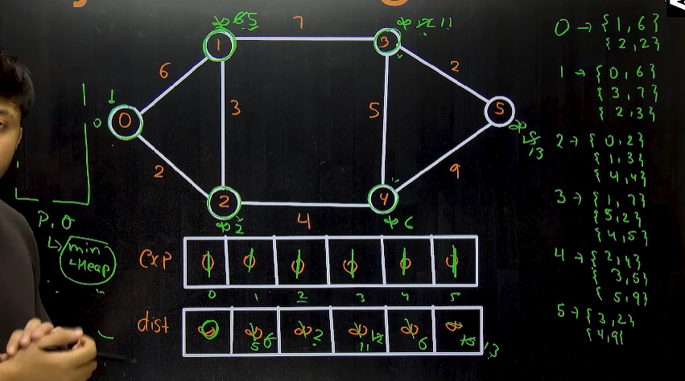
  + **Algorithm 🡪** 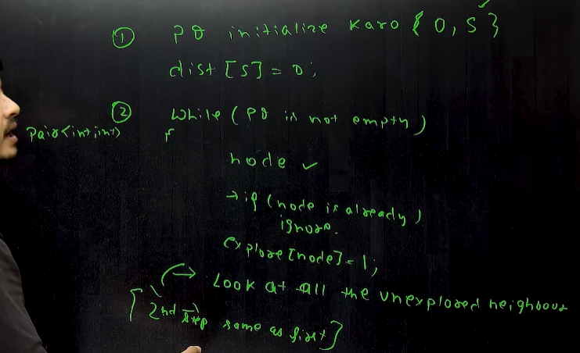 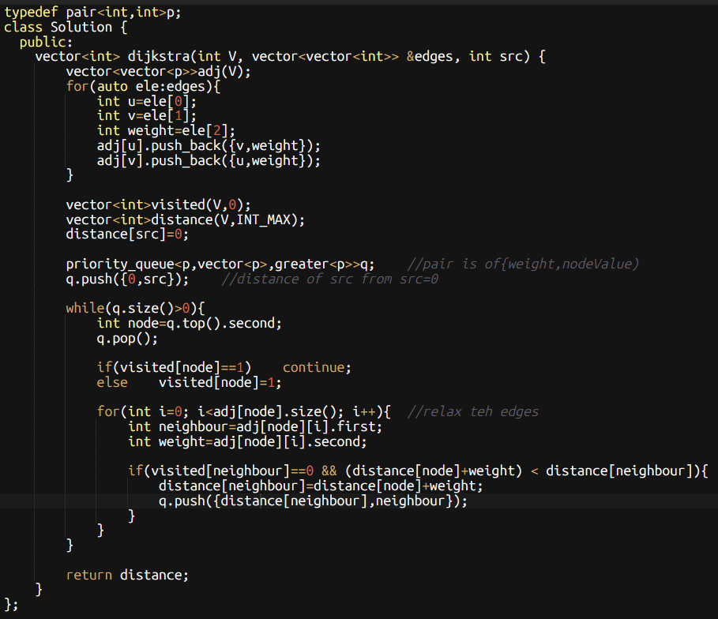 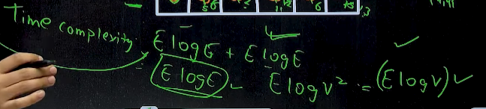
* 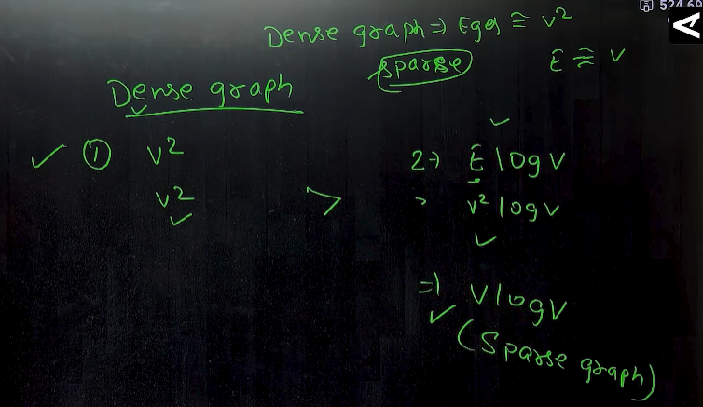
  + In case of dense graph, use method 1
  + In case of sparse graph , use method 2
* **Note : Dijkstra algo don’t work on negative weights.**

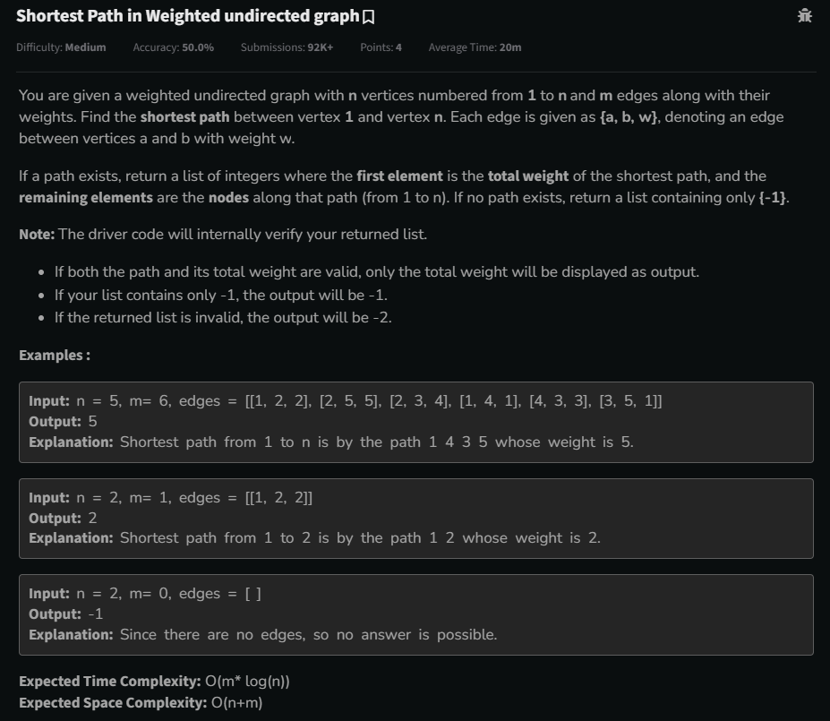

* 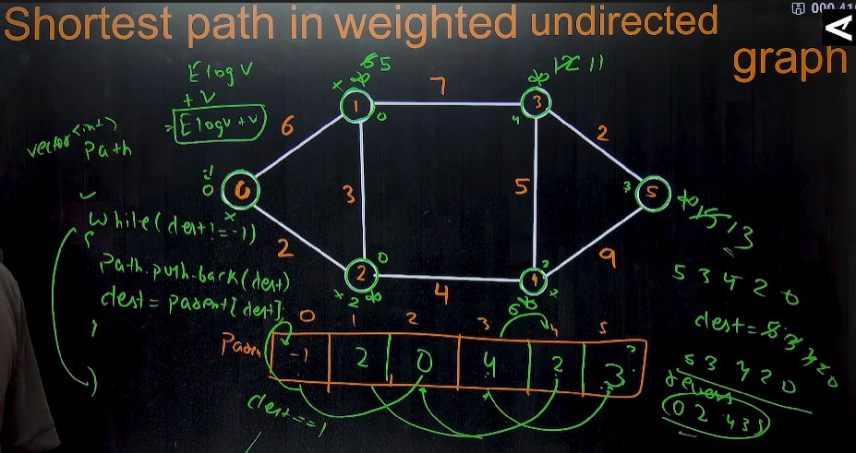
* 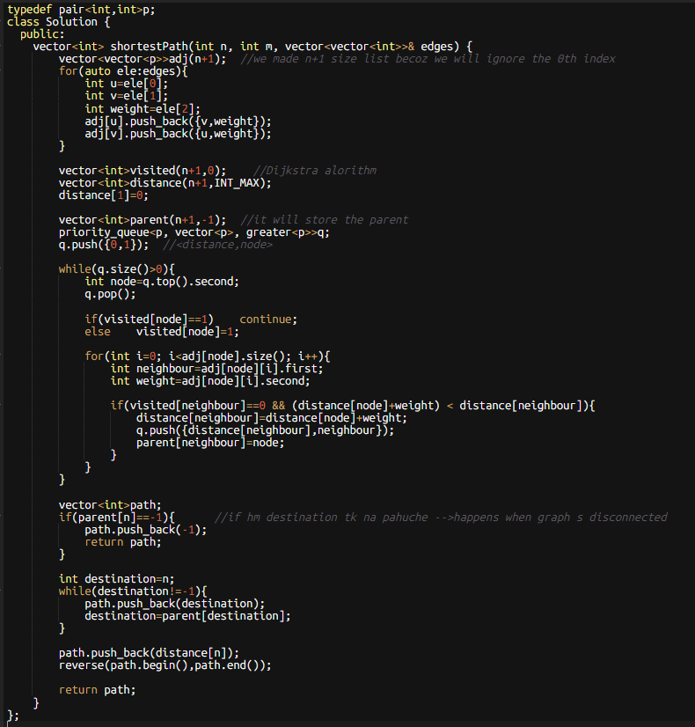

**Note: Dijkstra’s Algorithm can work on both, directed and undirected graph but can’t work on graph with negative weights.**

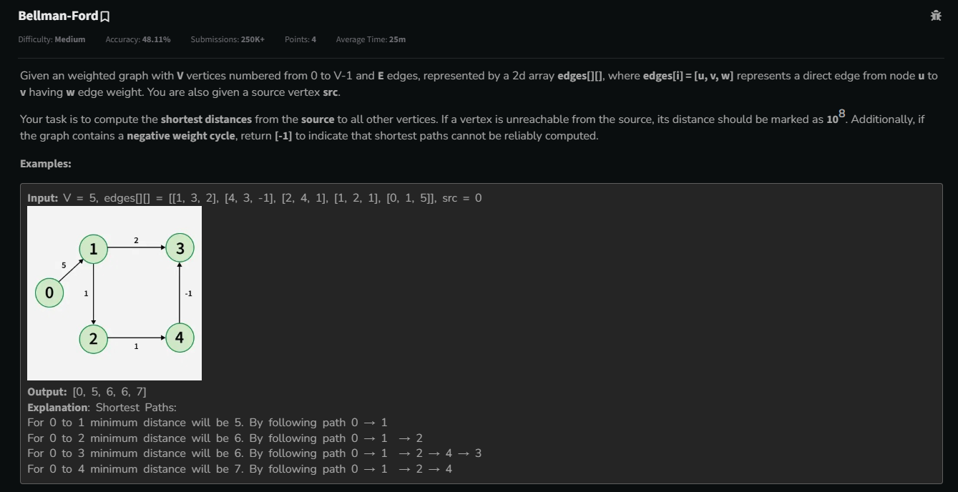 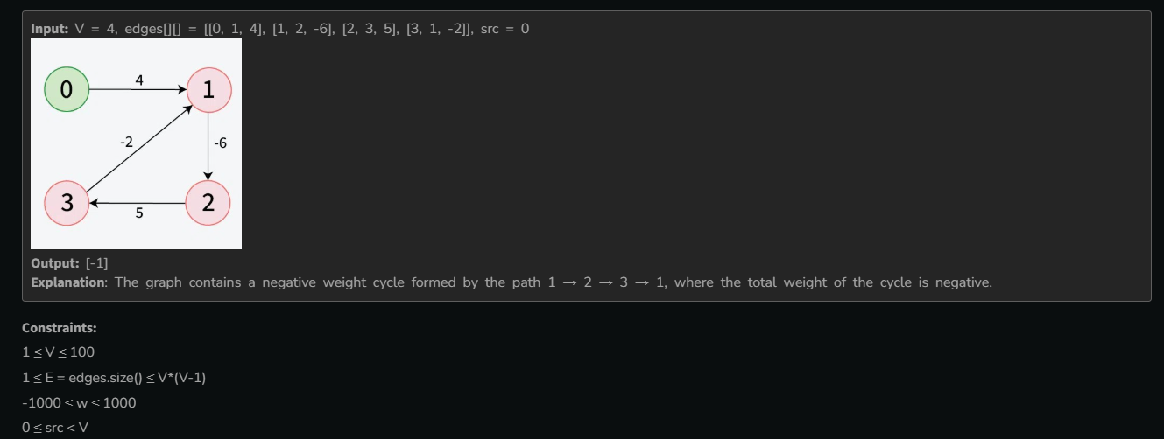

* 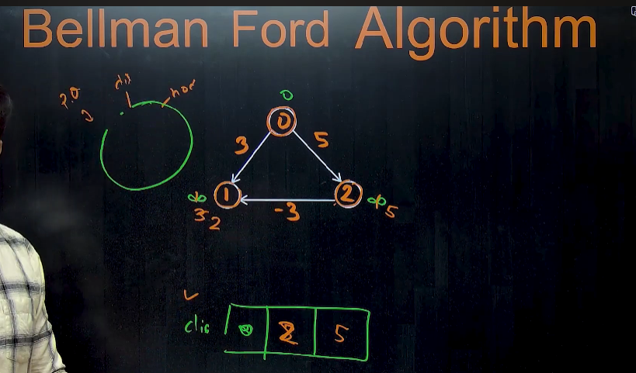**🡪** in dijkstra’s algorithm, hm visited vector bnaate h , and before working on any node we check that who visited h ya nhi, and if that node is visited then, we don’t work on that node again.
* So , in Bellman ford algorithm, agar hm **visited vector** ka, concept hta de, then it will be bellman ford algorithm , i.e we can visit the visited node again.
* 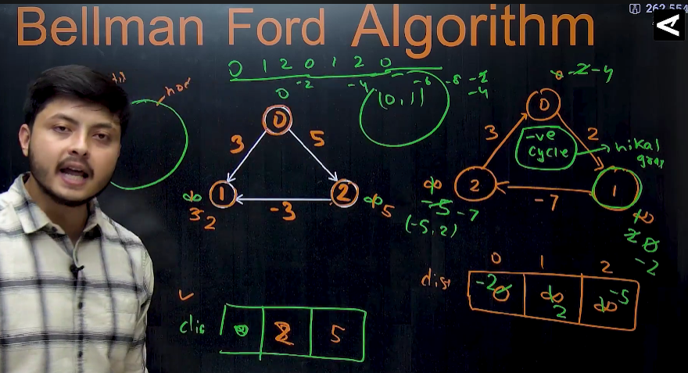
* 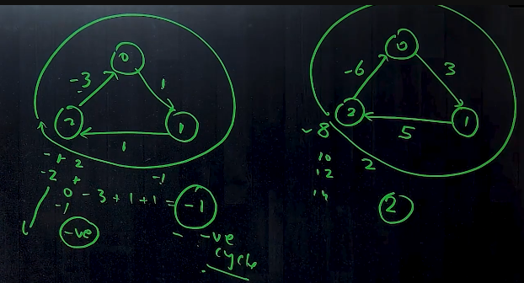**🡪** we can’t find the shortest path in graph having negative cycle because infinite loops are formed.
  + **Negative cycle means** sum of weights of the graph edges should be negative.
* 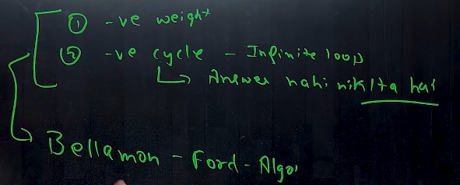**🡪dijkstra’s algo,** don’t work on negative weights and negative cycles (that forms infinite loops), and to recover from these problems, we use **Bellman Ford algorithm**
  + **Bellman Ford algorithm** works only on directed graph.
  + **If negative cycles are present** then this detects the negative cycle and says shortest path nhi nikal skta due to presence of negative cycles
  + **Algorithm 🡪** 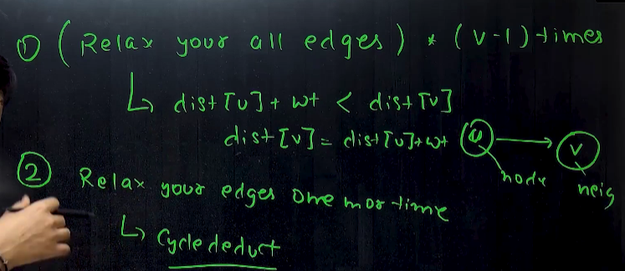 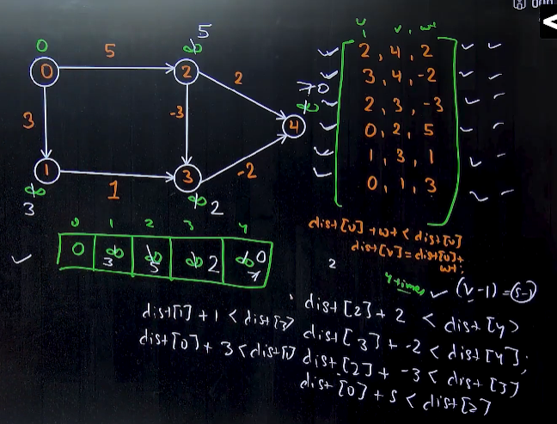 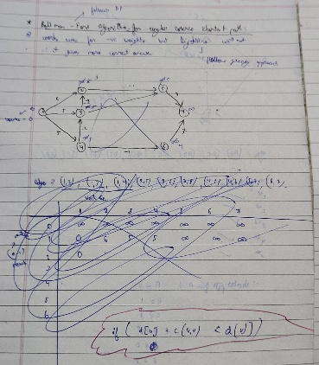 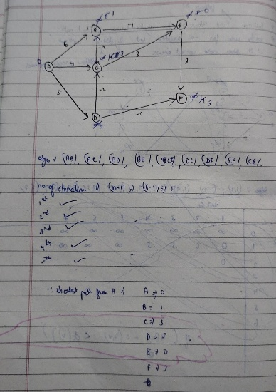 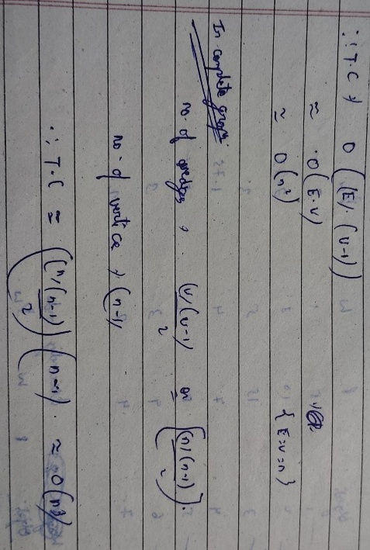
  + **Eg 1:** 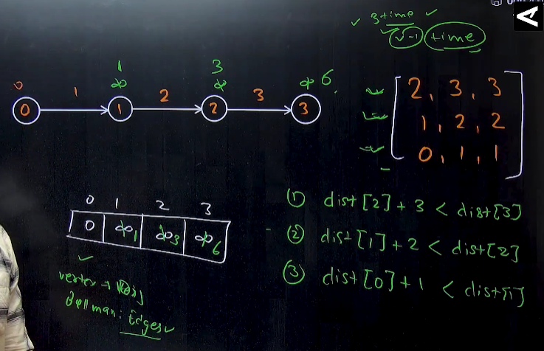
  + Eg 2: 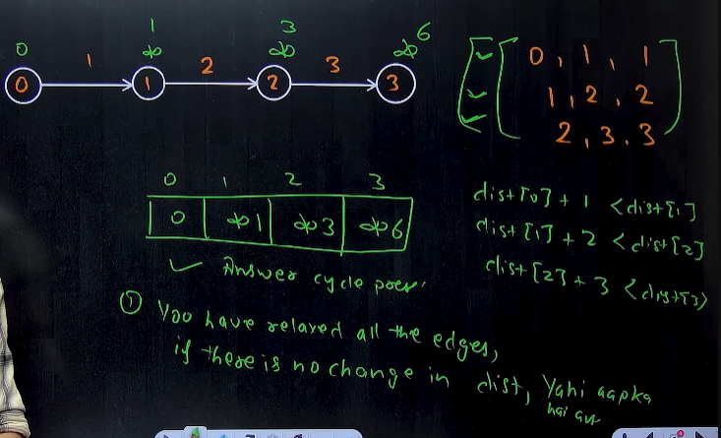
  + Eg 3: 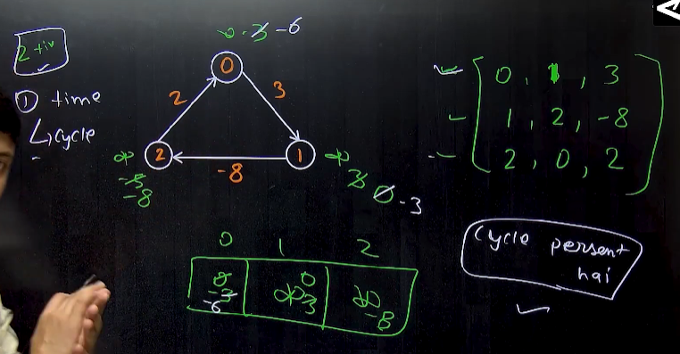

**Note: If there is an undirected graph, and negative weights are present in that , then we cant calculate the shortest path in that graph through any method .**

* **If there is a +ve weight then , use 🡪dijkstra’s algorithm**
* **If there is a -ve weight then , use 🡪Bellman ford algorithm**
* **Both Dijkstra and bellman ford algorithm calculates single source shortest path**
* **But Floyd warshall Algorithm, calculates the multi source shortest path**

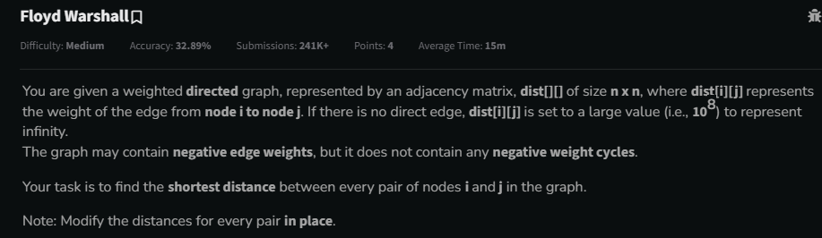 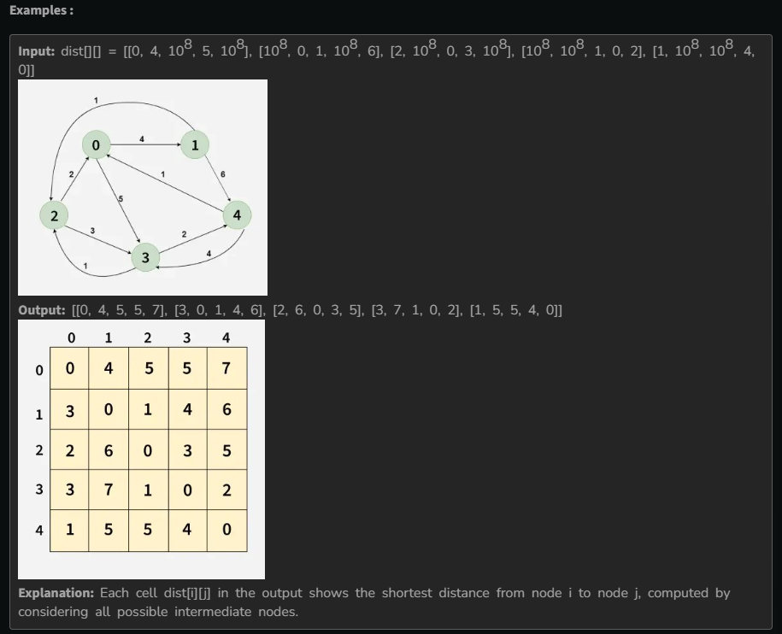 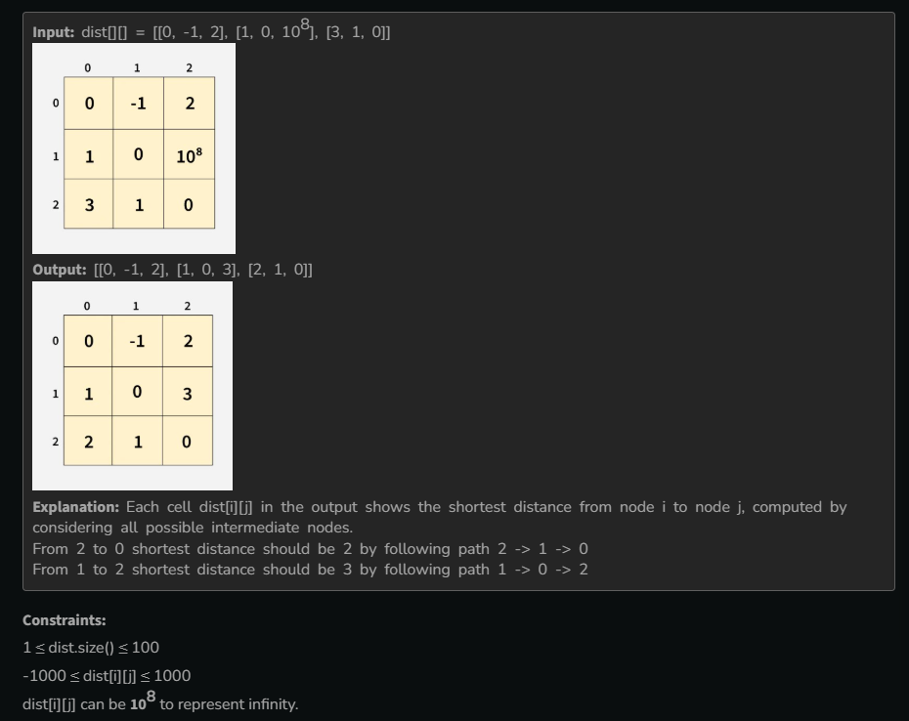

* 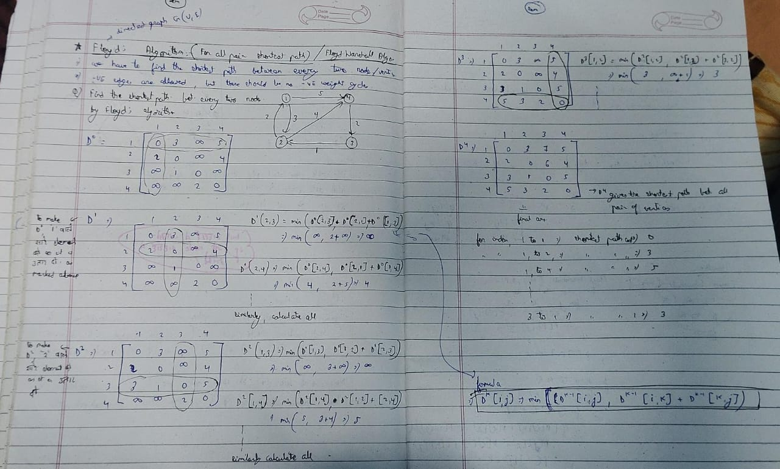 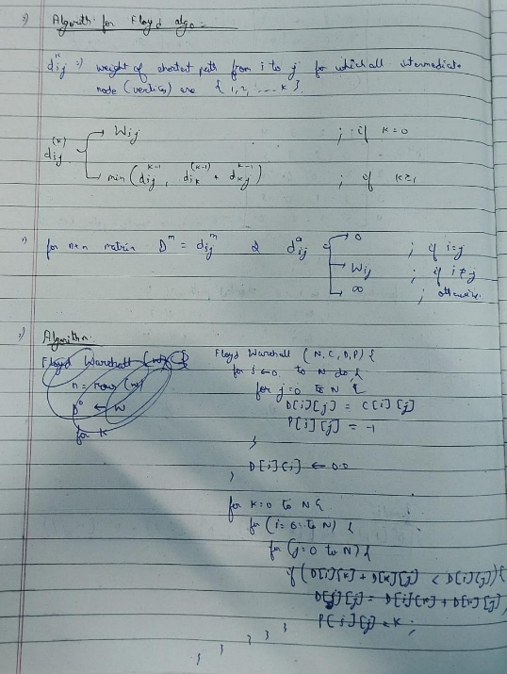 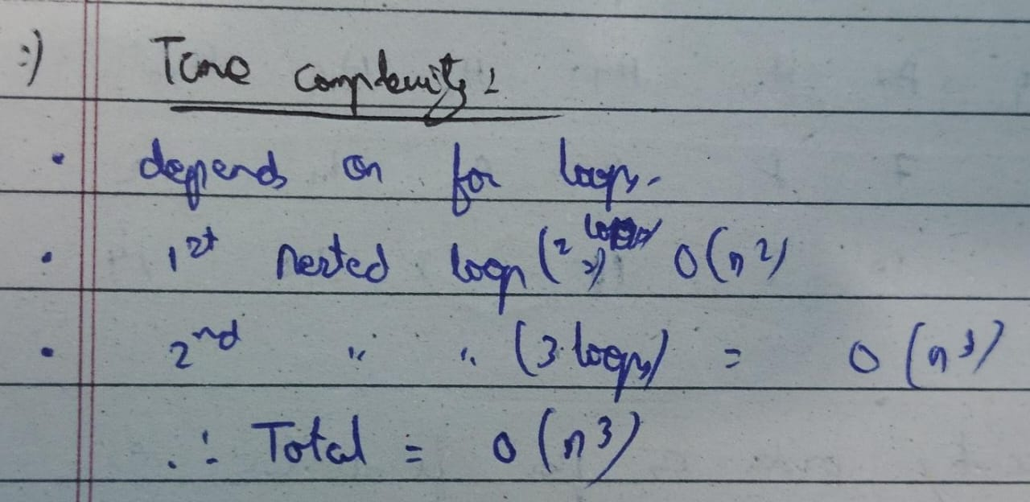
* 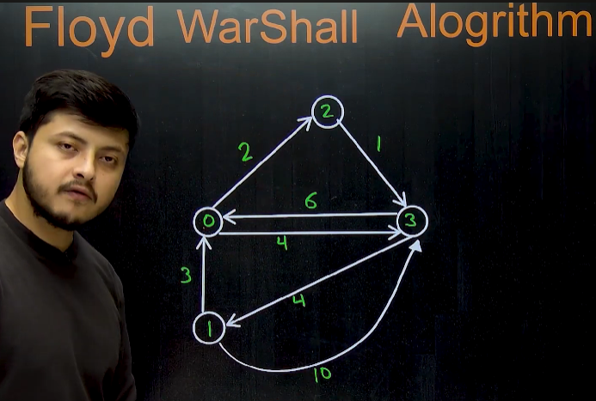
  + Floyd warshall algorithm works only on directed graph
  + Weight can be any , +ve or -ve
  + Can detect -ve cycles
* 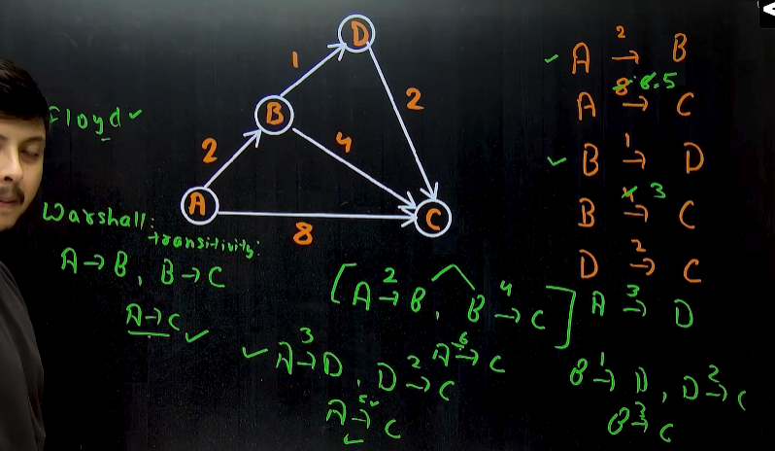
* 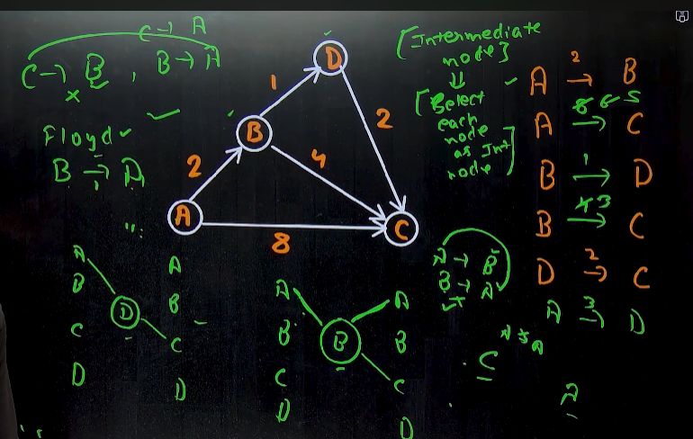🡪consider each as an Intermediate node 1 time.
* 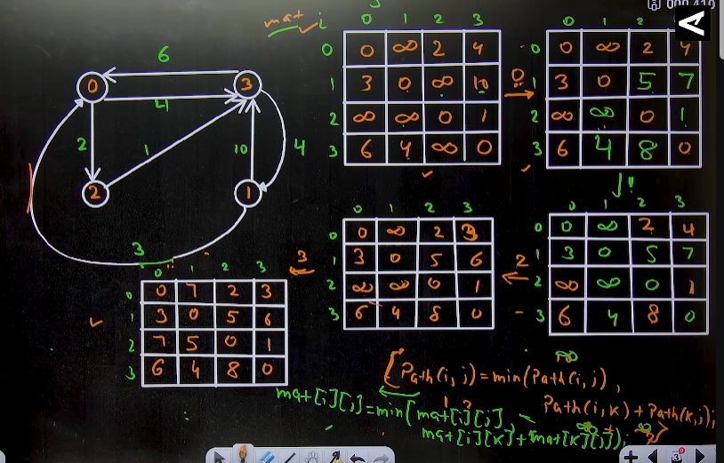
  + The order in which we select the intermediate node , dosen’t affect the final answer.
* Algorithm 🡪 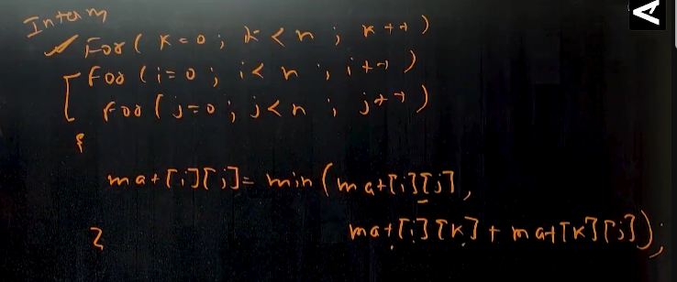
* 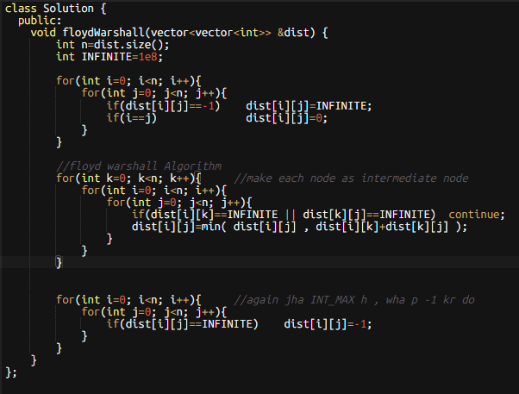🡪not ran perfectly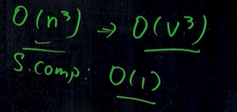

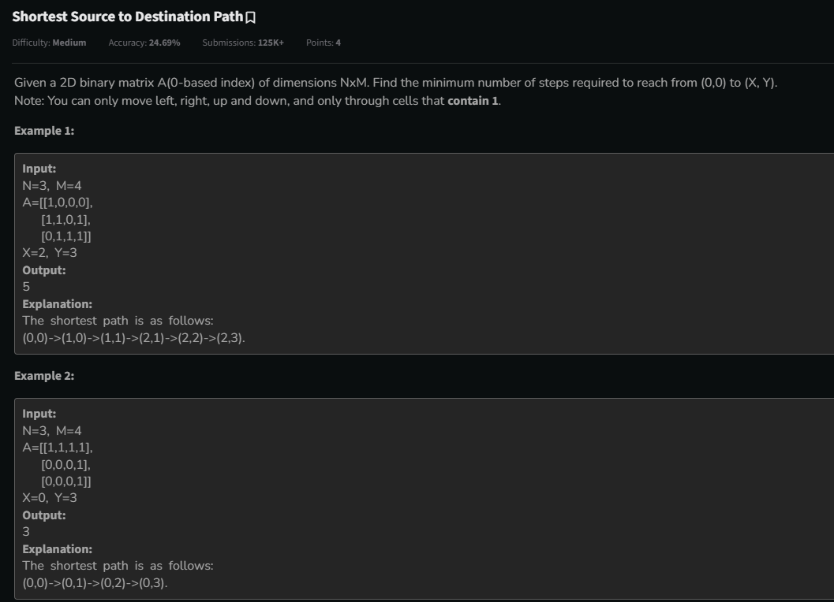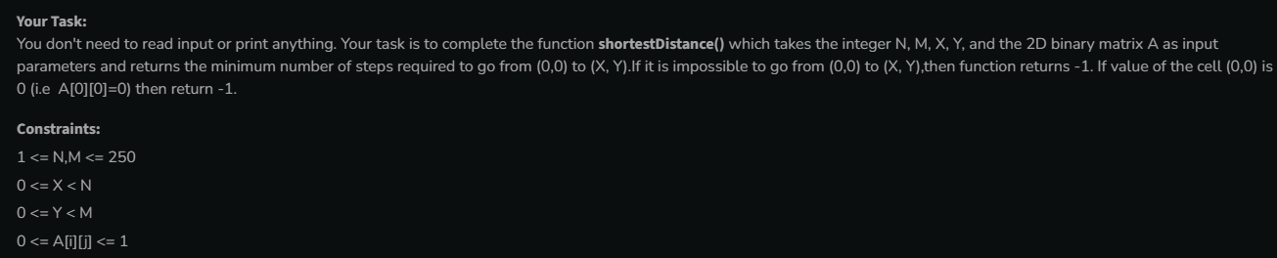

* 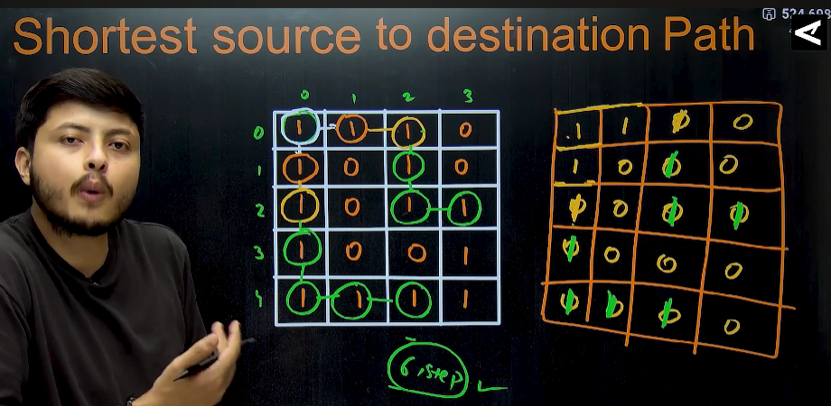🡪Use BFS technique
* Method 1🡪using visited array 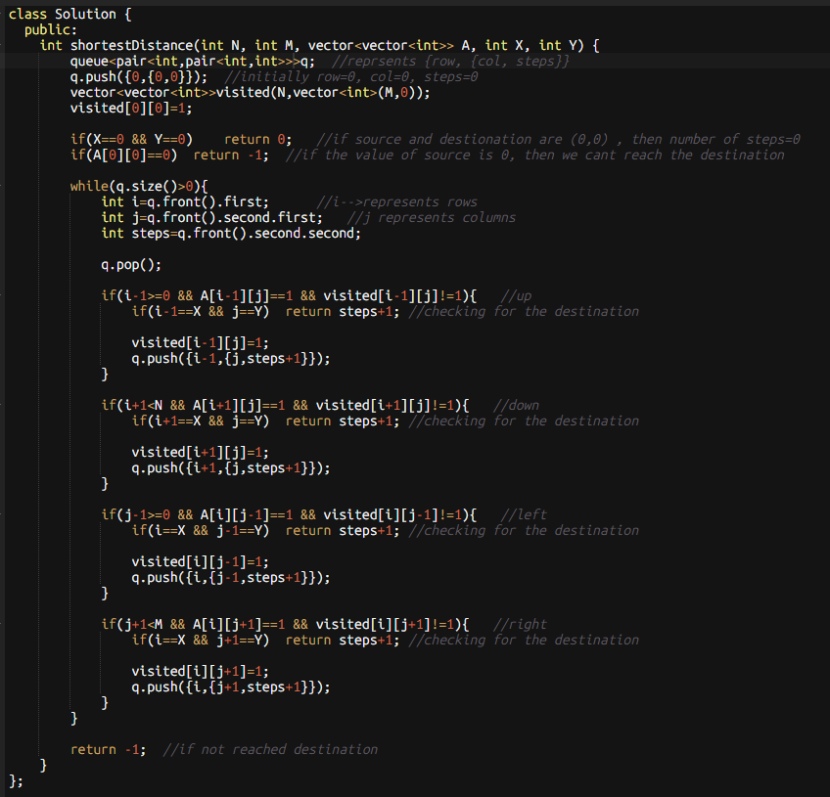
* Method 2🡪without using visited array, just making changes in the given array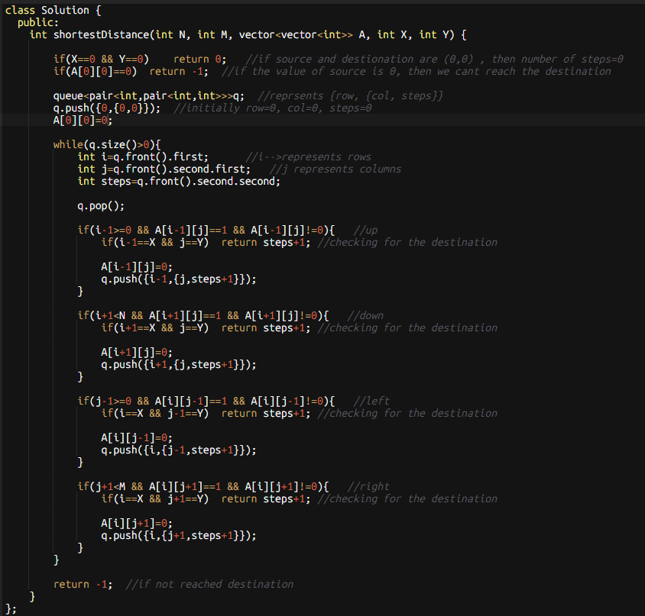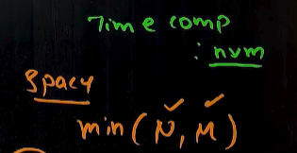

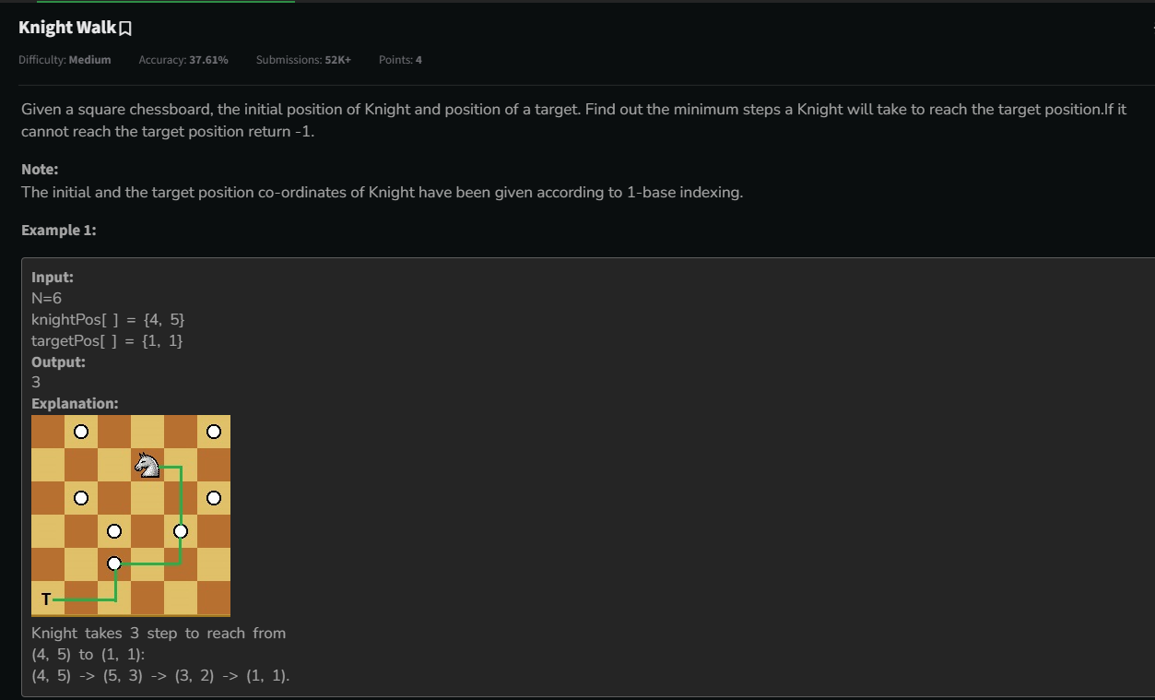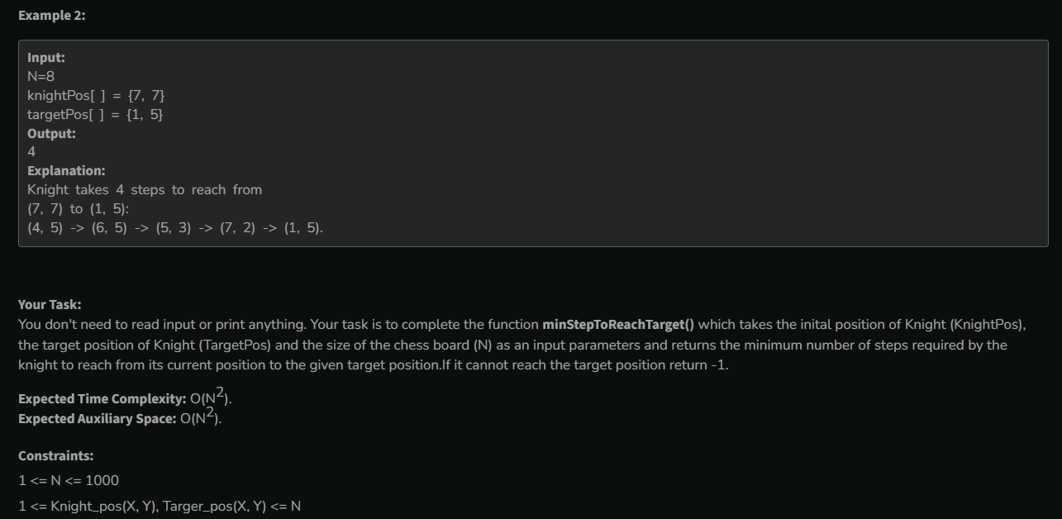

* 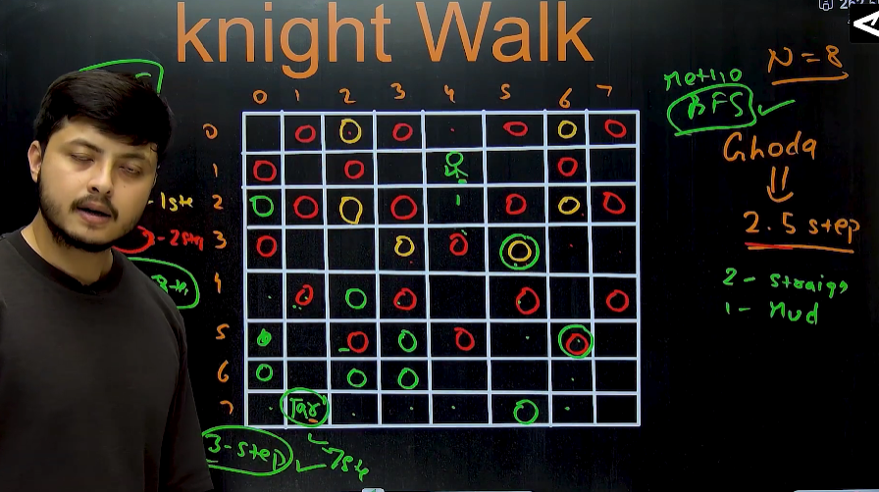
* Method 1 🡪 BFS

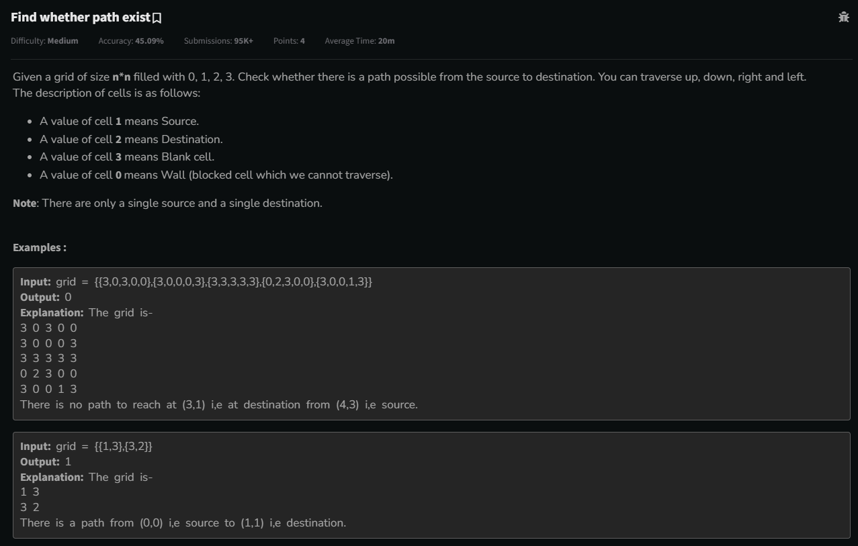

* 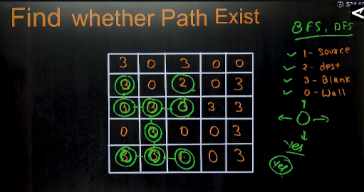

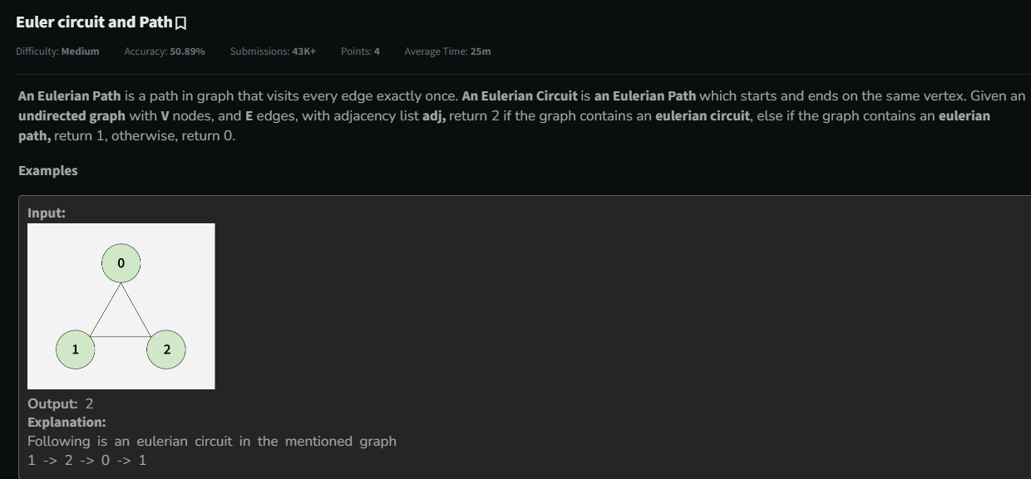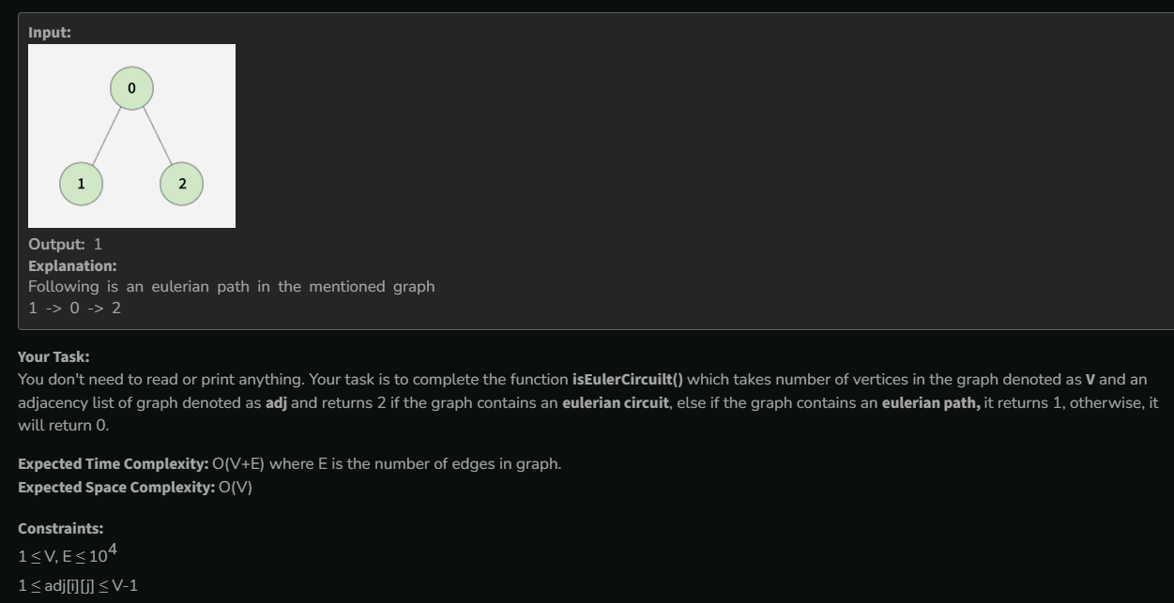

* 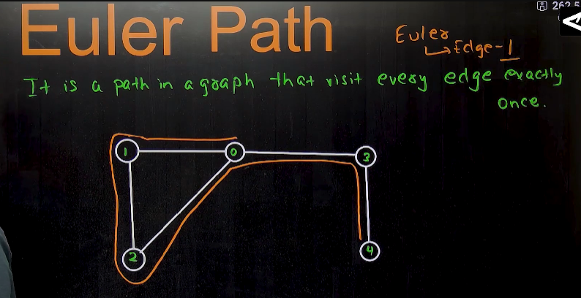
  + 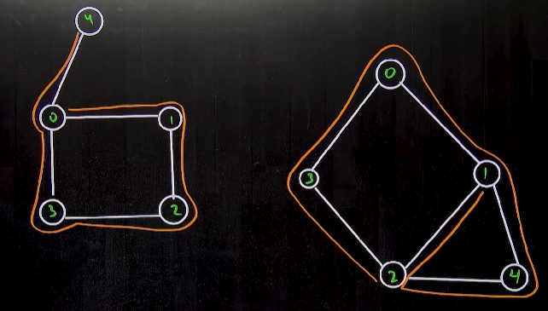
  + 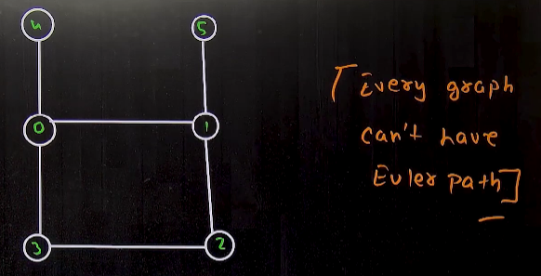
  + 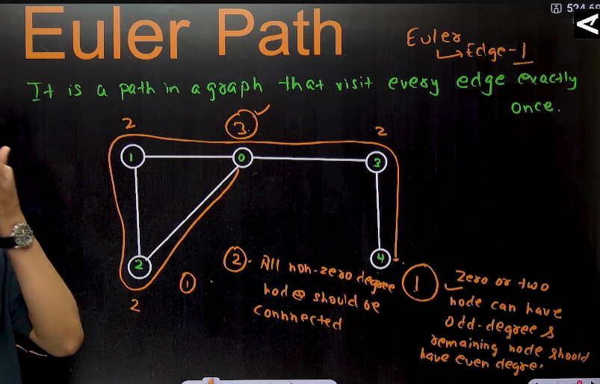🡪 condition
* 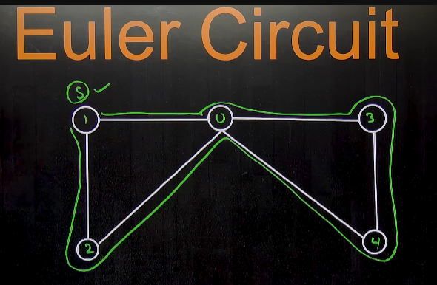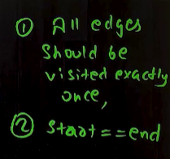
  + graph having Euler path and , also , starting and ending of the Euler path should be same🡪 called Euler circuit
  + In euler path, we cannot start from every node and get the euler path, but in case of Euler circuit, if the Euler path exists in the graph, then we can start from any node and we will get our Euler circuit
  + 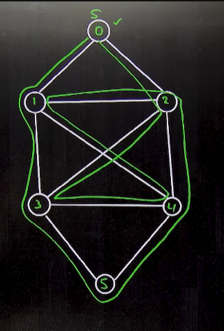
  + 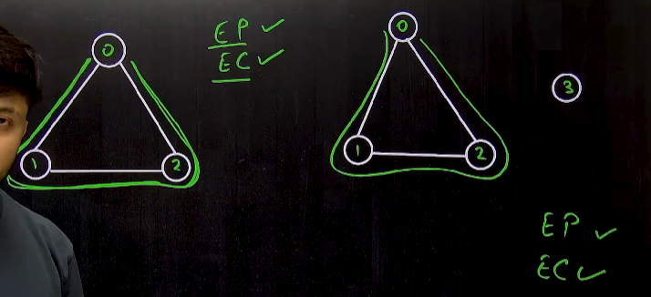🡪 both the graphs have Euler path and Euler circuit both
  + 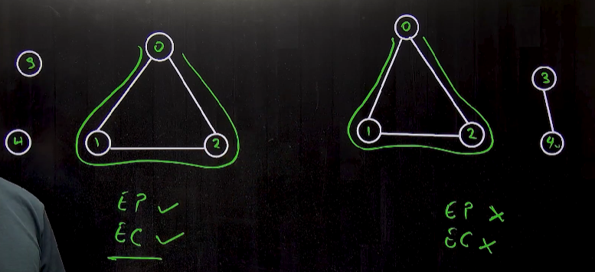
  + 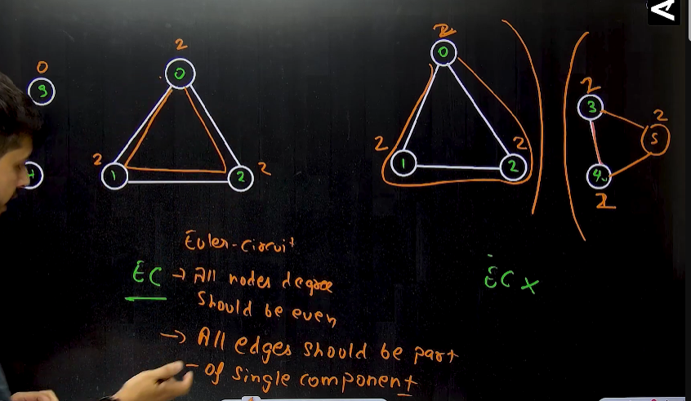🡪 condition
  + 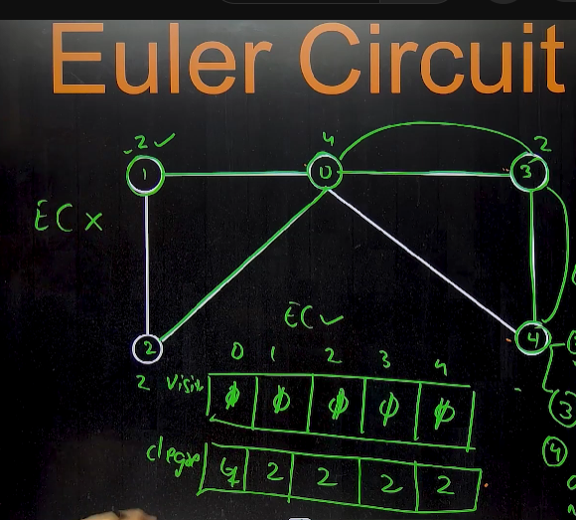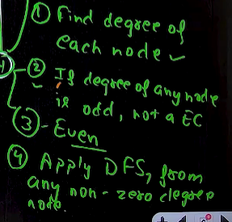🡪algorithm
* 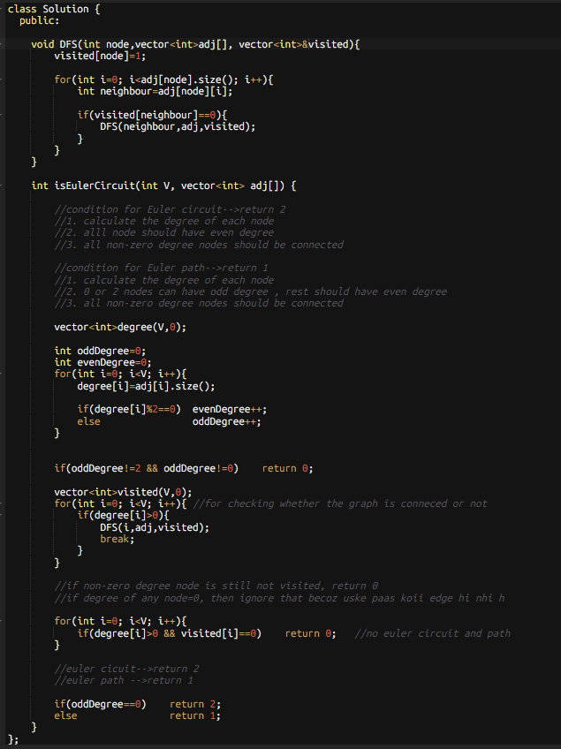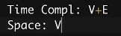

Note: 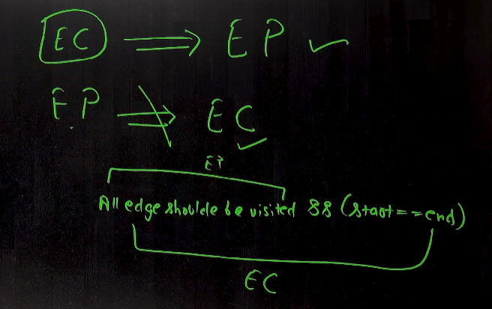

* 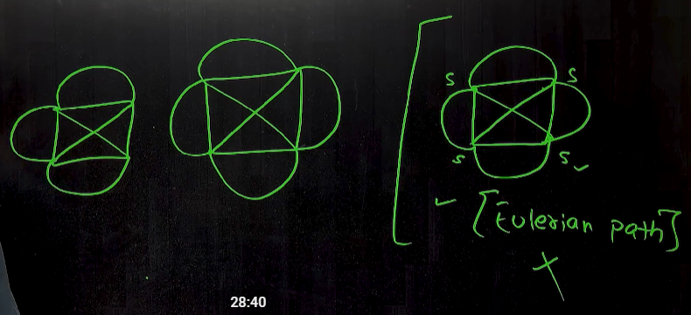

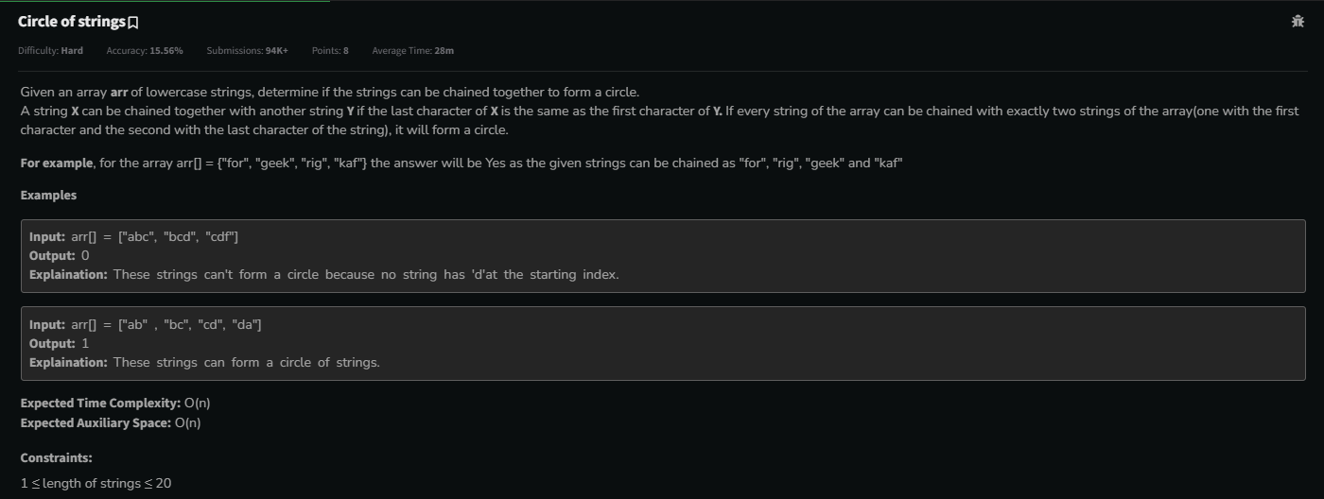

* 
  + 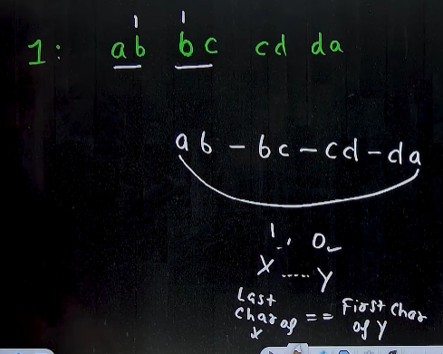
  + 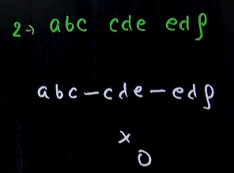
  + 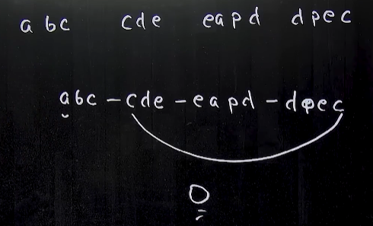
  + 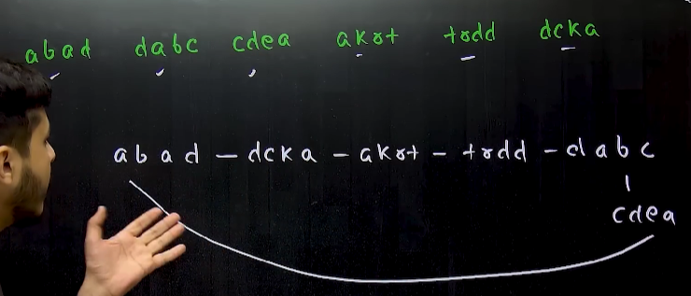
    - 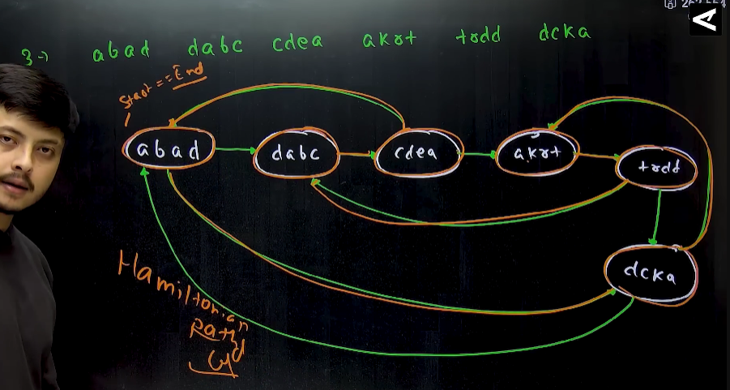
  + **Algorithm 🡪** 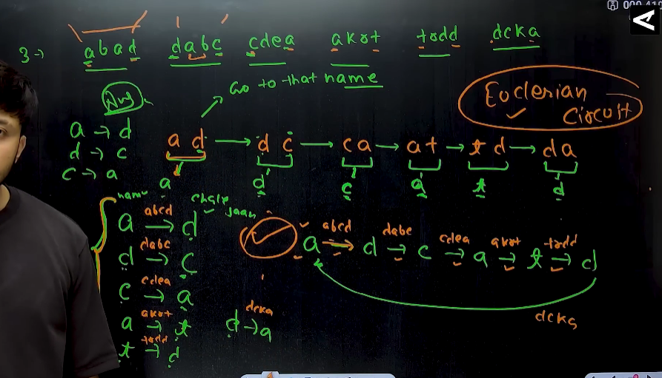 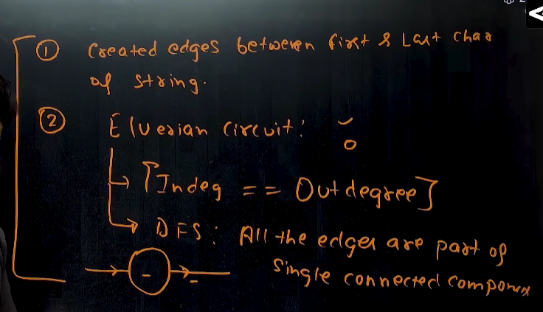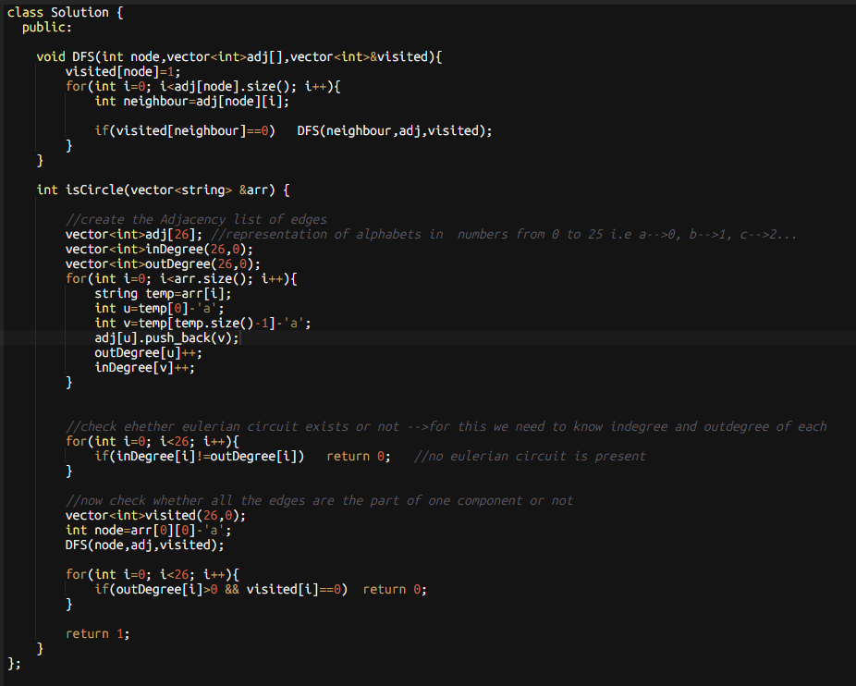

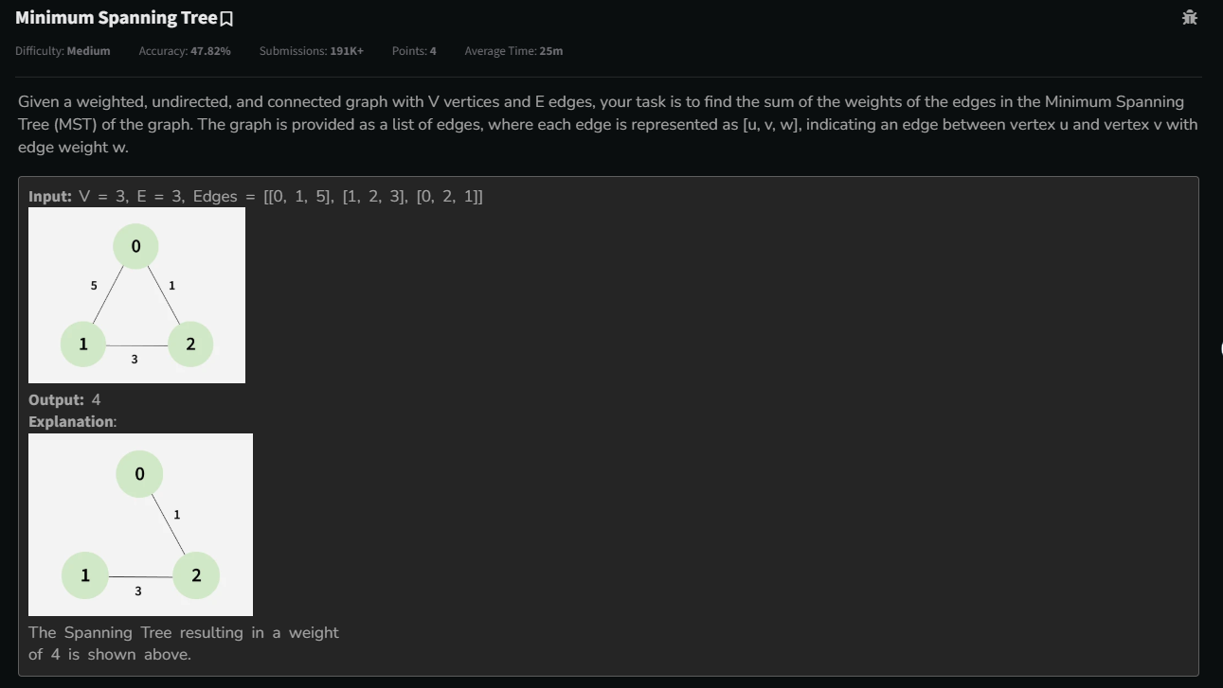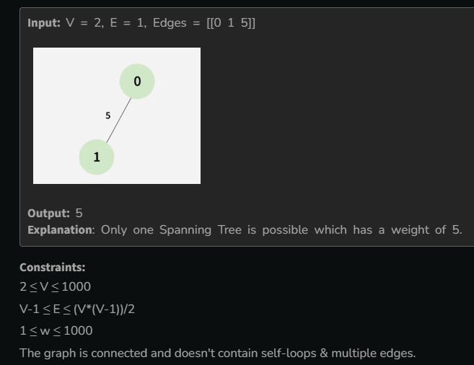

* 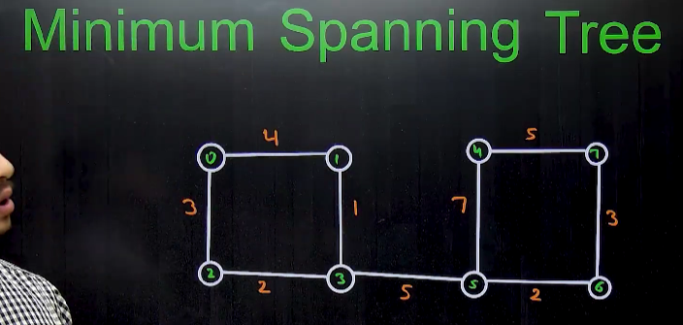
  + 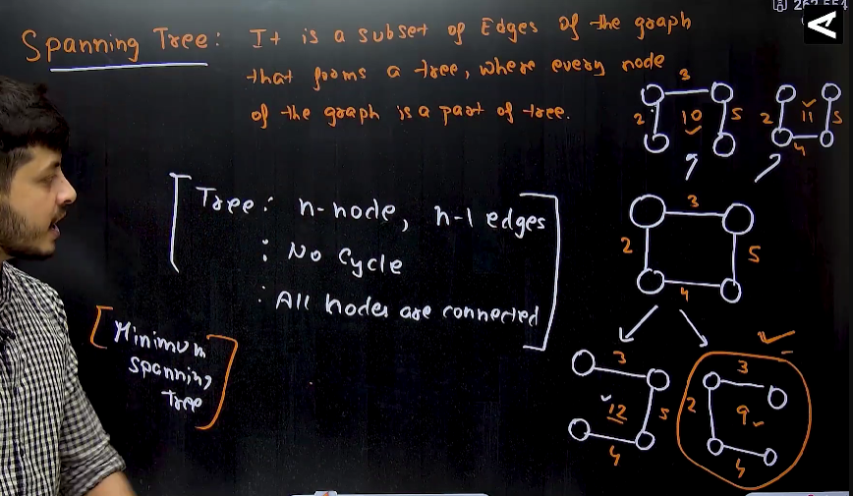
  + Methods to find the minimum spanning tree:
    - 1. Brute force🡪saare spanning tree nikaalo, and unme se sbse km jiska bhi cost hoga that will be minimum spanning tree
    - 2. Prism’s Algo🡪
    - 3. Kruksal’s Algo🡪
* Method 1🡪 Prism’s Algorithm
  + 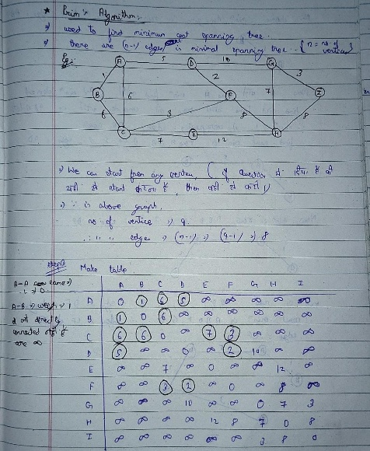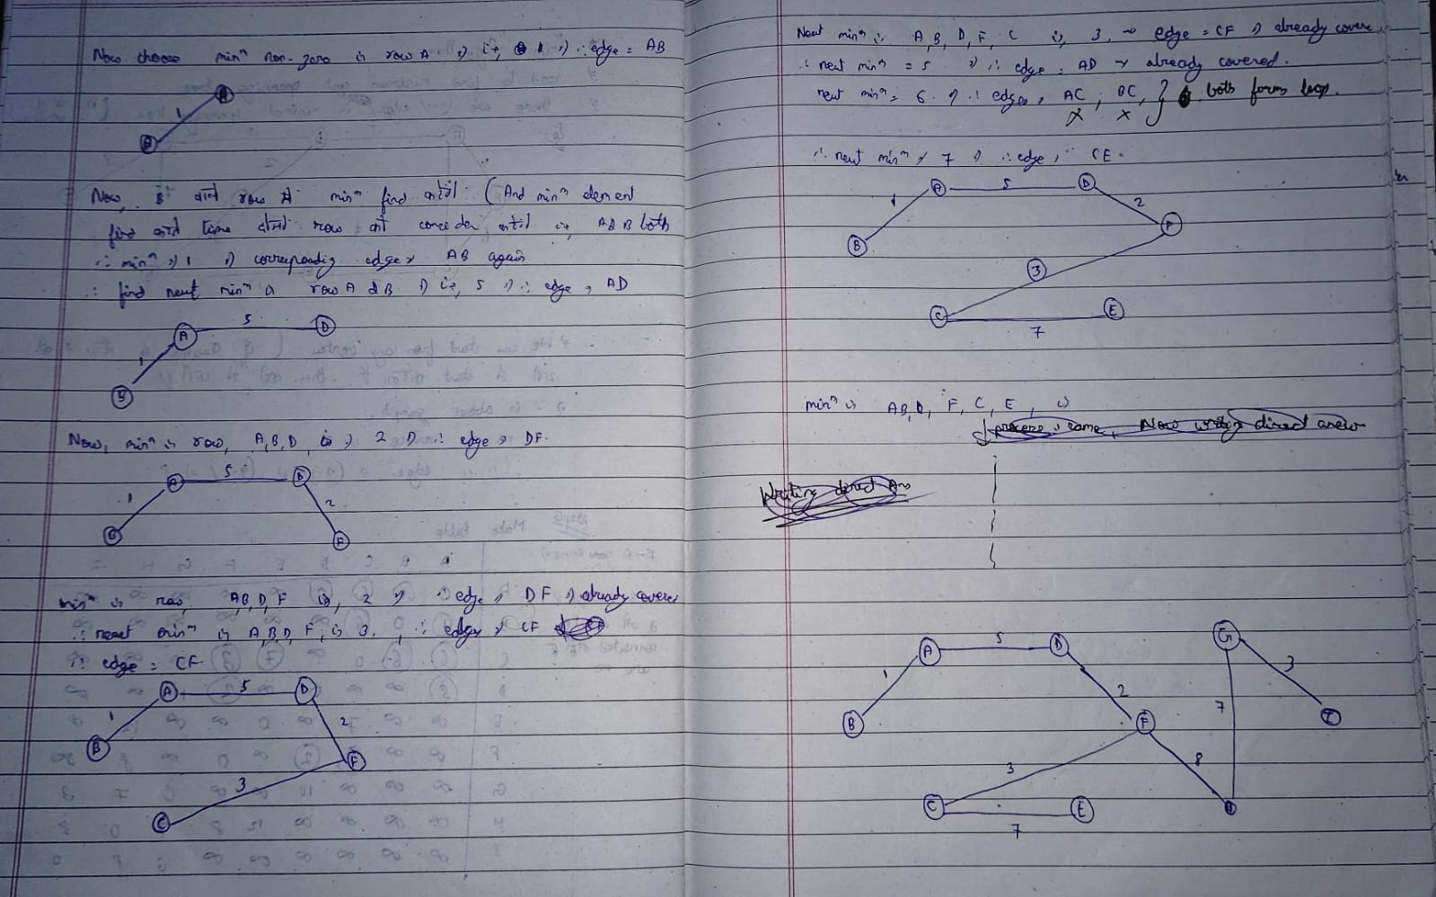
  + 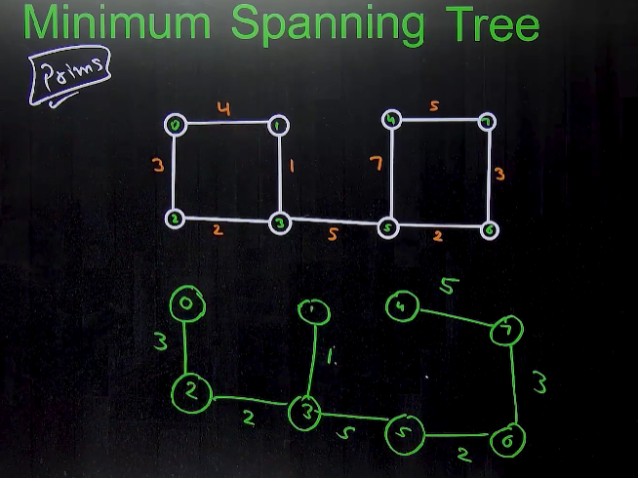
  + 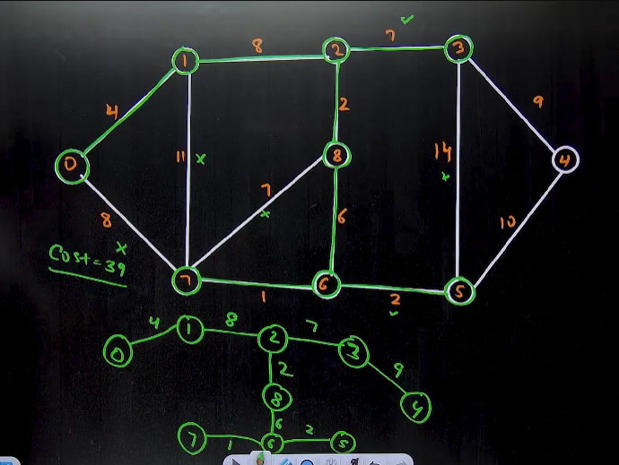
  + **Algorithm🡪 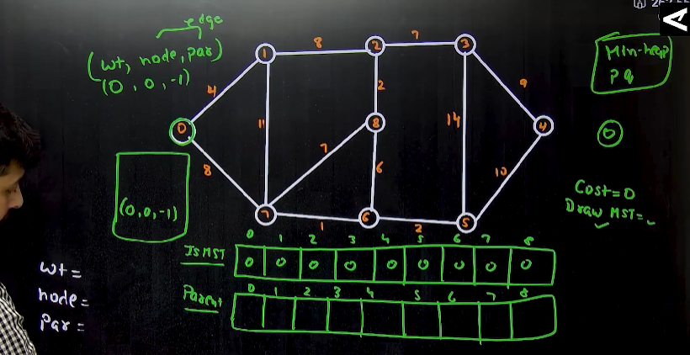🡪**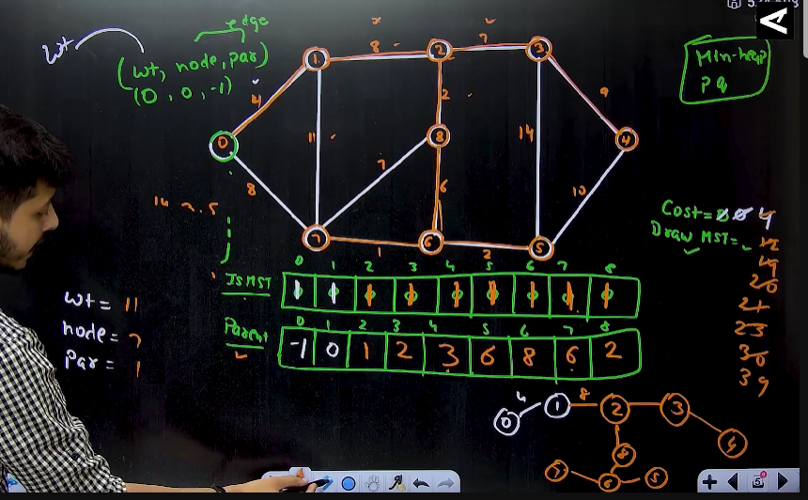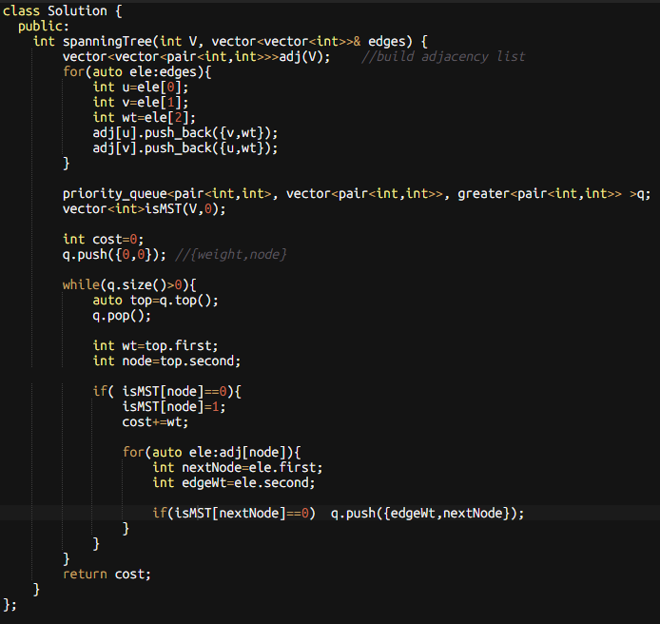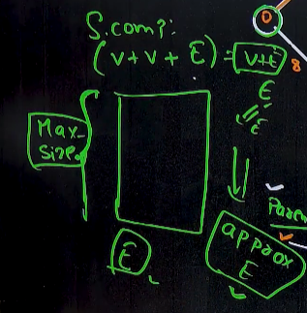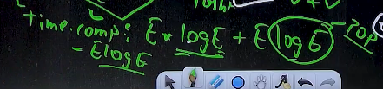
* **Method 2🡪Kruskal’s Algorithm 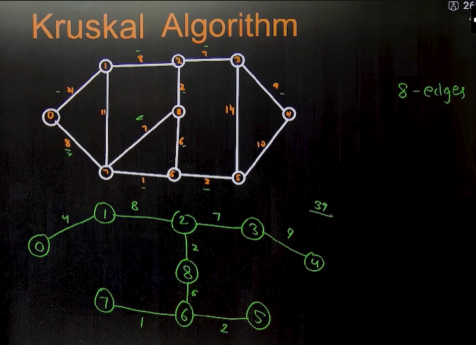🡪algorithm🡪** har time jo sbse Chhota hoga usko choose kro, and simulatenously check that (number of edges should be=n-1 && should not form a cycle) and **jaroori nhi h ki jis node p hmne end kiya h , ussi se connected nodes m explore krna h, hm overall nodes m se minimum search krna hoga**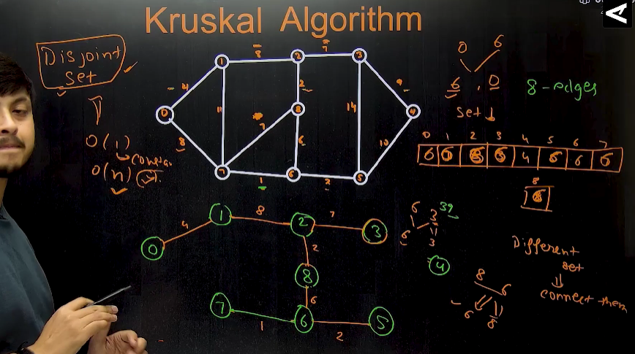
  + **Algorithm 🡪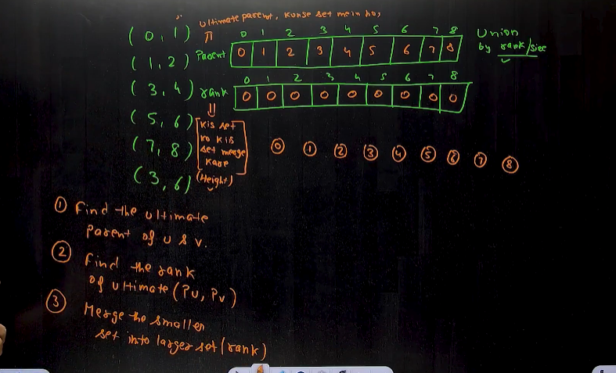🡪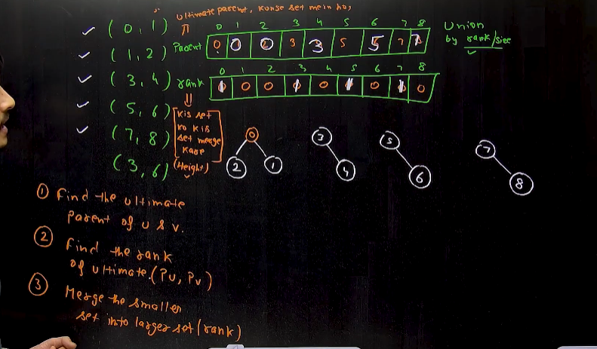🡪**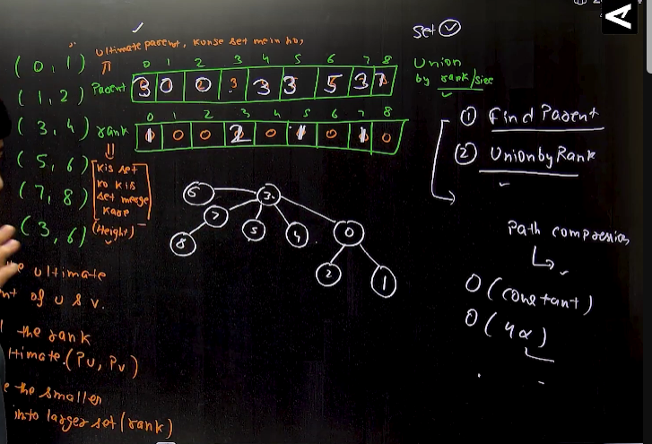
  + 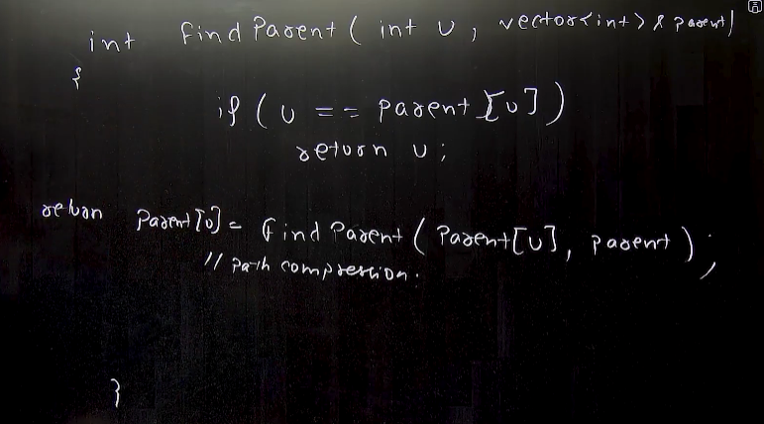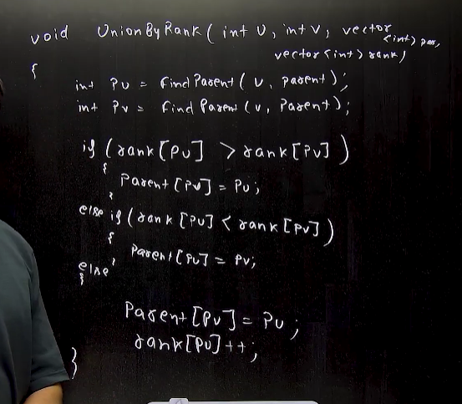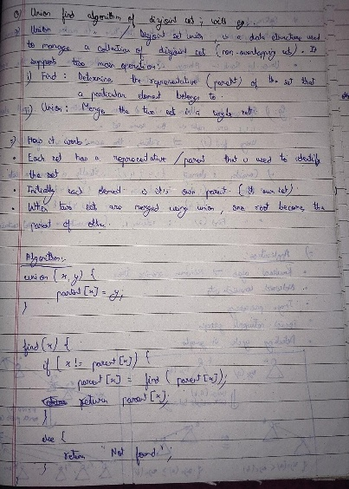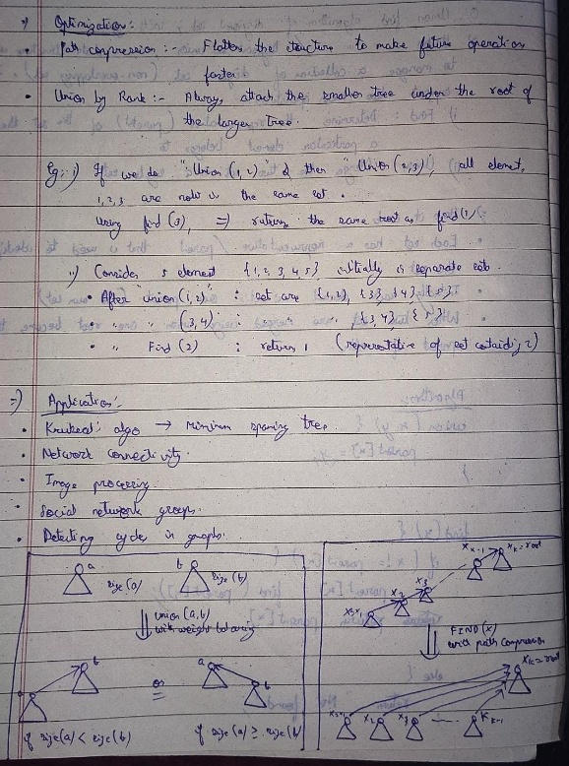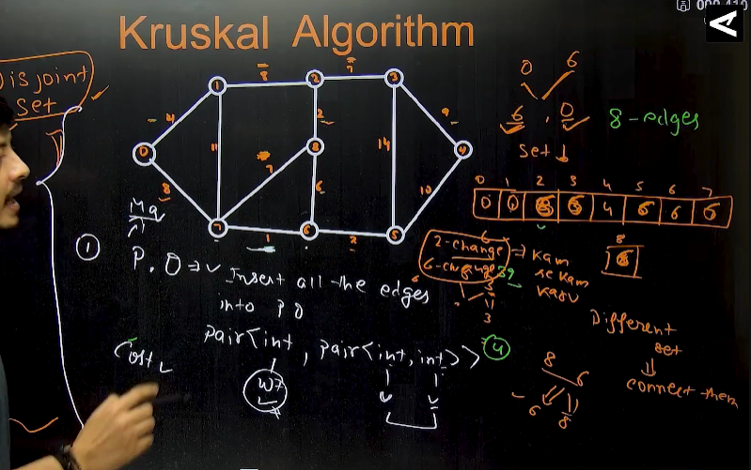
* 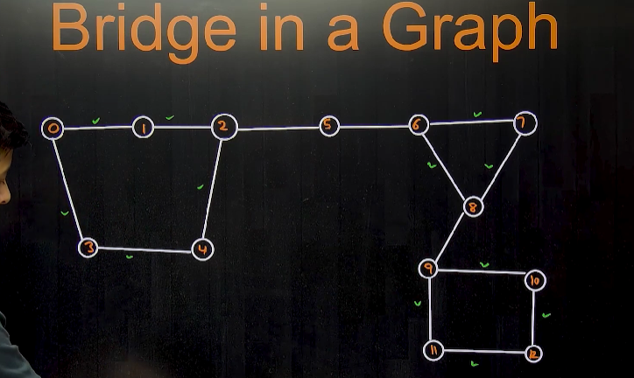
  + **Bridge** is an edge , that breaks the graph in two components
  + An edge that is not a part of any cycle then it is a bridge.
  + 
   